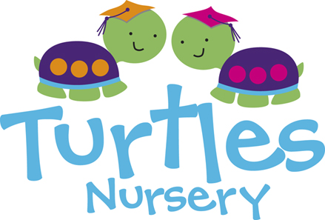
Registration Form 2021
Address: Turtles Nursery, 47 Dudley Court, 36 Endell Street, WC2H 9RF
Tel: 0207 240 8136
To register your child, please complete this form & return to nursery with your registration fee (non-refundable £100)

Full birth name of Child: Date of Birth:

Required Start Date: Funded Place Yes/No
Sessions | Mon | Tue | Wed | Thur | Fri
Morning 8am -12.30
Afternoon 1.30pm-6pm
Full Day 8am-6pm
Government Funded
*See Funding Pack for more information.
Parent/s Full Names:

Mobile telephone Number:

Email:

Home Address: Postcode:
Terms & Conditions in Brief;
A non-refundable registration Fee £100 payable to reserve your child’s place (this fee is offset against the settling in sessions) *FUNDED CHILDREN EXEMPT* Fees to be paid on the 1st of every month in advance by BACS. Bank. Details are: Barclays Bank 53039994 Sort Code 20-95-61. Fees are calculated & payable all year round. One Months notice in writing to withdraw your child or to make a permanent change in session plan. No refunds. Childcare vouchers accepted. A Welcome Pack & Terms and Conditions must be signed along with your £100 registration fee prior to starting nursery. Your details shall be entered onto our database and you will receive an extensive form to complete & return. You shall be given a settlement in guidance with specific dates and times & allocated a key person who will support you throughout your time at Turtles Nursery. News updates and information about Turtles shall be sent out via email regularly. Fully funded sessions for 2, 3, and 4 year old’s will be offered between 8:00-12:30 or 13:30-18:00 Monday to Friday only, please ask management for more information.
I understand and accept the terms and conditions listed above.
Parents Name: Parents Name:

Parents Signature: Parents Signature:
Age of Child | Session am or pm  8am-12:30pm or 1:30pm-6pm |  |  | Day (8am-6pm)
Under 2’s | £50 |  |  | £95
2-3 years | £45 |  |  | £90
3-5 years | £40 |  |  | £85

