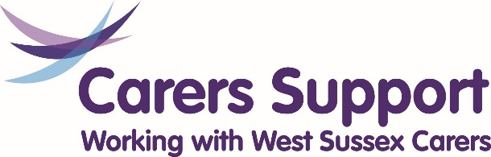

Carers Support West Sussex
Feedback form
We want to know how we are doing and if we have provided you with the support you need. Carers Support West Sussex (CSWS) is a charity and relies on public and charitable funds to provide its services. We want to ensure that we are meeting needs of family and friends carers and we can also report back to our funders. Please help us by answering a few questions:
- How have you come into contact with Carers Support West Sussex?
(tick all that apply)
- Someone phoned me
- I phoned Carers Support on their 0300 number
- I had a Carers Assessment
- I met individually with a member of staff or volunteer
- I came to a group session
- I came to a training session
- I attended an activity or event
- I saw one of the team at a Hospital
- I had a query about funding or equipment
- I went on Twitter/Facebook/Website or other social media
- I emailed/ received an email
- Other

Tell us more about your contact?

- Were staff or volunteers knowledgeable and helpful? Yes No Don’t know

- Were you able to access the support you needed? Yes No Don’t know

- Did you find the support and information you received helpful? Yes No Don’t know
(tick all that apply)
- I feel better informed
- I have more choices
- My health and wellbeing has improved
- I feel more confident in my caring role
- I have made more social contacts
- I am less stressed/anxious
- I feel more respected as a carer and treated as an expert partner in care planning
- I have more coping strategies
- I am more informed about carers rights

- Was your enquiry dealt with in a timely manner? Yes No Don’t know

- Are there ways we could improve our services? Yes No Don’t know

Tell us your ideas on how we can improve

- Would you recommend Carers Support West Sussex? Yes No Don’t know

- Any other comments that will help us support family and friends carers?

Please return this form to our Head office: Carers Support West Sussex, The Orchard, 1-2 Gleneagles Court, Brighton Road, Southgate, Crawley, West Sussex, RH10 6AD.
Any enquiries please contact 0300 028 8888 or info@carerssupport.org.uk

Thank you for taking the time to complete this form

