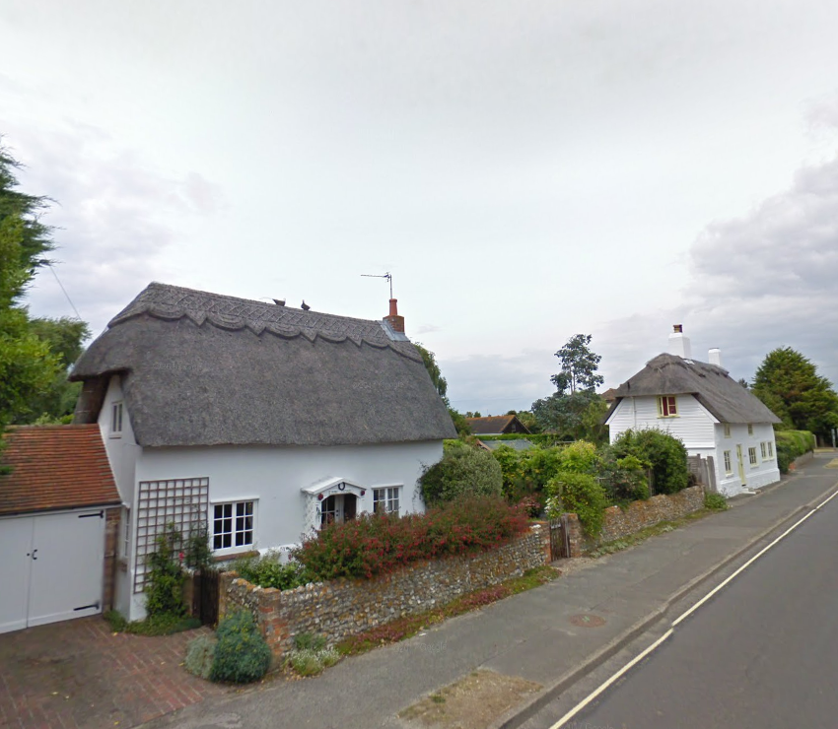
DRAFT

West Wittering Housing Needs Assessment (HNA)

January 2018

Quality information
Prepared by |  | Checked by |  | Approved by
Ivan Tennant, Principal Planner  Guillaume Rey, Planning Intern |  | Steve Smith, Technical Director

Revision history
Revision | Revision date | Details | Authorised | Name | Position

Prepared for:
West Wittering Parish Council

Prepared by:

‌AECOM
Aldgate Tower
2 Leman Street
London
E1 8FA
aecom.com

© 2017 AECOM . All Rights Reserved.
This document has been prepared by AECOM (“AECOM”) for sole use of our client (the “Client”) in accordance with generally accepted consultancy principles, the budget for fees and the terms of reference agreed between AECOM and the Client. Any information provided by third parties and referred to herein has not been checked or verified by AECOM, unless otherwise expressly stated in the document. No third party may rely upon this document without the prior and express written agreement of AECOM.

Table of Contents
1. Executive Summary 1-6
2. Context 2-15
2.1 Local planning context 2-15
3. Approach 3-16
3.1 Research questions 3-16
3.2 Tenure 3-16
3.3 Type and size 3-17
3.4 Housing for specialist groups 3-17
3.5 Study objectives 3-17
4. 1. Relevant Data 4-17
4.1 SHMA 4-17
5. RQ1. What quantity of housing is appropriate for the NPA? 5-19
5.1 Chichester Local Plan (2014-2023) 5-19
5.2 SHMA studies 5-19
5.3 MHCLG household projections 5-20
5.4 Dwelling growth 2001 – 2011 5-21
5.5 Dwelling growth since 2011 5-21
5.6 Dwelling growth 2001-2017 5-21
5.7 The standard methodology 5-21
6. RQ2. What affordable housing (social housing, affordable rented, shared ownership, intermediate rented) and market housing tenures should be included in the housing mix? 6-23
6.1 Definitional issues 6-23
6.2 Current tenure profile 6-24
6.3 Age structure 6-25
6.4 Household composition 6-26
6.5 Affordability 6-27
6.6 Housing waiting list 6-31
6.7 Conclusions 6-32
7. RQ3. What type (terrace, semi, bungalows, flats and detached) and size (number of habitable rooms) of housing is appropriate? 7-37
8. RQ4: What provision should be made for specialist housing within the NPA? 8-41
8.1 Sheltered and extra-care housing 8-41
9. Market signals 9-46
9.1 Employment and commuting trends 9-46
9.2 Housing transactions: prices 9-48
9.3 Housing transactions: volume 9-49
9.4 Migration 9-50
9.5 Overcrowding and concealed families 9-51
9.6 Rate of development 9-52
10. Conclusions 10-54
10.1 Overview 10-54
10.2 Recommendations for next steps 10-58

List of acronyms used in the text:

AH Affordable Housing (NPPF definition)
AHDNS14 Assessment of Housing Development Needs Study
AMH Affordable Market Housing
WWPC West Wittering Parish Council
CWSS12 Coastal West Sussex Strategic Housing Market Assessment
GT Gypsy & Traveller
GTAA Gypsy and Traveller Accommodation Assessment
HNA Housing Needs Assessment
LPA Local Planning Authority
MHCLG Ministry for Housing, Communities and Local Government (formerly DCLG)
NDP Neighbourhood Development Plan
NP Neighbourhood Plan
NPA Neighbourhood Plan Area
NPPF National Planning Policy Framework
ONS Office for National Statistics
PPG Planning Practice Guidance
PRS Private Rented Sector
RTF Rural Town and Fringe
ROANH14 Review of Objectively Assessed Housing Need in light of 2012-based Sub-national Population Projections
SHLAA Strategic Housing Land Availability Assessment
SHMA Strategic Housing Market Assessment
DCS District Core Strategy

Executive Summary
Introduction
- The 2011 Localism Act introduced neighbourhood planning, allowing Parishes, town councils or neighbourhood forums across England to develop and adopt legally binding development plans for their neighbourhood areas.
- As more and more town or Parish councils and neighbourhood forums seek to address housing growth, including tenure and type of new housing, it has become evident that emerging policies need to be underpinned by robust, objectively assessed housing data.
- In the words of the national Planning Practice Guidance (PPG), establishing future need for housing is not an exact science, and no single approach will provide a definitive answer. The process involves making balanced judgments, as well as gathering numbers and facts. At a neighbourhood planning level, one important consideration is determining the extent to which the neighbourhood diverges from the local authority ‘average’ in terms of housing need, reflecting the fact that a single town or neighbourhood almost never constitutes a housing market on its own and must therefore be assessed in its wider context.
- The guidance quoted above on housing needs assessment is primarily aimed at local planning authorities preparing Strategic Housing Market Assessments (SHMAs), which are used to determine housing need at a housing market area level. However, it helpfully states that those preparing neighbourhood plans can use the guidance to identify specific local needs that may be relevant to a neighbourhood, but that any assessment at such a local level should be proportionate.
- Our brief was to advise on data at this more local level to help West Wittering Parish Council (WWPC) understand, among other matters, the type, tenure and quantity of housing needed in their area to inform the development of evidence-based neighbourhood plan policies.

PPG-based assessment
- This objective and independent housing needs advice note follows the PPG approach where relevant. This ensures our findings are appropriately evidenced. The PPG advises that assessment of development needs should be thorough but proportionate and does not require planners to consider purely hypothetical future scenarios, only future scenarios that could be reasonably expected to occur.

Summary of Methodology
- Housing Needs Assessment at neighbourhood plan level can be focused either on quantity of housing needed, type of housing need, or both. In most cases, there is a need to focus on quantity where the housing target for the area being assessed is unclear, for example where the local authority has not set a specific target for the settlement, or where there is no local plan in place.
- In the case of WWPC, the current adopted Development Plan, the Chichester Local Plan (CLP), identifies a target of 50 dwellings for the Parish to be delivered over the Plan period of 2012-2029. As a plan that post-dates the National Planning Policy Framework, this should be used as a firm guide on housing numbers.
- However, Chichester District Council (CDC) is in the process of developing a new local plan and, while they are committed to providing the Parish with a housing needs figure, this has not yet been communicated. As such, WWPC wishes to generate their own assessment to ensure the final number used to support policies in their plan provides adequately for the future needs of the community, particularly in relation to the provision of dwellings suited to the needs of young people and families from the area to wish to continue to live there.
- In arriving at the final number, it is important to note that neighbourhood plans need to meet a number of Basic Conditions (tested through independent examination) in order to be ‘made’ by the LPA. One of these, Basic Condition E, requires the Neighbourhood Plan to be in ‘general conformity with the strategic policies’ of the Local Plan. In this case, this equates to the CLP and the emerging Local Plan once it has been adopted by the CDC (moreover, it is important that WWPC is mindful of the direction of travel of the emerging Local Plan both to influence this document and, given that, once adopted, the neighbourhood plan policies will need to satisfy Condition E). The PPG indicates that the level of housing development is likely to count as a strategic policy.
- In terms of the types of housing needed, there is generally more flexibility on what neighbourhood plans can include. In order to understand the types of housing needed in WWPC, we have gathered a wide range of local evidence and summarised it into policy recommendations designed to inform decisions on housing quantity and characteristics.
- It is also important to arrive at an appropriate Plan period for the neighbourhood plan so as to be able to gather data and carry out calculations that are critical to this HNA. We have been advised by WWPC of a Plan period of fifteen years, with a base year of 2018. The pPlan period we have used for the purposes of this HNA is therefore 2018-2033.
- In order to understand the types of housing needed in West Wittering, we have gathered a wide range of local evidence and distilled this into a series of policy recommendations designed to inform decisions on housing characteristics.
- Our approach is to provide advice on the housing required based on need and/or demand rather than supply. This is in line with the PPG, which states that ‘the assessment of development needs should be an objective assessment of need based on facts and unbiased evidence. Plan makers should not apply constraints to the overall assessment of need, such as limitations imposed by the supply of land for new development, historic under performance, viability, infrastructure or environmental constraints.’
- For this reason, we advise that the conclusions of this report should be assessed against supply-side considerations (including, for example, factors such as transport infrastructure, landscape constraints, flood risk and so on) as a separate and follow-on exercise.

Quantity of housing needed
- Our assessment of a wide range of data sources identified four separate projections of dwelling numbers for WWPC between 2018 and 2033:
      - Chichester Local Plan minimum derived figure generates a target of 139 dwellings over the Plan period 2018-2033, or 9 dwellings per annum (dpa);
      - Review of Objectively Assessed Housing Need (ROAHN) in light of 2012-based Sub-national Population Projections produces a target of 204 dwellings between 2018 and 2033 or 14 dpa;
      - MHCLG household projections generate a re-based projection of 249 dwellings over the Plan period or 17 dpa; and
      - A projection derived from homes growth between 2001 and 2017 of 136 homes over the Plan period of 2018-2033, or 9 dpa.
- These dwelling number projections are illustrated in Figure 1 below.

Figure 1: Dwelling projections for West Wittering, 2018-2033

Source: AECOM
- The graph above sets out the total number of homes factoring in each of the projections we have identified. So, for example, factoring in MHCLG derived data (orange line) to the number of dwellings that have already been built in the NPA between 2011 and 1st January 2016 (71) produces a requirement that the total number of homes (the total of those existing, plus additional dwellings completed over the Plan period) at the end of the Plan period in the NPA should come to 2060 homes.
- The starting point to arrive at an overall projection for housing numbers to be delivered in the NPA over the Plan period is the average of the four projections set out above; we depart from this approach if we have reason to believe a given projection should be accorded more weight than others, or should be excluded. For example, if the Local Plan was out of date in planning terms, or another projection was a clear outlier.
- In the case of West Wittering, we do not see any justification for awarding any one projection greater weight, therefore the initial housing projection for the town is 182 dwellings, or 12 dpa (rounded) over the Plan period.
- Moreover, a further assessment of relevant factors applied to this initial projection indicates that market signals (for example, the economic context in which the NPA sits and the movement of house prices)) are likely to impact on it. We have applied our professional judgment on the scales of increase and decrease in housing requirement associated with each factor on a scale from one to three, where one arrow indicates ‘some impact’, two arrows ‘stronger impact’ and three arrows an even stronger impact. Factors are set out in the table below in alphabetical but no other order.

Table 1: Summary of factors specific to West Wittering with a potential impact on neighbourhood plan housing quantity
Factor | Source(s) (see Chapter 5) | Possible impact on housing needed | Conclusion
Employment trends | LEPSEP, CLP, Census 2001/11 | ↑↑ | The wider economic area has been shown to have numerous global and competitive companies across a wide range of sectors, with a potential for growth.  Furthermore, future investment in transport infrastructure has been shown to have a likely impact on West Wittering in terms of demand for housing, as is potential growth in intrinsic businesses based inside the NPA. Therefore two up arrows have been deemed appropriate.
Housing transactions (prices) | PPG, Land Registry Price Paid Data for 2007-2016, SHMA | ↑↑ | The West Wittering NPA has been shown to have experienced an 18% increase in price paid for properties of all types over a ten year period.  The price paid varies per housing type (detached, semi-detached, terraced and flats) but has remained relatively high across all types. Although price growth in West Wittering was less than in the District as a whole, this was from a higher base, and therefore, two up arrows have been deemed appropriate.
Housing Transactions (volume) | Land Registry Price Paid Data for 2007-2016, Census 2001/2011 data, SHMA | ↑ | The evidence gathered suggests there is a high demand in the NPA for semi-detached housing relative to supply (the number of sales of semi-detached dwellings as a proportion of all sales exceeds the proportion they represent of the housing stock). This ‘high demand’ scenario justifies one up arrow.
Migration | Census 2001/2011 | ↔ | Migration is not seen as a significant factor in determining housing need given that just 22% of the 6.1% of West Wittering residents born outside of the UK arrived in the last 10 years.
Overcrowding and concealment | Census 2001/ 2011 | ↔ | There is no evidence of overcrowding in West Wittering and although there is some evidence of concealed families, these are not deemed particularly significant given the levels seen in Chichester District as a whole.
Rate of development | Chichester District Council Authority’s Monitoring Report 2015-2016, SHMA | ↔ | Chichester District has consistently met, or exceeded its housing target in recent years. Furthermore, the rate of development in West Wittering shows that actual supply is in line with planned supply. Therefore it is reasonable to suggest that the rate of development indicates there is only a small potential for future under-delivery and, as such, a neutral arrow is considered appropriate.

- Table 2 summarises the market signals that need to be taken into account before arriving at a final housing needs figure for the Parish. Two key factors have been identified that would suggest an uplift is warranted. Firstly, the anticipated employment growth in the wider District and, secondly, the house price growth in recent years together with the indication from local estate agents that house prices are high in West Wittering compared with its immediate context (see Table 2 below).
- The evidence assembled points to a severe misalignment between the housing stock and the needs of the community, with a preponderance of larger, detached dwellings and a shortage of smaller, more affordable homes. Rather than necessarily substantially increasing the overall stock of dwellings, an important policy objective should be re-balancing the housing stock profile to address these misalignment. While this will inevitably mean additional development, it does not provide the basis for an uplift in the housing target put forward above.
- As regards the evidence of employment growth, data of this kind should be treated with caution given the difficulty in making accurate economic forecasts. At the neighbourhood plan level, it can only rarely be used as the sole basis for justifying an uplift in the housing needs number, for example where the evidence is incontrovertible and is reinforced by other market signals.
- These factors therefore do not justify an uplift in the figure of 182 set out above, particularly in light of the NPA fulfilling its housing targets under the current adopted plan.
Table 2: Summary of factors specific to West Wittering with a potential impact on neighbourhood plan housing characteristics
Factor | Source(s) (see Chapter 3) | Possible impact on housing needed | Conclusion
Affordable Housing (AH) | Land Registry price paid data, CWSS12, AHDNS14, Local Agents survey | According to data presented in CWSS12, 70% of all households in Chichester South (a sub-area of the HMA in which West Wittering is located) can access private rented housing, and 50% are able to buy an entry-level (two bedroom) dwelling priced at £160,000.  Local agents reported at the end of 2017 that prices for entry level dwellings (two bedroom) may be substantially greater than those reported in the CWSS12, and may have reached around £280,000.  A Median Affordability Ratio (MAR) of 3.9 is recorded for Chichester South.  The Lower Quartile Affordability Ratio (LQAR) for Chichester is reported to be 10.41.  Between 2007 and 2016, house prices were reported to have increased by 18% in West Wittering. | Based on evidence of need drawn from Chichester’s Housing Waiting List Register (that shows nine households expressing an interest in occupying housing in West Wittering), there is no basis on which to seek a different proportion of affordable housing from new residential development coming forward over the Plan period than Policy 34 of CLP.  However, given that the waiting list may under-report need and the conclusions in this study relating to affordability of housing to those on low incomes, WWPC should adopt an assertive attitude regarding the delivery of affordable housing.  The high LQAR suggests those households on the lowest incomes will struggle to access housing of a suitable size; it is therefore appropriate that the majority of AH fall into the ‘social rented’ category.  Given the relatively high cost of housing in West Wittering (based on estate agent feedback) we do not see a role for Discounted for Sale Dwellings (for example starter homes) given that, once the 20% discount has been taken into account, prices are likely to remain beyond the reach of first time buyers.  Notwithstanding this, we do see a role for other forms of intermediate housing, for example shared equity dwellings.
Demand/need for smaller dwellings | Census 2001/2011, CWSS12 | Census data shows a high proportion of the population living alone (37.5%) compared with the District as a whole (32%); this group has grown substantially over the inter-censual period, recording an increase of 59 households over the period, the majority of whom were under 65.  4% of households occupy dwellings of 1-3 habitable rooms.  In Chichester South, the CWSS12 suggests roughly a third of all new residential development for the open market should be of 1-3 habitable rooms in size.  For affordable homes, the CWSS12 suggests a larger proportion should be concentrated at the smaller end of the scale than for open market dwellings, with 66.8% of all new AH dwellings being 1-3 habitable rooms in size. | The low proportion of households living in small dwellings must lead us to query whether the housing stock is suited to community need given, firstly, the changes that have been observed over the inter-censual period, in particular the growth in one person households and, secondly, the affordability issues faced by those on lower incomes.  Evidence from the CWSS12 provides clear support for smaller dwellings, and may be used as the justification for developing policy in this direction.
Demographic change | Census 2001/2011 | The 2011 Census identified an under-representation of those aged under 44 in the NPA, with large disparities with District and national geographies.  Over the inter-censual period, the representation of families declined, with the largest fall being those with dependent children (10.2%).  42% of residents were aged 65+ at the time of the last Census.  Data for the District provides a strong indication that the growth in one-person households as a share of the overall population will continue to increase over the Plan period.  Using District level data as a guide to future trends, the characteristics identified in Census are likely to become more pronounced over the Plan period. | The relatively low number of adults aged under 44, and the fall in families threaten to undermine the vitality and viability of the settlement. If this continues, it is likely to reduce demand for infrastructure targeted at these groups, for example primary schools, as well as businesses and services for the general population.
Dwelling type | Census 2001/2011 | West Wittering shows a clear preponderance of detached dwellings, in contrast to Chichester which shows a more even balance between houses of different types. | The dominance of detached dwellings is consistent with the finding that the housing market is beyond the reach of many and there is a fundamental misalignment between the existing housing stock and the type and size of dwellings required by the community in future years.
Family-sized housing | CWSS12 | In Chichester South, the CWSS12 suggests medium sized homes of three bedrooms (4-5 habitable rooms) should constitute 48.5% of all market dwellings, and 18.2% should be apportioned to larger homes.  In Chichester South, the CWSS12 suggests 30.1% of affordable homes should be medium sized homes of three bedrooms (4-5 habitable rooms), and only 3% of larger size. | There is a strong argument for the provision of family housing within the overall mix. The evidence assembled may be used to justify policy that seeks a balanced community in terms of age, household composition and income group.
Housing for independent living for older people | CWSS12, Census, Housing Learning and Improvement Network | The District data shows a substantial increase in the population of those aged 65+.  Given that the population of the NPA is already strongly ageing, a reasonable conclusion would be that trends forecast for the District are likely to be more extreme in West Wittering. | Using the Housing LIN approach, over the Plan period, this HNA has identified a need in the Parish for:  10 additional conventional sheltered housing units  20 additional leasehold sheltered housing units  4 additional ‘enhanced’ sheltered units, split 50:50 between those for rent and those for sale  3 additional extra care housing units for rent  6 additional extra care housing units for sale  1 additional specialist dementia care home  There is no obligation on the Parish to satisfy the need for 44 specialist dwellings for the elderly, and they may be better provided at settlements that can provide better access to services; however, the need should be borne in mind in formulating the plan’s housing policies.

Recommendations for next steps
- This neighbourhood plan housing needs advice has aimed to provide WWPC with evidence on housing trends from a range of sources. We recommend that the Parish should, as a next step, discuss the contents and conclusions with CDC with a view to agreeing and formulating draft housing policies, in particular the appropriate approach to identifying the level of new housing need in the NP area, bearing the following in mind:
- Neighbourhood Planning Basic Condition A, that it has regard to national policies and advice contained in guidance issued by the Secretary of State; Condition D, that the making of the neighbourhood plan contributes to the achievement of sustainable development; and Condition E, which is the need for the neighbourhood plan to be in general conformity with the adopted strategic development plan;
- the views of CDC – in particular in relation to the housing need figure that should be adopted;
- the views of local residents;
- the views of other relevant local stakeholders, including housing developers;
- the numerous supply-side considerations, including local environmental constraints, the location and characteristics of suitable land, and any capacity work carried out by the CDC, including but not limited to the SHLAA;
- the recommendations and findings of this study; and
- the impact of the new Government proposed standard methodology on calculating housing need for the District and its neighbourhoods.
- Recent changes to the planning system, forthcoming changes to the NPPF, as well as the implementation of the Housing and Planning Act, will continue to affect housing policies at a local authority and, by extension, a neighbourhood level.
- This advice note has been provided in good faith by AECOM on the basis of housing data and national guidance current at the time of writing (alongside other relevant and available information).
- Bearing this in mind, we recommend that the steering group should monitor carefully strategies and documents with an impact on housing policy produced by the LPA or any other relevant body and review the neighbourhood plan accordingly to ensure that general conformity is maintained.
- At the same time, monitoring on-going demographic or other trends over the period in which the neighbourhood plan is being developed (factors summarised in Table 1) would help ensure the relevance and credibility of its policies.

Context
- West Wittering is a village and civil Parish sitting within the Chichester District of West Sussex, situated nine miles south-west of Chichester and approximately 30 minutes by car to Portsmouth. It lies near the mouth of Chichester Harbour and is bordered by the famous West Wittering sandy beach to the south. The B2179 road runs from north to south of the village and connects it to the A286 road. Figure 2 presents the neighbourhood plan area boundaries.
Figure 2: West Wittering Parish Council Neighbourhood Plan Area
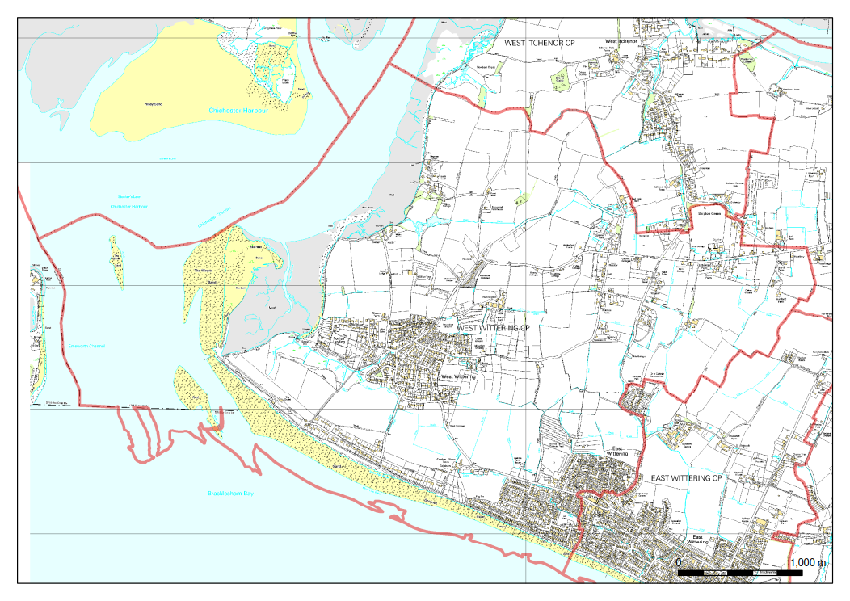
Source: CDC

Local planning context
- In line with the basic conditions of Neighbourhood Planning, Neighbourhood Development Plans (NDPs) are required to be in general conformity with adopted strategic local policies. Consequently, there is a requirement for the relevant Local Plan to be reviewed as part of this HNA. The Chichester Local Plan, adopted in July 2015, is the most up-to-date local plan for the area and so has been reviewed for policies relevant to housing need.

Chichester Local Plan (adopted, July 2015)
- Policy 2 – Development Strategy and Settlement Hierarchy sets out the settlement strategy and identifies the locations where sustainable development will be accommodated. Growth will be primarily focused in Chichester City and four other settlement hubs including East Wittering which covers the eastern part of the Neighbourhood Plan Area. Services villages such as West Wittering are designated as areas of limited growth and suitable for small scale housing developments.
- Policy 4 – Housing Provision sets the target number of homes for the entire District at 7,388, and stipulates that this should be distributed across three different parts of the District: the East-West Corridor, the Manhood Peninsula and the North of Plan Area. The Manhood Peninsula where West Wittering is located should accommodate 893 homes over the Plan period (2012-2029). The policy goes on to state that Policy 5 should apply to Parish housing sites.
- Policy 5 – Parish Housing Sites 2012-2029 identifies the specific needs of local communities. It states that 860 homes are to be planned in Parish housing sites including 50 in West Wittering. Small scale housing sites will be identified to address these needs in neighbourhood plans or in a Site Allocations DPD which the Council will prepare following adoption of the Local Plan.
- Policy 34 – Affordable Housing sets out the District’s requirements for the provision of 30% affordable housing on sites of 11 dwellings or more. Commuted sums will only be accepted in exceptional circumstances. On sites of 6 to 10 dwellings in areas designated as rural areas, the Council will seek a financial contribution for the provision of affordable dwellings as a commuted sum unless the developer makes onsite provision.
- Policy 35 – Affordable Housing Exception Sites sets out the criteria that have to be met for affordable housing to be permitted on exception sites outside of settlement boundaries to meet a specific local need where there are no available and deliverable sites within a settlement.
- Policy 36 – Planning for Gypsies,Travellers and Travelling Show people identifies a potential need for additional permanent residential pitches and plots for the period 2012 to 2027 and sets out the list of criteria that must be met in identifying suitable sites.

Approach

Research questions
- Housing Needs Assessment at neighbourhood plan level can be focused either on quantity of housing needed, type of housing need, or both. In most cases, there is a need to focus on quantity where the housing target for the settlement being assessed is unclear, for example where the local authority has not set a specific target for the settlement, or where there is no local plan in place.

Quantity
- The Local Authority, Chichester District Council (CDC), is in the process of developing a new Local Plan. They have committed to providing West Wittering Parish Council with a housing number, updating the allocation of 50 dwellings to the settlement area that appears in the current adopted Local Plan.
- Despite commitment from CDC to provide the group with this number, WWPC wishes to generate their own assessment to ensure that the final dwelling number used to support policies in their plan provides adequately for the future needs of the community, particularly in relation to the provision of dwellings suited to the needs of young people and families from the area who wish to continue to live there.
RQ1. What quantity of housing is appropriate for the NPA?
- It is therefore necessary to arrive at an estimate for the required housing growth based on a number of reliable sources:
- a number derived from the Local Plan;
- SHMA studies - proportional share drawn from OAN;
- MHCLG Household projections; and
- Net dwelling completion rates 2001-2016.
- In addition to the question of quantity, is it important to break this down to enable policy to be developed that reflects community need. This question relates to the tenure, type and size of dwellings together with the requirement for ‘specialist’ housing suited to the needs of niche groups.

Tenure
- WWPC has expressed an interest in seeing more affordable housing in the NPA so as to support the viability of the settlement, particularly in respect of enabling young people living on modest incomes to find suitable housing in the NPA. There is an associated concern that market housing is predominantly targeted at the needs of people seeking second homes; this has led, for example, to the loss of council housing through right to buy, which has subsequently been sold on as second homes.
- This study will therefore explore tenure mix with a particular focus on affordable housing including the role of shared ownership and discounted market housing suited to the needs of those doing vital but relatively low paid work, for example caring for the elderly.

RQ2. What affordable housing (social housing, affordable rented, shared ownership, intermediate rented) and market tenures should be included in the housing mix?

Type and size
- WWPC aspires to provide housing suitable throughout life, so allowing residents to stay in the village at every stage of their lives if they wish. There is an interest therefore to understand how this may be achieved through the delivery of dwellings of different types and sizes.

RQ3. What type (terrace, semi, bungalows, flats and detached) and size (number of habitable rooms) of housing is appropriate?

Housing for specialist groups
- WWPC has commented that older people are under-served in the area as there are few suitable dwellings for people to ‘downsize’ into; in addition, there is limited provision of specialist housing for the elderly in West Wittering.

RQ4. What provision should be made for specialist housing within the NPA?

Study objectives
- The objectives of this assessment can be summarised as:
- collation of a range of data with relevance to housing need in West Wittering relative to Chichester;
- analysis of that data to determine patterns of housing need and demand; and
- setting out recommendations based on our data analysis that can be used to inform the Neighbourhood Plan’s housing policies.
- The remainder of this report is structured around the objectives set out abov, whilst chapter 9 sets out our conclusions and recommendations based on our data analysis that can be used to inform the Neighbourhood Plan’s housing policies.

Relevant Data

SHMA
- The PPG states that neighbourhood planners can refer to existing needs assessments prepared by the local planning authority as a starting point. The Strategic Market Housing Assessment (SHMA) employed by the CDC to support their housing policies, the Coastal West Sussex SHMA, published in November 2012 (CWSS12), based on an analysis of migration and commuting patterns together with house price differentials, identifies ‘a Sussex Coast Housing Market stretching from Seaford in the east to West Wittering in the West along the Coast…. The housing market includes the local authorities of Chichester, Arun, Worthing, Adur, Brighton and Hove and Lewes.’ It is therefore reasonable to turn to this, together with updates to this document, the Review of Objectively Assessed Housing Need in light of 2012-based Sub-national Population Projections, published in August 2014 (ROANH14), and the Assessment of Housing Development Needs Study, published in April 2014 (AHDNS14) in search of relevant evidence to respond to the Research Questions posed in this HNA. These studies are referred to henceforward as the ‘SHMA studies.’
- PPG defines an HMA as a geographical area ‘defined by household demand and preferences for all types of housing, reflecting the key functional linkages between places where people live and work.’ It goes on to remark that ‘establishing the assessment area may identify smaller sub-markets with specific features, and it may be appropriate to investigate these specifically in order to create a detailed picture of local need. It is important also to recognise that there are ‘market segments,’ i.e. not all housing types or economic development have the same appeal to different occupants.’
- PPG therefore sets two principle tests for identifying a functional HMA: patterns of demand for housing and commuting relationships. The first can be denoted by the concept of ‘self-containment’, the degree to which household moves are contained within a certain geographical area, and the second by ‘travel to work areas’. It is generally assumed that a strong HMA will show 70% of household moves to be contained within it.
- In the case of West Wittering, the SHMA studies provides a finer grain analysis, producing data within ‘sub-areas’ of which the constituent local authorities are made up. The relevant sub-area for West Wittering is Chichester South.
- The SHMA studies draw upon a range of data including population and demographic projections, housing market transactions and employment scenarios to derive the objectively-assessed housing need for the District. As such, it contains a number of points of relevance when determining housing need within the NPA.
- This provides a strong starting point for policy development that aims to build on and add local specificity to those policies of the LPA by enabling a comparison to be made with Parish-level data (gathered as part of the preparation of this study), given that such an exercise reveals contrasts as well as similarities.

RQ1. What quantity of housing is appropriate for the NPA?

- We have estimated the quantity of housing needed in the NPA according to four different sources; these are:
  - Chichester Local Plan minimum derived figure generates a target of 139 dwellings over the Plan period 2018-2033, or 9 dpa;
  - Review of Objectively Assessed Housing Need in light of 2012-based Subnational Population Projections produces a target of 204 dwellings between 2018 and 2033 or 14 dpa;
  - MHCLG Household projections generate a re-based projection of 249 dwellings over the Plan period or 17 dpa; and
  - A projection derived from homes growth between 2001 and 2017 of 136 homes over the Plan period of 2018-2033, or 9 dpa.
- These calculations are set out below.

Chichester Local Plan (2014-2023)
- The Chichester District Council puts forward a housing requirement for 7,388 for the District over the Plan period between 2012 and 2029 under Policy 4. Given the Plan period advised by WWPC of 2018-2033, it is necessary to identify an annual target in order to calculate a projection for the Parish. The District council’s overall target expressd as an annual figure is 435 dwellings per annum (dpa).
- The proportional share for West Wittering can be calculated based on the proportion of the total dwellings in the District that fall into the NPA. At the time of the last Census (2011) there were 53,813 dwellings across the District, and 1,740 dwellings in the NPA, or 3.23% of all dwellings in Chichester District.
- Therefore, 14 dpa (3.23% of 7,338) should be allocated as the ‘fair share’ of the District target; this results in a total of 210 (14 x 15) dwellings over the Plan period.
- In arriving at a final total for West Wittering, it is important to take into consideration that 71 dwellings were built between 2012 and 2017 in the NPA. Allowing for these completed dwellings, a housing target for West Wittering that is in conformity with the Chichester Local Plan would be 139 dwellings (210 - 71) between 2018 and 2033 or 14 dpa.

SHMA studies
- It is important to remember that the SHMA studies present a demand-side only, or ‘unconstrained’ assessment of need (often identified as Objectively Assessed Need, or OAN), as opposed to a final housing target. The final housing target will take into account a number of other factors, including for example the availability of land, viability, infrastructure and environmental constraints and the results of consultation.
- The SHMA studies present an appropriate starting point for deriving need at the NPA level, because it is an authoritative source of evidence, and importantly, because it takes into account the latest population and household projections, as set out in the 2014 Sub-National Population Projections (SNPP) on which the Household Projections are based, which the PPG guidance suggests should be taken as a ‘starting point’ in determining need at the local authority level.
- In the case of West Wittering, the Analysis of Objectively Assessed Housing Need in light of 2012-based Sub-national Population Projections has been prepared to update the findings of the Assessment of Housing Development Need Study: Sussex Coast HMA relating to Chichester District, to reflect the release of new 2012-based SNPP by the Office for National Statistics (ONS) in May 2014. It sets out revised findings regarding the OAN for housing in Chichester District to 2029.
- The 2014 version identifies an OAN for Chichester District over the period 2013 - 29 of 560 - 575 dpa. For the purposes of this HNA, we have taken a mid-point in this range of 568 dpa.
- To calculate the NPA’s ‘fair share’ of this target, it is again possible to use the NPA’s proportion of dwellings in the District (3.23%). This produces a figure of 18.35 dpa. Given the proposed Plan period of 2018 – 2033 (15 years), this results in a housing needs figure for West Wittering of 275 dwellings.
- However, it is necessary to take into consideration dwellings built in the NPA in recent years. Since 2011, as set out above, 71 dwellings have been built; this leads to a final target of 204 dwellings over the Plan period.

MHCLG household projections
- MHCLG periodically publishes household projections. The PPG recommends that these household projections should form the starting point for the assessment of housing need.
- The most recent (2014-based) household projections were published in July 2016, and extend to 2039. Although population projections are only available at a local authority level, a calculation of the share for the NPA is nevertheless possible for the household projections based on the NPA’s household numbers in the 2011 Census.
- At the 2011 Census, Chichester District had 49,848 households and the NPA 1,352 households, or 2.71% of the total (rounded).
- In the 2014-based household projections, the projection for 2029 is 58,625 households in Chichester District or an additional 4,812 households. Assuming it continues to form 2.71% of the District total, the NPA’s total number of households in 2029 would be 1,590 (rounded); therefore 238 new households will form in the NPA between 2011 and 2029 (or a rate of growth of 13 households per year).
- Number of households does not, however, equate precisely to number of dwellings, with the latter slightly higher in most places. The NPA is no exception; in the 2011 Census, there were 1,352 households but 1,740 dwellings. This gives a ratio of 0.78 households per dwelling. In the case of NPA, then, a projection of 238 new households (between 2011 and 2029) translates into a need for 306 dwellings (rounded to the nearest whole number).
- These figures are based on the assumption that 2014-based government projections as to household growth at the LPA level are accurate. As the annual mid-year population estimates have now been released for 2016, the 2014-based household projections may need to be ‘rebased’ for accuracy. The mid-2016 population estimates give the actual number of people in the LPA at that point, meaning the difference between the estimated and the previously projected number of households can to be taken into account in future projections.
- The 2014-based household projections were based on the 2014-based SNPP, which estimated that by 2016 there would be 117,259 people in Chichester. The mid-2016 estimates show that, based on the latest information, there were estimated to be 118,175 people, which is higher than the projections by 916 people. Assuming average household sizes remain constant (in 2011 there were an average of 2.28 people per household, obtained by dividing population by number of households) this equates to 401 additional households across Chichester.
- Taking 59,026 (58,625 + 401) as our revised household number at 2029, and assuming it continues to form 2.71% of the District total, the NPA’s total number of households in 2029 would be 1,601 (rounded), producing a revised growth in the number of households between 2011 and 2029 of 249, 11 more than in the 2014-based household projections.
- Taking into account the disparity between household numbers and dwelling numbers, a projection of 249 new households between 2011 and 2029 translates into a need for 320 dwellings. Netting off the 71 dwellings completed since 2011, we arrive at a re-based household projections-derived dwelling requirement of 249 dwellings (rounded) over the Plan period or 21 dwellings per annum.
- This projection is an entirely unconstrained, theoretical figure comprising a relative proportion of the overall projected increase, and thus does not take into account political, economic, demographic or any other drivers that might have influenced, or may in future influence, the Local Plan distribution across the District and hence any difference between this figure and a future Local Plan-derived figure.

Dwelling growth 2001 – 2011
- Consideration of home growth 2001-2011 provides a projection based on the rate of delivery of net new homes between the two censuses. There was an increase of 74 dwellings in the NPA between these two dates, or an average annual rate of increase of 7.4 homes. Multiplying this annual figure by the number of years from 2017 until the end of the Plan period (16 years) would produce 118 homes (rounded).

Dwelling growth since 2011
- It is also helpful to consider a projection based on the rate of delivery of net new homes since the last Census (2011), using data gathered and monitored by the LPA. As we have seen, between 2011 and 2017, 71 new dwellings were completed. This equates to an annual rate of delivery of 11.83 homes (71 divided by 6, the number of years elapsed). If this rate of delivery continued to 2033, this would equate to a projection of 176 (rounded) homes from 2018 to the end of the Plan period.

Dwelling growth 2001-2017

- It is important to note the disparity between the two ‘home growth’ figures; this reflects the susceptibility of the development industry to fluctuations in demand and costs of development, among other factors. To allow for these peaks and troughs, and to provide a more realistic picture of the quantum of development that could be delivered over the Plan period, we have taken the aggregate of the homes growth between 2001 and 2017; this comes to 145 (74 + 71) dwellings. Expressed as an annual average rate, this is 9.06 dpa. This produces a projection derived from homes growth between 2001 and 2017 of 136 homes over the Plan period of 2018-2033 (9.06 x 15).

The standard methodology
- On September 14th, 2017, the Department for Communities and Local Government (MHCLG) published “Planning for the right homes in the right places: consultation proposals” (the consultation proposals), a consultation on a new proposed Standard Methodology for Assessing Housing Need (SMAHN) for arriving at an OAN for housing for individual local authorities, thus avoiding both the expense of producing complex SHMAs and the disagreements surrounding their methodologies. MHCLG has stated that “this consultation sets out a number of proposals to reform the planning system" including "how neighbourhood planning groups can have greater certainty on the level of housing need to plan for”.
- Whilst the document is currently being consulted on at the time of this HNA report, it is important to consider the implications of this emerging policy guidance for potential housing need calculations in the NDP. Therefore, what follows is an assessment of the NPA’s housing need based on the new proposed methodology which, should the policy be put in place in its current form, provide the preferred figures for housing need in the area. This projection is included for information only, bearing in mind that the consultation makes clear that LPAs will have the option of using alternative methods of calculating their OAN, so long as the number they arrive at exceeds that produced by the new standard methodology.
- Proposed updates to the PPG include a requirement that LPAs provide a housing need figure to neighbourhood planning groups, and that they may do this by making a reasoned judgement based on the settlement strategy and housing allocations in their plan, so long as the local plan provides a sufficiently up-to-date basis to do so. The starting point for using the SMAHN for the neighbourhood level is therefore whether the current Local Plan was adopted before or after the introduction of the NPPF.
- In the case of West Wittering, the Chichester Local Plan was adopted in 2015, and therefore provides an up-to-date basis for arriving at a housing need figure for the NPA. The indicative assessment using the SMAHN formula is 609 dwellings per annum for Chichester. This is an uplift on the current figure of 435 set out in the Chichester Local Plan of around 40%, and suggests there should be an increase of 2,965 dwellings over the Plan period from 2012 to 2029, or a new target of 10,353. As this total falls within the proposed 40% cap, it is reasonable to assume at this point that Chichester may see an uplift in its housing need figure in the order of 40% with the introduction of the SMAHN.
- Assuming a new OAN for housing of 609 dwellings, this would produce a revised projection for the NPA based on this number of 3.23%. Taking into account the 71 dwellings built in the Parish since the 2011 Census, a housing needs figure that is compliant with the SMAHN is 264 dwellings or 22 dpa.

RQ2. What affordable housing (social housing, affordable rented, shared ownership, intermediate rented) and market housing tenures should be included in the housing mix?
- The provision of affordable housing is critical to the continuation of most communities as viable settlements; it needs however to be understood in relation to other tenures. The PPG states that HNAs should investigate household tenure in the current stock and recent supply, and make an assessment, based on a reasonable interpretation of the evidence gathered, whether continuation of these trends would meet future needs or whether, on account of significant misalignments between supply of housing falling into different tenure types and local need/demand, policies should support a change to the profile of tenure within the NPA’s housing stock.

Definitional issues
- It is necessary at this stage of the study to make clear the distinction between affordable homes as a piece of planning terminology and the colloquial meaning of the phrase. In the course of this study, we refer to Affordable Housing, abbreviated to ‘AH’. We mean by this those forms of housing tenure that fall within the definition of Affordable Housing set out in the NPPF: social, affordable rented and various forms of intermediate housing. To distinguish this from the colloquial definition, we refer to the latter as Affordable Market Housing (AMH).
- In this paragraph we briefly review the proposed reforms to the definition of AH set out in the Government’s Housing White Paper published in February 2017. These reforms make clear its commitment to home ownership but recognised the important role of affordable rent for those not currently seeking home ownership. The changes proposed would broaden the definition of affordable housing, supporting ‘present and future innovation by housing providers in meeting the needs of a wide range of households who are unable to access market housing’. This would include ‘products that are analogous to low cost market housing or intermediate rent, such as discount market sales or innovative rent to buy housing. Some of these products may not be subject to ‘in perpetuity’ restrictions or have recycled subsidy’.
- The Housing and Planning Act 2016 made provision for a new simplified definition of affordable housing as ‘new dwellings…to be made available for people whose needs are not adequately served by the commercial housing market’. Secondary legislation is required to implement this definition, necessitating further parliamentary debate.
- The Housing White Paper confirms that a revised definition of AH will be brought forward through changes to the NPPF later this year, proposing a definition as ‘housing that is provided for sale or rent to those whose needs are not met by the market (this can include housing that provides a subsidised route to home ownership’ and which ‘meets the criteria’ for one of the following models:
  - Social rented housing, defined as currently and owned by local authorities and private registered providers with guideline target rents determined through the national rent regime. It may be owned by other persons and provided under equivalent rental arrangements, as agreed with the local authority or Homes and Communities Agency;
  - Affordable rented housing, defined as currently and let by local authorities or private registered providers of social housing to households eligible for social rented housing. Affordable rent is controlled at no more than 80% of the local market rent including service charges where applicable;
  - Starter Homes, as defined in the Housing and Planning Act 2016 and subsequent secondary legislation with an income restriction of £80,000 outside London. These homes are expected to provide a new low cost market housing product for first time buyers between the ages of 23 and 40 with a mortgage, sold for no more than 80% of open market value and capped at £250,000 outside London;
  - Discounted market sales housing, sold at a discount of at least 20% below market value with provision to remain at a discount for future eligible households. Eligibility is to be determined with regard to local incomes and house prices;
  - Affordable private rent housing, made available for rent at a level which is at least 20% below local market rent with provision to ensure that rent remains at a discounted level or alternative affordable housing provision is made if the discount is withdrawn. This is viewed as particularly suited to the provision of affordable housing in Build to Rent schemes; and
  - Intermediate housing, defined to include discounted market sales and affordable private rent housing – as outlined above – and other housing that is ‘provided for sale and rent at a cost above social rent, but below market levels’.
- A transition period is proposed to enable a review of local policies, with the revised definitions intended to apply from April 2018. The Government also intends to introduce a requirement for sites of 10 units or more to ensure that at least 10% of all homes are affordable home ownership products, including Starter Homes, shared ownership homes and homes available for discount market sale.
- The evidence assembled to answer RQ2 seeks to populate a series of ‘key indicators’; these are the age structure of the population, household composition and income both now and how they are forecast to change in future years. Through a consideration of these trends and how they interrelate to each other, it is possible to arrive at recommendations as to how not only the tenure of housing in the plan area, but also type and size should be modified through planning policy.

Current tenure profile
- Before we present this data, it is necessary to present a picture of tenure in the NPA based on the most recent reliable data. The table below presents Census data from 2011 that shows the overwhelming majority of dwellings in the NPA are in owner occupation. The tenure profile offers some stark contrasts with District data, the representation of those dwellings in owner occupation exceeds the District by 16.3%, the stock of socially rented dwellings is substantially less, showing a difference of roughly 10%.
Table 3: Tenure (households) in West Wittering, 2011
Tenure | West Wittering | Chichester | England
Owned; total | 80.9% | 67.2% | 63.3%
Shared ownership | 0.3% | 0.9% | 0.8%
Social rented; total | 5.3% | 14.9% | 17.7%
Private rented; total | 11.2% | 14.9% | 16.8%
Source: Census 2011, AECOM calculations
- The below shows how tenure has shifted during the inter-censual period. The level of owner-occupation has remained broadly constant while there has been, in line with the District and the country as a whole, a substantial increase in privately rented dwellings. In terms of additional dwellings, the number of homes within the PRS increased from 91 to 151; those socially rented increased from 64 to 71. The increase in dwellings in shared ownership is somewhat misleading, given the low base. Dwellings falling into this tenure increased from 3 to 4 homes.
Table 4: Rates of tenure change in West Wittering, 2001-2011
Tenure | West Wittering | Chichester | England
Owned; total | -2.4% | 4.2% | -0.6%
Shared ownership | 33.3% | 138.2% | 30.0%
Social rented; total | 10.9% | 10.0% | -0.9%
Private rented; total | 65.9% | 76.7% | 82.4%
Source: Census 2001 and 2011, AECOM calculations

Age structure
- Figure 3 below presents age structure data for the geographies of West Wittering together with the local authority and England. This shows some striking contrasts, in particular the massive preponderance of older people and the relative under-representation of younger people in the Parish when compared with these other geographies. Those aged over 65 make up some 42% of the population, whereas those aged between 0 and 44 constitute roughly 31% of the population. The representation of those aged 45-65 are however similar other the other geographies.
Figure 3: Age structure

Source: Census 2011, AECOM calculations
- Table 5 below provide a longitudinal perspective, recording how the population has shifted during the inter-censual period. All age groups, bar those aged over 65, have seen a fall in numbers. Indeed, the overall population has fallen from 2,792 in 2001 to 2,700 in 2011.
Table 5: Rate of change in the age structure of the population of West Wittering, 2001-2011
Age group | West Wittering | Chichester | England
0-15 | -5.2% | -1.4% | 1.2%
16-24 | -16.1% | 15.7% | 17.2%
25-44 | -7.1% | -3.9% | 1.4%
45-64 | -7.5% | 12.9% | 15.2%
65-84 | 0.8% | 12.4% | 9.1%
85 and over | 21.5% | 21.9% | 23.7%
Source: Census 2001 and 2011, AECOM calculations
- Table 6 reproduces Table 3 from ROAHN14 in which projections for how the age structure at the District level will change between the years 2013 and 2029 are set out. At the District level the loss of those falling into younger age groups is less pronounced than in West Wittering with some, for example those of school age, aged 10-14 years of age (yoa) increasing in number; this is matched a commensurate increase in adults in their late thirties. The majority however of the increase in population is made up of people over the age of 65; the total increase in those falling into these age groups totals 10,958 of a total increase of 14,568, or 75%.

Table 6: Population change 2013 to 2029 by five year age bands – Chichester
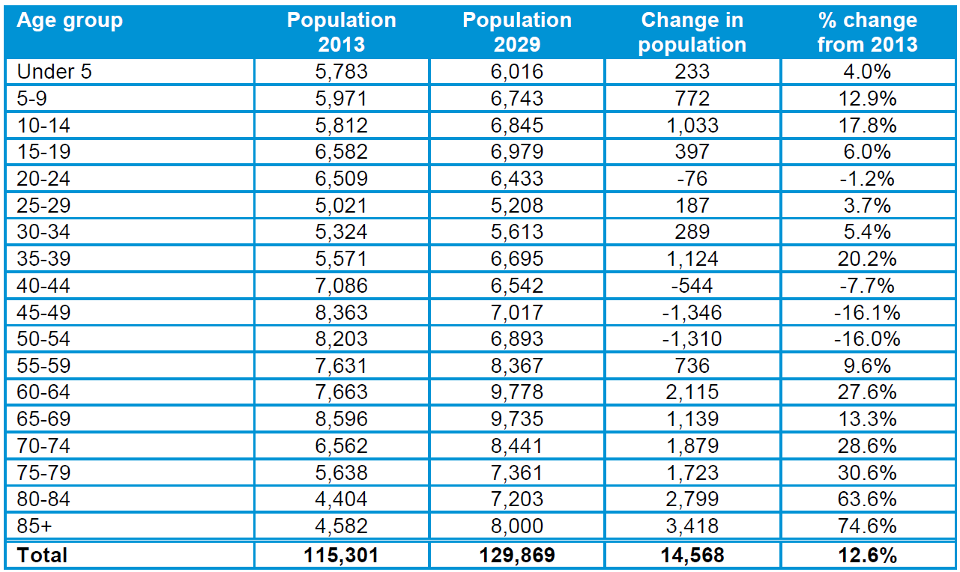
Source: ONS

- Bringing together our findings relating to age structure, the NPA already has a strong representation of those falling into older age categories, with 42% aged 65+ at the time of the last Census; it also shows an under-representation of those aged under 44, with large disparities with District and national geographies. Using District level data as a guide to future trends, these characteristics are likely to become more pronounced over the Plan period. The District data shows a substantial increase in the population of those aged 65+; given the population of the NPA already exhibits a strongly aging population, a reasonable conclusion would be that trends forecast for the District are likely to be more extreme in West Wittering.

Household composition
- In Table 7 below we present data relating to household composition; the proportion of the population who reported living alone in West Wittering in 2011 was 37.5%, a figure that exceeds the District by 5.5%. The large older population seen in our examination of age structure is also picked up in data relating to household composition with a substantially larger proportion of both one-person and family households being aged 65 or over. It is also notable that a substantially lower proportion of family households have dependent children, again suggesting a higher representation than the District of ‘empty-nesters.’
Table 7: Household composition (by household) in West Wittering, 2011
 |  | West Wittering | Chichester | England
One person household | Total | 37.5% | 32.0% | 30.2%
 | Aged 65 and over | 26.6% | 17.3% | 12.4%
 | Other | 10.9% | 14.7% | 17.9%
One family only[1] | Total | 58.2% | 61.8% | 61.8%
 | All aged 65 and over | 21.3% | 12.6% | 8.1%
 | With no children | 15.3% | 19.1% | 17.6%
 | With dependent children | 13.0% | 22.1% | 26.5%
 | All children Non-Dependent | 8.6% | 8.1% | 9.6%
Other household types | Total | 4.3% | 6.2% | 8.0%
Source: Census 2011, AECOM calculations
- The change in household composition over the inter-censual period is shown in Table 8 below. This reveals a substantial increase in one-person households over the period. Within a population that is declining over-all, the number of one-person households increased by 59 households, of which the majority were below the age of 65.
- Overall, the representation of families declined, with the largest fall those with dependent children. This group fell in numerical terms by 20 households over the period. While the growth in one-person households is mirrored in the District (although the change if less pronounced), the District saw an increase in family households, led by those with non-dependent children.
Table 8: Rates of change in household composition in West Wittering, 2001-2011
Household type |  | Percentage change, 2001-2011
 |  | West Wittering | Chichester | England
One person household | Total | 13.2% | 15.6% | 8.4%
 | Aged 65 and over | 2.3% | 1.2% | -7.3%
 | Other | 52.6% | 38.8% | 22.7%
One family only | Total | -7.1% | 4.9% | 5.4%
 | All aged 65 and over | -7.7% | -1.6% | -2.0%
 | With no children | -5.9% | 7.1% | 7.1%
 | With dependent children | -10.2% | 4.1% | 5.0%
 | All children non-dependent | -2.5% | 13.8% | 10.6%
Other household types | Total | -1.7% | 17.1% | 28.9%
Source: Census 2011, AECOM calculations
- In Table 9 below we reproduce data from the ROANH14 that forecasts changes in household type in Chichester District over the period 2013 to 2029. This suggests the increase in one-person households and family households without children that has been seen within the District during the inter-censual period will be sustained over the next decade. The document comments, ‘Over half (54%) of the growth is accounted for by one person households which are projected to rise by 4,800 from 2013 to 2029, or 297 per year on average.’
Table 9: Household projections by household type (part return to trend headship) – Chichester
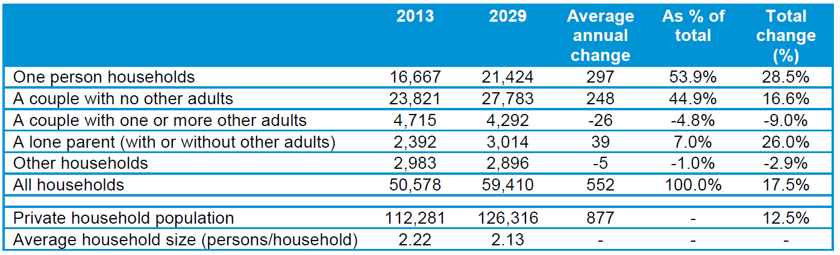
Source: ROANH14

- Bringing together the evidence relating to change in household composition, Census data shows a high proportion of the population are live alone (37.5%) compared with the District (32%); this group has grown substantially over the inter-censual period, recording an increase of 59 households over the period, the majority of whom were aged under 65.Overall, the representation of families declined, with the largest fall those with dependent children (10.2%). Data for the District provides a strong indication that the growth in one-person households as a share of the overall population will continue to increase over the Plan period.

Affordability
- An examination of the affordability of housing within a given place should focus that proportion of all households that are unable to access suitable housing given their household type without subsidy in some form. To understand this, the concepts of the ‘income’ and ‘purchase’ thresholds are employed.
- Income thresholds consider the affordability of private rented accommodation, and are derived from the annualisation of the monthly rents, and assumes this annualised cost represents a maximum of 25% of annual household income. This allows enough money for a given household to afford other domestic overheads as well as some discretionary spend, in this way supporting overall well-being.
- The purchase threshold follows a similar logic but considers the affordability of dwellings for sale. It is calculated by netting off 10% off the lower quartile house price to reflect the purchase deposit. The resulting cost is divided by a set multiple (typically 3-4) to reflect the standard household income requirement to access mortgage products.
- In Figure 4 below we reproduce Figure 3 from the CWSS12; this employs an ‘income’ and ‘purchase’ threshold approach to identify the income required to occupy a two bedroom home at the District level within four different tenures. A two bedroom home is considered appropriate as an entry-level home bearing in mind the need to avoid over-crowding, the predominance of family households in West Wittering and the inherent adaptability of dwellings of this size over a smaller unit.
Figure 4: Household income required to buy or rent a 2-bed property
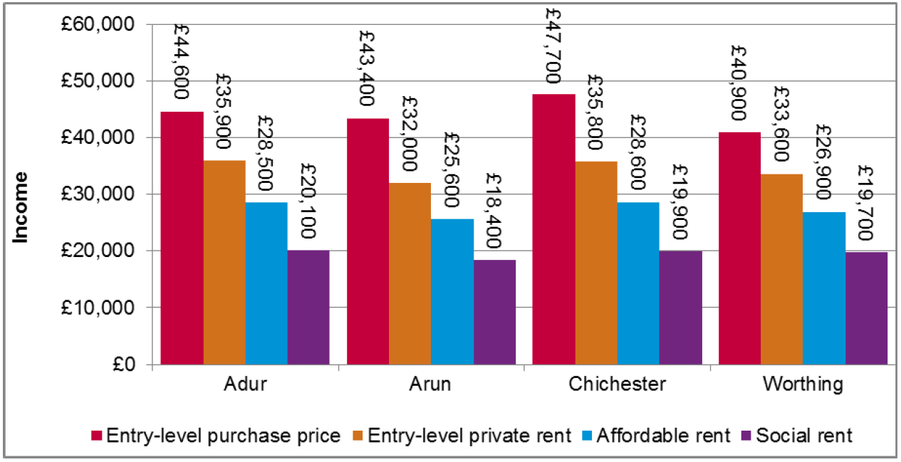
- In Figure 5 below we reproduce Figure 91 from the CWSS12; this shows estimated median incomes in each of the sub-areas. This suggests that for people living in Chichester South, the sub-area of which West Wittering forms a part, the majority of households are able to afford private rental dwellings and affordable housing products, but only a minority are able to access entry level market homes for sale.

Figure 5: Distribution of household income in Coastal West Sussex HMA
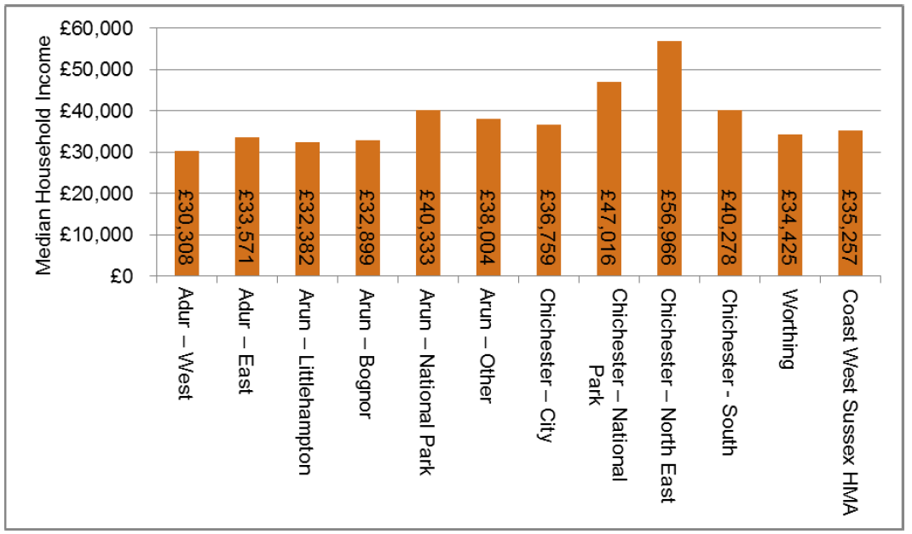
Source: CWSS12 (Derived from Experian and ONS data)

- A more accurate assessment of the proportion of households able to access market dwellings in West Wittering may be obtained through a simple income and purchase threshold calculation using data provided by the CWSS12.
- In Figure 6 below we reproduce Figure 78. This presents data drawn from an online Estate and Letting Agents Survey at the sub-area level and reveals that a two bedroom home, suitable for a family household consisting of 3-4 individuals, was valued at £156,000 in April 2012. Working from the data set out Figure 5 above, we can therefore calculate that the purchase threshold for dwellings of this size would, using a multiple of income set at 3.5, be £40,114.
- Given the median income level of £40,278, this suggests roughly half of households are able to access entry level dwellings for sale within the sub-area. The difference with Figure 5 above can in part be explained by house prices in Chichester South being substantially less than for Chichester as a whole.
Figure 6: Estimated entry-level purchase price by sub-area
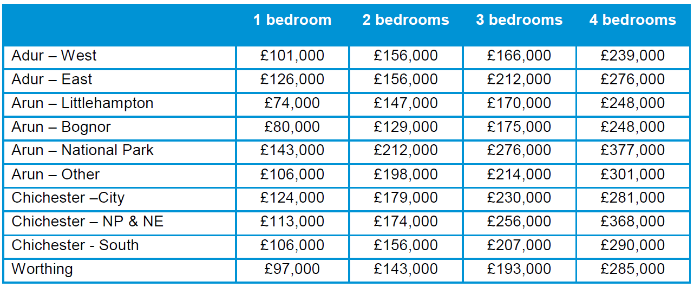
Source: Online Estate and Letting Agents Survey (April 2012)

- Considering rental properties, in Table 10 below we reproduce Figure 81 from the CWSS12 which provides data on entry-level private rents. Applying the ‘Income Threshold’ approach, again taking a two-bedroom home as our definition of the ‘entry-level’ dwelling, the required income for a dwelling of this size in Chichester South is £30,000; this is calculated by taking the monthly rent of £625, multiplying by 12 (£7,500), and multiplying this by a further 4 to reflect the threshold of 25%.
Table 10: Estimated entry-level private rents by sub-area (pcm)
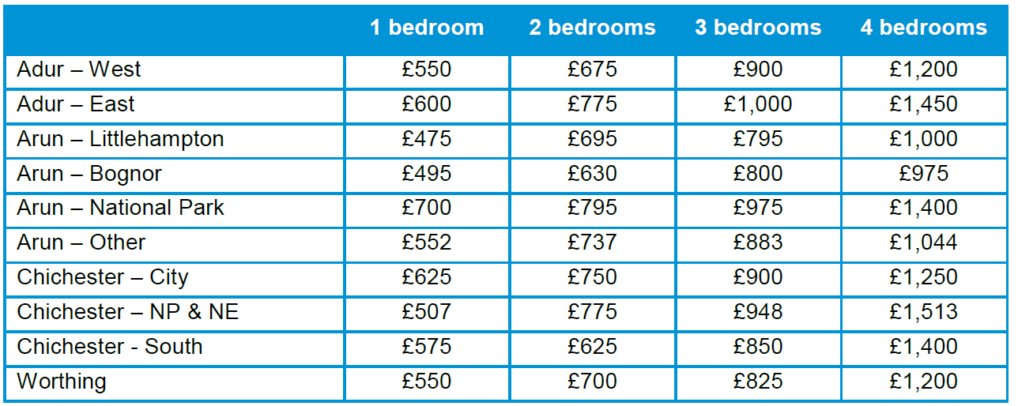
Source: Online Estate and Letting Agents Survey (April 2012)

- In Table 11 below we reproduce figure 93 from the CWSS12 that provides an estimation of that proportion of households for unable to access market housing (for sale or for rent). This shows that roughly 30% of all households cannot afford housing suited to their needs without subsidy. We note that the findings match our own calculations, arriving at a threshold of £30,000 to access market housing in Chichester South.
Table 11: Estimated proportion of households unable to afford market housing without subsidy
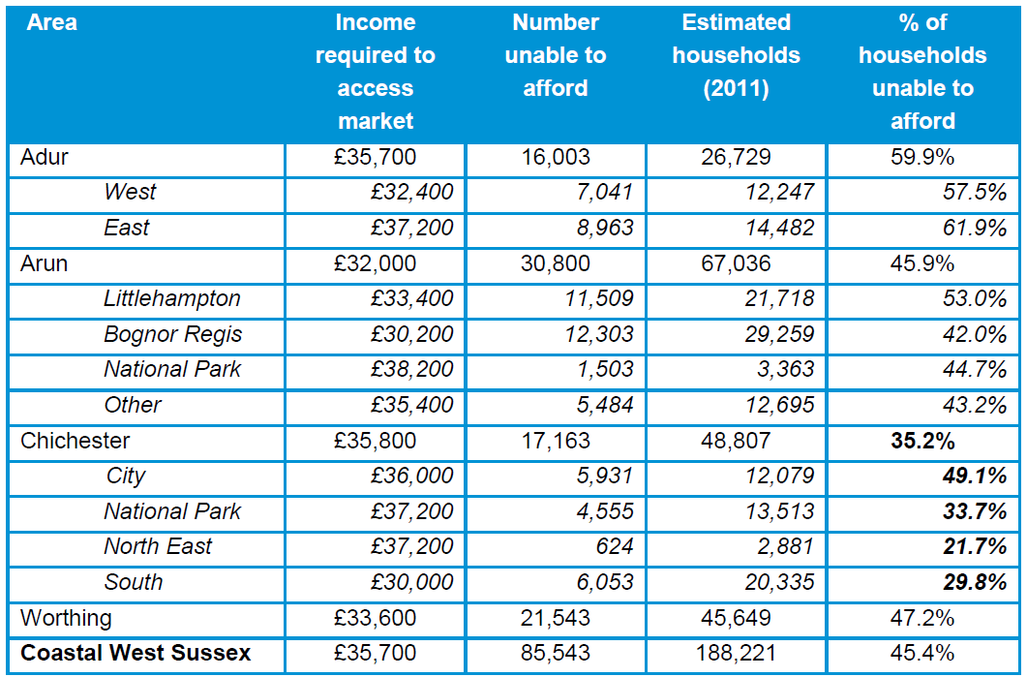
Source: Online Estate and Letting Agents Survey (April 2012) and Experian (2011)

- It is important to bear in mind that this data was gathered in 2012, and should therefore be treated with some caution. However, given broader economic trends in the UK since 2012, it is unlikely affordability has improved substantially, indeed the reverse may be the case.
- A more up-to-date indication of affordability can be taken from the AHDNS14; this study records the ‘Affordability Ratio’. This is a standard measure of affordability which expresses house prices as a multiple of household income.
- AHDNS14 comments that, ‘the evidence indicates that affordability issues are significantly more acute in Chichester than comparator areas with the District having a lower quartile affordability ratio of 10.41, considerably worse than the county average (9.10). Affordability has worsened markedly since 1997 (when the ratio was 4.40); however, over the past decade it has worsened at a slower rate in Chichester (86%) than across West Sussex as a whole (115%).
- We can calculate from the purchase threshold set out above that the Median Affordability Ratio for Chichester South was 3.87 (£156,000/£40,278). This suggests that, while the majority of households are able to access housing suited to their needs within the sub-area, there is an acute affordability crisis affecting those on lower incomes.
- We have noted above that a realistic multiple of household income considered by providers of mortgage products does not exceed 4; therefore, 10.41 supports the conclusion that for those on low incomes market housing for purchase is well beyond their means, providing a strong argument for social rented dwellings to accommodate those most in need.
- Given these trends of worsening affordability at the District level, it is not unreasonable to assume the affordability picture is worse now in the NPA than in 2011. Indeed, Land Registry Price Paid data suggests that between 2007 and 2016 house prices increased in West Wittering by an average of 18%; unless average household incomes increased by the same margin or more, affordability would indeed have deteriorated.
- Moreover, it is worth bearing in mind that West Wittering itself may be a pocket of high prices. Land registry price paid data suggests that, on average, dwellings in the settlement were 35% higher than for Chichester as a whole. As part of this HNA, we have canvassed the view of estate agents operating in the area primarily to check the assumption that Chichester South was a suitable proxy for West Wittering as regards the market for private housing.
- The feedback we received from two agents (Astons and Henry Adams) were that ‘West Wittering village itself does command a higher price than the surrounding areas such as East Wittering or Bracklesham Bay. They reported that house prices have increased substantially over the past 5 years, by between 20 and 30%.
- In addition, in response to the question, ‘please can you supply approximate prices for the following different types of dwelling (by way of example properties sold in the second half of 2017)’ in respect of a two bedroom dwelling, Astons provided an estimate of £250,000 and Henry Adams put forward £325,000; from this data it is possible to derive an average of £287,500 and treat this as a working valuation for an entry level property in West Wittering at the start of 2018.
- At the very least, this calls into question as to whether the figure of £156,000 for a two bedroom home in Chichester South reported in the CWSS12 can be used as a proxy for West Wittering. If this provides a more accurate estimate of entry-level house prices this would indicate a more serious position as regards affordability within the designated area.
- The ‘purchase threshold’ calculation for a property valued at £287,500, using an income multiple set at 3.5, would be £74,185. This figure is greatly in excess of the median income for Chichester South of £40,278 in 2012 and should therefore be considered beyond the means of households at this income level. This is reinforced by the Affordability Ratio we can calculate from this figure; assuming median household incomes have remained static since 2012, this metric would stand at 7.13.
- Notwithstanding, it is important to acknowledge the function local housing market may cover a geography that is greater than West Wittering alone, with households on lower incomes may be able to access more affordable dwellings within neighbouring areas.

Housing waiting list
- So far, we have considered housing need based on a statistical understanding of affordability derived from household income. A necessary additional component to quantify need for AH in the NPA is identifiable demand expressed through entries on a housing needs register. In the absence of such a register that is specific to the NPA, the data contained in the Housing Register Waiting List (HRWL) for the whole District maintained by Chichester District Council (CDC) may be used.
- CDC were contacted for their assessment of the number of households currently on the waiting list that live in West Wittering. They reported back, ‘there are currently 21 households on the housing register with a local connection to West Wittering, of which 43% (9 households) are in bands A-C and are considered as having a high priority housing need.’
- To understand the significance of this in policy terms, it is necessary to consider how many affordable homes would come forward in the event the Parish fulfilled the housing need figure set out above through the operation of the Local Authority’s affordable housing policies. This will provide an indication as to whether these policies are sufficient for the purposes of satisfying the Parish’s affordable housing needs.
- The average of the housing needs projections for the NPA derived from the four projections put forward in ‘quantity’ is 182 dwellings (rounded) to be delivered over the Plan period; the figure of 9 households represents 5% of this number (rounded). As we have seen, policy 34 of the CLP requires 30% affordable housing on sites of 11 dwellings or more and on sites of 6 to 10 dwellings in areas designated as rural areas, the Council will seek a financial contribution for the provision of affordable dwellings as a commuted sum unless the developer makes onsite provision.
- This suggests that, assuming the Parish achieves the housing numbers set out in this study over the Plan period, it will have little difficulty meeting the need for AH based on the local authority’s’ HRWL given that 182 dwellings may yield 55 dwellings (rounded). Moreover, these enquiries are from people whose needs could be addressed elsewhere in the District.
- Notwithstanding, it is important to note this does not take account of any backlog of need and future needs arising.
- Given the strategic nature of Policy 34, it will be challenging, within the neighbourhood plan, for the NDP to develop a policy that departs from it. On the basis of the evidence gathered, therefore, we do not see sufficient justification for the West Wittering Neighbourhood Plan to set its own affordable housing target.
- Nevertheless, if WWPC is to have confidence it’s AH needs are to be achieved in future years an assertive position as regards AH should be adopted, together with additional evidence to show need within the NPA, for example a Parish-level housing register waiting list (PHRWL). Such a register, if regularly maintained, would provide an up-to-date tool for attracting additional AH supported by robust evidence of local need, and justify the AH exception sites, if appropriate.
- In addition, a PHRWL could be used as a lobbying tool to resist cases where developers are seeking a low AH allocation on a given site or to re-negotiate S106 commitments to provide affordable housing part way through the delivery of a scheme.

Conclusions
- Bringing together our findings relating to affordability, the evidence we have gathered suggests roughly half of all households are able to access an entry level dwelling within the NPA; this increases to 70% when private rented sector dwellings are taken into consideration.
- There is a stark contrast between the median affordability ratio (MAR) of 3.9 within Chichester South and the lower quartile affordability ratio (LQAR) for Chichester, reported to be 10.41. Notwithstanding the difference in geography, this suggests an acute affordability crisis at the District level for those on lower incomes. It is reasonable to assume a similar position exists within the NPA given that, according to Land Registry price paid data house prices increased in West Wittering by 18% between 2007 and 2016 and, on average, dwellings in the settlement were 35% higher than for Chichester as a whole.
- Based on evidence of need drawn from Chichester’s housing waiting list register (that shows 9 households expressing an interest in occupying housing in West Wittering, there is no basis on which to seek a different proportion of affordable housing from development than Policy 34 of CLP.
- However, given the conclusions in this study relating to affordability of housing on low incomes, WWPC should adopt an assertive attitude as regards the delivery of affordable housing in practice.

Market segmentation
- Bringing together the evidence from our consideration of affordability, age structure and household composition, in line with PPG, we have sought to identify the different market segments in the population of West Wittering. We then use this understanding to put forward recommendations for policy relating to Affordable Housing as well as and size and tenure of dwelling.
- In order to understand the terminology surrounding size of dwellings, it is important to note the number of rooms recorded in Census excludes kitchen, bathrooms and toilets. In the market segments table that follows, ‘dwelling size’ should be translated as follows:
- 1 room = bedsit
- 2 rooms = flat/house with one bedroom
- 3 rooms = flat/house 2 bedrooms
- 4 rooms = flat/house with 2 bedrooms and 2 reception rooms, or 3 bedrooms and 1reception room
- 5 rooms = flat/house with 3 bedrooms and 2 reception rooms
- 6 rooms = house with 3 bedrooms and 3 reception rooms or 4 bedrooms and 2 reception rooms
- 7+ rooms = house with 4, 5 or more bedrooms house
- The table on the page below indicates the different market segments, and the degree to which they are a growing, stable or declining group within the local population. One ‘up’ arrow indicates this grouping is growing modestly in the NPA; two ‘up’ arrows indicates strong growth, three ‘up’ arrows suggests very rapid growth in years to come. Where segments are falling in numbers, or not growing, neutral or down arrows are shown.
- It is important to note that, the private sector is good at picking up market trends that result from, among other factors, changes in social behaviours and demographic shifts. For this reason, policy intervention is only justified in the case of market failure (where the market is unable, for reasons of viability, or there are incentives, deliberate or otherwise, that drive the market not to respond to trends). Examples include the provision of homes to those on low incomes and the under-supply of dwellings for the elderly.
- Similarly, because, generally speaking, the market is able to deliver the homes required for the majority of residents (either through for-sale dwellings or for-rent), policy intervention is only required where the evidence is both compelling and the circumstances it describes serious. This is because policies carry both costs and risks; this can distort the market, preventing it from providing homes (and encouraging a position of market equilibrium in which homes are accessible to target markets).
- In the case of West Wittering, these conditions are captured in the substantial forecast increase in the numbers of those aged 65 and over; this calls for a policy response to address the specific needs of this market segment; this is discussed in more detail later in this HNA.
- A further trend that threatens to undermine the vitality and viability of the settlement is the fall in the number of younger families in the NPA over the Plan period, particularly those with dependent children. Clearly, if this trend continues, it is likely to reduce demand for infrastructure targeted at families, for example primary schools and play services and may undermine the vitality and viability of neighbourhood.
Table 12: Market segments analysis
Market segments | Income range | Tenure | Presence in Plan Area | Size of home
Young family where parents are aged 24-44 with 1+ children aged 0-15 | Median | PRS, Social housing, shared equity, AMH | ↓ | 5 rooms
Professional Head of Household Young family where parents are aged 24-44 with 1+ children aged 0-15 | Mean | AMH, Market Housing (MH) | ↓ | 5 rooms
Professional Head of Household family where parent are aged 44-64 with non-dependent children living at home | >Mean (equity rich) | Market Housing | ↓ | 6+ rooms
Lone parent (with 1+ children) | Lower Quartile (equity poor) | Social Housing | ↔ | 3 rooms
One person household aged under 65 | Median (equity poor) | PRS, shared equity, DMH | ↑ | 2 rooms
One person household aged 65+ with wealth | Median (equity rich) | Market Housing | ↑↑↑ | 2-3 rooms
One person household aged 65+ without wealth | Lower Quartile (equity poor) | Social Housing | ↑↑↑ | 2 rooms
Young couple no children | >Mean (equity poor) | Market Housing, Shared Equity, DMH | ↔ | 4+ rooms
Concealed households | Lower Quartile (equity poor) | Social Housing | ↔ | 1-3 rooms
Source: AECOM
- In Table 13 below we provide a table, devised by Nathaniel Litchfield and Partners, setting out recommended dwelling sizes for different household types. This table has been defined on the basis of the following assumptions,
  - Smaller apartments/flats or houses will be more suitable for meeting the initial requirements of married couples until the age they have a family. Those households without children could occupy either houses or flats of the appropriate size;
  - Cohabiting couples and lone parents will want and require similar sizes of housing to married couples. Those households without children could occupy either houses or flats of the appropriate size;
  - Smaller apartments/flats or houses will be more suitable to meeting the requirements of single person households;
  - According to their composition, institutional accommodation such as a residential care home, hostel or purpose-built student accommodation accommodation may provide a suitable form of specialist housing for groups such as elderly people and students;
  - Further qualitative allowances will need to be made of households at retirement age who are likely to continue living in their previous home unless more manageable two bed flats, houses and bungalows are available; and
  - The requirement for housing with care, including supported housing and extra care provision, is likely to increase at 85 and above.
Table 13: Estimated housing size required by household type, by age of head of household
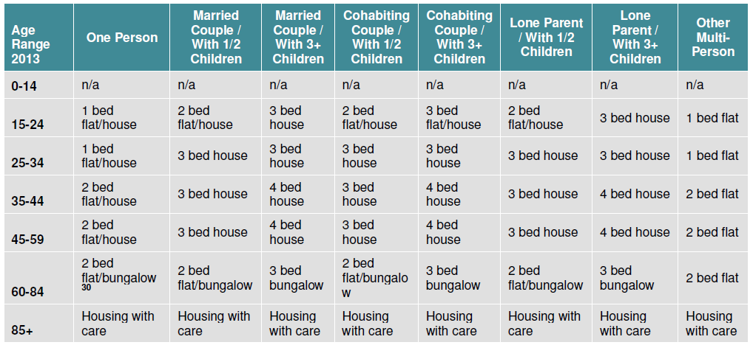
Source: NLP

Arrows analysis

- The principle trends that have been identified are,
  - a decline in the number of those aged under 44, and a corresponding decline in all households with children, in particular younger families;
  - the presence of a large minority of older residents (aged 65+), and the forecast this trend will continue; and
  - the increase in one-person households as a share of the overall population.
- We note that the first of these trends threaten to undermine the vitality and viability of the settlement. If this continues, it is likely to reduce demand for infrastructure targeted at families, for example primary schools and play services.

Housing tenure
- Earlier in this study, we identified the various different tenures that constitute AH: social rented housing, affordable rented housing, shared ownership, discounted market sales housing (Starter Homes) and affordable private rent housing.
- This variety of affordable housing tenures reflects an ambition by the Government to introduce market principles into the provision of subsidised housing. The aim is to divide affordable housing into a series of products design to appeal to different sectors of the market and, by changing eligibility criteria, bring rents closer in line with people’s willingness to pay.
- A good example is, in 2012, the introduction of affordable rented dwellings, rent for this tenure would be set at up to 80% of market rent, with the additional income being used to help fund the development of new homes. Labelled and ‘intermediate’ product, this would be suitable for people with an income that precludes them from eligibility for the social rented dwellings, but who cannot afford to access the private market.
- The overall aim is to reduce the group who are eligible for social rented dwellings to those who have, relatively speaking, very low household income. Within this segment of the market principles also apply given the link between rents and size of dwelling, with a strong financial incentive for households only occupy a dwelling suited to their size, based on an ‘occupancy rating’ formula set by the Government that establishes what is appropriate.
- We consider each of the AH tenures in turn, before arriving at a recommendation for how the quota of AH yielded by development should be divided between these tenure types.

Social rented housing

- Rents in socially rented properties reflect a ‘formula rent’ based on a combination of individual property values and average earnings in each area, maintaining substantial discounts to market rents. As such, it is suitable for the needs of those on low incomes, and is subject to strict eligibility criteria. As we have seen, the majority of households in Chichester South are able to afford market dwellings (for sale or rent); of the 30% that cannot, the evidence we have gathered, in particular the Lower Quartile Affordability Ratio of 10.41, suggests there is a significant minority who experience great difficulty in accessing housing suited to their needs. This will be exacerbated by the reported increase in house prices in the area in recent years. Moreover, in order to address demographic trends that have seen a decline in the number of young family households, it is appropriate for social rented housing to form the majority of affordable homes provided.

Discounted market housing (starter homes)
- As we have seen, Housing and Planning Act 2016 (HPA) includes provisions to introduce a general duty on planning authorities in England to promote the supply of ‘starter homes,’ and a specific duty to require a minimum number or proportion of ‘starter homes’ on certain residential development sites. The relevant legislative provisions are, however, not yet in force and no specific proportion or minimum has been put forward.
- The Housing White Paper sheds further light on the government’s intentions in this area. It states that, ‘in keeping with our approach to deliver a range of affordable homes to buy, rather than a mandatory requirement for ‘starter homes,’ we intend to amend the NPPF to introduce a clear policy expectation that housing sites deliver a minimum of 10% affordable home ownership units. It will be for local areas to work with developers to agree an appropriate level of delivery of ‘starter homes’, alongside other affordable home ownership and rented tenures.’
- This is a substantial watering-down of the ‘starter home’ requirement as envisaged when policy contained in the Housing and Planning Act was first conceived. In effect, it leaves it to local groups, including neighbourhood plans, to decide an appropriate level of affordable home ownership products, while taking note of the 10% policy expectation.
- The decision whether to treat Discounted Market Sale Homes (DMSH) as affordable housing should be determined by whether lowering the asking price of new build homes of a size and type suitable to first time buyers by 20% would bring them within reach of people currently unable to access AMH for purchase.
- So as to provide a conservative assessment of suitability of DMSH, we propose to use the higher property values reported by estate agents; this set a value of £287,500 on an entry level dwelling. As we have seen, allowing for a 10% deposit, reducing the value of a LQ property priced at £287,500 for mortgage purposes to £ 151,589, and applying a further discount of 20% to arrive at the approximate selling price of a DMSH of £235,750, a house-hold on the median income for mid-Sussex of £40,278 would struggle to afford a dwelling at this price-point. The Income Threshold at a multiple of 3.5 is £ 67,357. On the basis of the evidence we have gathered, we would therefore not recommend DMSH form part of the AH quota within the NPA, notwithstanding the government’s policy expectation.

Shared ownership
- As we have seen, the shared ownership tenure has seen modest growth in the NPA between the 2001 and 2011 Censuses. It is therefore worth considering its future role in West Wittering. Shared ownership involves the purchaser buying an initial share in a property typically of between 25% and 75% and paying rent on the share retained by the provider. Shared ownership is flexible in two respects, in the share which can be purchased and in the rental payable on the share retained by the provider. Both of these are variable.
- The share owned by the leaseholder can be varied by 'stair-casing'. Generally, stair-casing will be upward, thereby increasing the share owned. In exceptional circumstances (as a result of financial difficulties, and where the alternative is repossession), and at the discretion of the provider, shared owners may staircase down, thereby reducing the share they own.
- Shared equity constitutes a form of AH, targeting those on incomes around the mean; as such, it is termed ‘intermediate’ and is available to both first-time buyers, people who have owned a home previously and council and housing association tenants with a good credit rating whose household income does not exceed £60,000. Given these conditions, on the basis of the affordability analysis discussed above, it should form part of the AH mix in the Parish.

Affordable rent
- Commentators have repeatedly raised concerns about affordable rent not constituting a realistic form of AH given that in many areas this reduces rent to levels that are still beyond the means of the target group: those on incomes substantially below the mean. The neighbourhood plan should flag the need for the cost of AH targeted at those on lower quartile household incomes to be linked to these income levels.

Market housing
- Given the limited quantity of Affordable Housing in the NPA, the needs of the great majority of the people will be served by the market. People on higher incomes will be able to access a variety of market dwellings; their choices will be driven principally by how much they can afford to spend, the extent to which old age is driving their choice of home as well as personal taste.
- The operation of the market is the best means of addressing the demand for different types of housing for sale. It is important planning policy does not place unnecessary burdens on the market preventing its ability to respond to demand; this is after all the principal way equilibrium is achieved in the housing market and house price growth kept in check. In this way the notion of viability is essential. It is important not to deter development in the context of clear housing need; to do so will not only frustrate the delivery of new housing but also may deprive the community of resources for infrastructure improvements.

RQ3. What type (terrace, semi, bungalows, flats and detached) and size (number of habitable rooms) of housing is appropriate?
- As identified earlier in this study, PPG recommends a consideration of the existing housing provision and its suitability, having regard for demographic shifts in age and household composition as well as affordability, to address future as well as current community need. For this reason, we start with a consideration type and size within the existing housing stock.
- In Table 14 below we set out the balance of dwellings of different types in the NPA; this shows a clear preponderance of detached homes at 63.4% of all dwellings. Indeed, houses and bungalows form the great majority of dwellings, with flats only representing 6.8% of total housing stock. This is particularly significant given the sharp contrast with the District level geography in which there is a more even balance between houses of different types.
Table 14: Accommodation type (households) in West Wittering, 2011
Dwelling type |  | West Wittering | Chichester | England
Whole house or bungalow | Detached | 63.4% | 37.4% | 22.4%
 | Semi-detached | 19.5% | 27.3% | 31.2%
 | Terraced | 8.3% | 18.4% | 24.5%
Flat, maisonette or apartment | Purpose-built block of flats or tenement | 6.8% | 12.9% | 16.4%
 | Parts of a converted or shared house | 0.9% | 2.2% | 3.8%
 | In commercial building | 0.7% | 1.0% | 1.0%
Source: Census 2011, AECOM Calculations
- In Table 15 below we note the change in the distribution of dwellings according to size over the inter-censual period; this should be read in conjunction with Table 14above that provides the percentage changes. This shows more clearly where the changes have arisen.
- Table 15 shows the change in numerical terms and reveals that, during this period, the number of households living in small dwellings sized between 1 and 3 habitable rooms increased by 30, in larger family homes of 6 habitable rooms or more by 64, but 78 fewer households were occupying dwellings of medium size (4-5 habitable rooms). Overall, in 2011, only 4% of households were living in small dwellings, the balance was split between medium sized and large dwellings, with 30% of households living in the former and 44% in the latter.
- It is possible to use this data as a proxy for the distribution of size of dwellings across the NPA; firstly, there are very few small dwellings, this must lead us to query whether the housing stock is suited to community need given given the changes that have been observed over the inter-censual period, in particular the growth in one person households.
- Bearing in mind the preponderance of detached dwellings, the fact that larger dwellings constitute the greatest minority within the housing stock (44%) has implications for affordability. Land Registry price paid data suggests the average price for a detached dwelling in West Wittering in 2016 was £664,593. The ‘purchase threshold’ for a dwelling of this size would be £170,895. This suggests a large proportion of all dwellings in West Wittering are well beyond the means of those on average households incomes.

Table 15: Rates of change in number of rooms per household in West Wittering, 2001-2011
 | 2001 | 2001 | 2011 | 2011
Number of Rooms | West Wittering | Chichester | West Wittering | Chichester
1 Room | 3 | 254 | 2 | 195
2 Rooms | 6 | 763 | 12 | 1004
3 Rooms | 24 | 3326 | 49 | 4090
4 Rooms | 291 | 8689 | 225 | 8829
5 Rooms | 307 | 11294 | 295 | 11009
6 Rooms | 244 | 8568 | 242 | 9310
7 Rooms | 154 | 4926 | 184 | 5667
8 Rooms or more | 307 | 7976 | 143 | 4119
9 Rooms or more |  |  | 200 | 5625
Source: Census 2001 and 2011, AECOM calculations
Table 16: Rates of change (%) in number of rooms per household in West Wittering, 2001-2011
Number of rooms | West Wittering | Chichester | England
1 Room | -33.3% | -23.2% | -5.2%
2 Rooms | 100.0% | 31.6% | 24.2%
3 Rooms | 104.2% | 23.0% | 20.4%
4 Rooms | -22.7% | 1.6% | 3.5%
5 Rooms | -3.9% | -2.5% | -1.8%
6 Rooms | -0.8% | 8.7% | 2.1%
7 Rooms | 19.5% | 15.0% | 17.9%
8 Rooms or more | 11.7% | 22.2% | 29.8%
Source: Census 2001 and 2011, AECOM calculations
- The CWSS12 is helpful in clarifying the size of dwellings suited to meeting the needs of the various sub-areas including Chichester South. In Tables 15 and 16 below we reproduce Figures 211 and 212 from the CWSS12 that provides estimates of dwellings required from 2011 to 2031 for market and affordable housing respectively. Noting that a one bedroom home is likely to be dwelling of 1-2 habitable rooms, and a 2 bedroom home a dwelling of 3 habitable rooms, in Chichester South, the CWSS12 suggests roughly a third of all new residential development for the open market should fall into these categories. Medium sized homes of three bedrooms (4-5 habitable rooms) should constitute 48.5% of all dwellings, and the balance of 18.2% should be apportioned to larger dwellings.
Table 17: % Estimated size of dwellings required 2011 to 2031 by sub-area – Market Housing
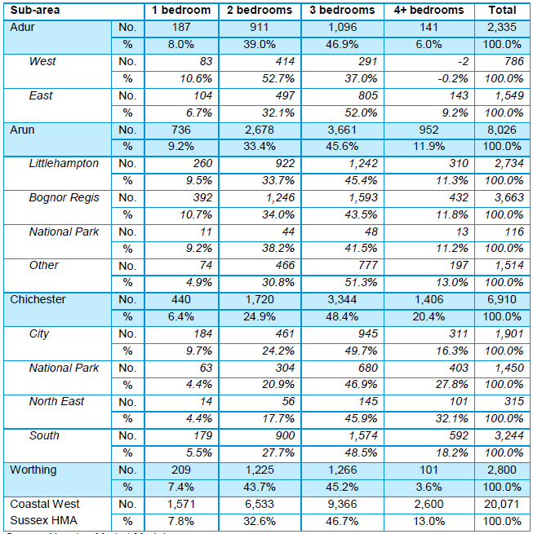
Source: SHMA Housing Market Model

- For affordable homes, the CWSS12 suggests a larger proportion should be concentrated at the smaller end of the scale, with 66.8% of all new AH dwellings being 1-3 habitable rooms in size. 30.1% of medium size, and only 3% of larger size.

Table 18: Estimated size of dwellings required 2011 to 2031 by sub-area – affordable housing
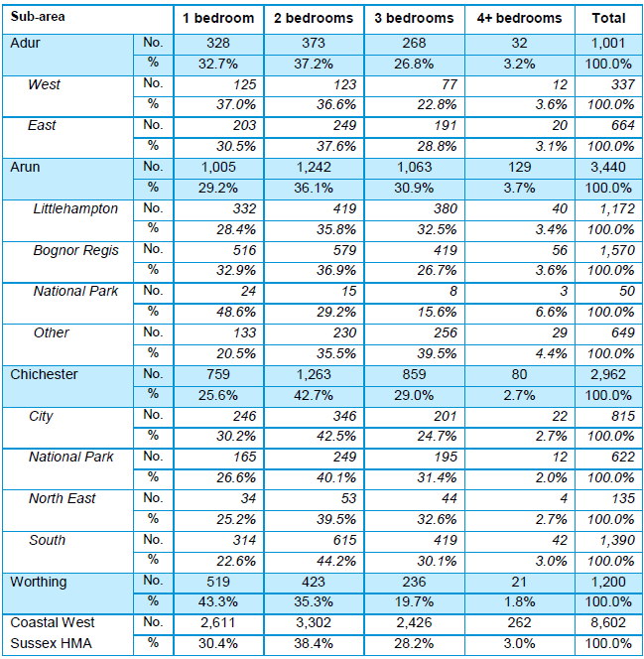
Source: SHMA Housing Market Model

RQ4: What provision should be made for specialist housing within the NPA?

Sheltered and extra-care housing
- As we have seen, given the significant forecast increases in people aged 75+, it is appropriate for policy to provide support for a significant quantum of sheltered and extra care housing as part of the delivery of new housing. Table 19 below identifies the growth in the population of over 75s between 2011 and 2031.
Table 19: Change in the population of over 75s between 2011 and 2031
Age band | 2011 |  |  | 2033
 | Population West Whittering | Population Chichester | Percentage of population | Population Chichester | Population West Whittering) | Projected 75+ population Chichester
All ages | 2,700 | 113,794 | 2.37% | 131,099 | 3107
75+ | 1,136 |  | 42% | 24,246 |  | 1305
Source: 2014-based Sub-national population projections, MHCLG and Census 2011 (ONS) AECOM calculations

- In arriving at an appropriate level of housing for older people of different types, we have applied the Housing Learning and Improvement Network’s suggested numbers per 1,000 of the 75+ population.
- The table above shows an estimate of the increase in the numbers of older people aged 75+ of 169 (1,305-1,136).
- The method we use to arrive this number can only be an estimate given that MHCLG population projections do not provide data at the Parish level. AECOM uses a four step method to arrive at the estimate:
- The population size for Chichester is taken;
- We arrive at an estimate of the size of the total population in West Wittering at end of Plan period by assuming it is the same proportion of the Chichester population as in 2011;
- To arrive at an estimate of the 75+ population in West Wittering at the end of the Plan period, we assume % in the NPA is the same as it was in 2011.
- Given the projected increase in the numbers of the older population, it is important to acknowledge this may under-estimate the numbers of elderly in 2033. The following data should therefore be treated as an estimate.
- Our method results in (using the housing LIN approach), over the Plan period, in a Parish need for:
- additional conventional sheltered housing units = 60 x 16.9% = 10 (rounded)
- additional leasehold sheltered housing units = 120 x 16.9% = 20 (rounded)
- additional ‘enhanced’ sheltered units, split 50:50 between those for rent and those for sale = 20 x 16.9% = 4 (rounded)
- additional extra care housing units for rent =15 x 16.9% = 3 (rounded)
- additional extra care housing units for sale = 30 x 16.9% = 6 (rounded)
- additional specialist dementia care home = 6 x 16.9% = 1 (rounded)
- Note that there is no obligation for these all to be provided within the Parish itself and clearly in some cases, such as providing a single specialist dementia care dwelling, it would not be economically feasible to do so. As such, these 40 specialist dwellings need not be thought of as all needing to be provided within the neighbourhood plan housing target- rather, there will be some overlap between these dwellings and the target, depending on the number that could be provided within the Parish itself.
- This specialist dwelling need is likely therefore to be split between the Parish and the rest of the District, which will enable the elderly to live either within or as close to the Parish as possible, taking account of the fact that West Wittering is unlikely to be able to provide many of the specialist housing types needed within its own boundaries- although there could be the potential for these to be provided at, for example, Chichester or Bognor Regis, taking account of their higher levels of accessibility to services and facilities, which will help in the recruitment and retention of specialist care staff and enable economies of scale (e.g. a centralised dementia care unit or enhanced sheltered development serving a widely dispersed rural population from a single location).

Retirement villages
- Projects that involve the delivery of multiple homes satisfy the desire on the part of many older people to live in an environment with people facing similar challenges; retirement villages are often a cost-effective means of delivering sheltered and extra care housing together with the facilities and services these settlements imply. Given the numbers of units that result from the LIN analysis, it would be appropriate to consider this approach to the delivery of housing for the elderly in West Wittering.
- This is in line with community need as understood by WTC who comment, ‘there is a demand for self-catered independent good quality safe and secure housing where similar minded individuals can live as a community with access to facilities, especially reasonable shopping, transport, doctors, opticians and dentists.’
- Such schemes should be explored through joint working with CDC and other Parishes to identify sites that could address collective need.

Senior co-housing
- Co-housing has been identified as being particularly suited to the needs of older residents. It offers a way for a group of people with similar interests and needs to come together to create an environment suited specifically to their requirements. Moreover, it can be designed to help address one of the most important issues for older people: isolation and loneliness. A number of successful case studies exist of both projects developed specifically with the needs of older people in mind, and others that encourage multi-generational housing, such as Featherstone Lodge in Forest Hill and LILAC in Leeds. In the first example, the design facilitated the creation of public areas that encouraged social interaction between members of the community, moreover, a ‘common house’ was built in the grounds of the scheme that provided a shared space in which people could come together for meeting and shared activities.

Multi-generational homes
- Multi-generational living has been identified as a possible solution not only for older people, but all generations where it makes financial sense to share accommodation, particularly younger people who are struggling to set up their own households. This gives rise not only to designs for new homes, but conversions to existing dwellings, introducing internal subdivisions and peripheral extensions to create internal layouts that balance the private needs of different generations with the benefits of over-lapping, shared communal spaces.
- The phenomenon of the aging population has an up-side; with increases in the quality of health-care, older people are able to live active lives for longer, the so-called ‘third age’ after retirement when people still want to live fully active lives. Within a household or community where tasks and facilities are shared, they are in a good position to take on both voluntary and paid work, for example looking after grandchildren or taking care of the elderly.

Lifetime homes
- Many local authorities incorporate policy into their Local Plans that a proportion of new homes should be built according to ‘lifetime homes’ principles; these are ordinary homes incorporating a number of design criteria that can be universally applied to new homes at minimal cost, for example parking that makes getting in and out of the car as simple and convenient as possible and ensuring movement in hallways and through doorways should be as convenient to the widest range of people, including those using mobility aids or wheelchairs, and those moving furniture or other objects.

Right-sizing
- As we have identified earlier, there is a need for a greater number of the type of dwellings that facilitate ‘right-sizing’ for older people. It is important to note, this does not necessarily imply moving to a smaller home. Many older people have the wealth (and the choice that comes with it) to create a home suited to having visitors and accommodating care staff, who may need to make over-night stays.
- For this reason, it is important to recognise that different ages have different needs, thus in the provision of housing, choice is critical, catering for those with relatively modest requirements, to those who are more dependent on help. The provision of choice that responds to need is part of creating a smoothly operating local housing market in which older people are able move out of family homes when they wish, thus freeing up these properties for others.

Planning flexibility
- Planning policy can be mobilised to help properties to become more adaptable in the context of an increasingly elderly population. This includes allowing the conversion of conventional dwellings or groups of dwellings (for example terraced housing) into multiple homes, particularly where additional features are included to address ‘lifetime homes’ criteria and to encourage interaction with the wider community. This can incorporate bigger community open space as a result of joining up different gardens. This is not dissimilar to the practice of ‘alley-gating’ where alleyways between the backs of terraced housing have been gated off, and turned into shared community spaces.

Lifetime neighbourhoods
- Creating an environment in which older people feel both welcome and comfortable does not end at the front door. Research exists that considers life-time neighbourhoods, in which the public realm is designed to address the needs of older people, and activates the benefits they can bring in supporting local businesses and encouraging improved public realm for everyone, for example providing more greenery and more walkable, better connected places.
- Given the expanded role of neighbourhood planning around design outlined in the Housing White Paper of 2017, a compelling notion is that of ‘the amplification of impact of micro-environmental features’ to describe that particular way in which we become more sensitive to the ordinary, smallest features of urban space as we age. This places a particular emphasis on care and reflection in how we design, for example paths and public seating; this, in turn, calls for the participation of older people in the process of design.
- Design approaches exist that provide a starting point for locally informed policy development in this area, these include Manchester’s Design for Access 2 and the work of Inclusive Design for Getting Outdoors (IDGO); IDGO have identified material features that make everyday negotiation of urban space that much easier for older people; these include wide and flat tarmac footways, easy transition level changes, clear, simple and visible signage, frequent warm and supportive seating and well-maintained, safe and open toilets.
- In addition, the notion of ‘pensioner play-grounds,’ ‘green-gyms,’ community gardens and various forms of guerrilla gardening (for example the Edible Todmorden project) encourage active use of public space and facilities on the part of an older demographic.

Age-friendliness
- Since the millennium policy at the international level has been directed towards a more holistic appreciation of what an ‘age-friendly’ urban environment looks like. It has been remarked this should extend beyond physical installations, such as public seating and access to WCs, but embrace means mobilising civic agency among older group to forestall incipient marginalisation, enabling them to continue to make a full and active contribution to community life.
- In 2006 the World Health Organisation (WHO) began developing the ‘Age-Friendly Cities’ movement, now a worldwide network of over 200 member cities around the world. They have produced a guide that offers a way of analysing the city from the perspective of older people, using a framework of inter-related domains: transportation, housing, social participation, respect and social inclusion, communication and information, civic participation and employment, health and community services.
- Considering the housing domain, the WHO study identifies a check list of attributes necessary to foster a sense of belonging and well-being among older people. In addition to affordability and designing accommodation with the needs of older people in mind, the adaptability of dwellings is important, for example their capacity to accommodate chair-lifts that enable older people to continue to live in two-storey homes.
- The WHO also identified access to services, particularly those that become increasingly important as people get older, such as places of worship and community centres. Moreover, optimising well-being has much to do with being able to maintain links with existing networks, which is best achieved by enabling people to remain in their existing communities for as long as possible. In the Australian city of Melville small clusters of senior's housing with small gardens are made available throughout the city, so that older people are not isolated from the community and particularly from children.

Housing for people with dementia
- Enabling people with dementia to live in their own homes for longer is critical to their quality of life as a result of the familiarity of surroundings and the help with retaining memories this facilitates. The challenge with this is two-fold; firstly the lack of appropriate adaptations in properties and, secondly, the support required to ensure a home is safe and suitable.
- Selwood Housing in the South West has pioneered approaches that help overcome these, for example the installation of property exit sensors to inform a monitoring centre when tenants leave their home and then not return within a pre-determined time.
- In figure 14 below we reproduce a chart showing the impact that early and appropriate intervention can have on the prospect of people with dementia remaining in their own home for longer.
Figure 7: Dementia care chart
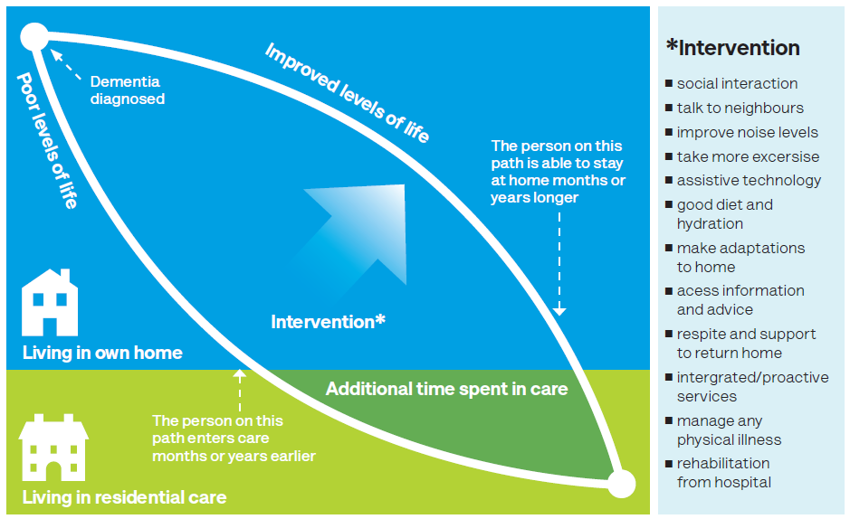
Source: Dementia Services Development Centre, 2013

The role of the Local Authority
- As suggested above, it is appropriate for the neighbourhood group to work closely with the LPA to develop policy and approaches to addressing the need for housing for elderly people in the area. The LPA is under an obligation through national policy to address the needs of older people, it is therefore appropriate they should play the strategic role in co-ordinating new efforts by housing providers, adult care services, primary care and health trusts, private and third sector organisations to meet the housing needs of older people across the District.

Market signals
- The PPG highlights the importance of taking market signals into account when assessing housing need, given they provide an indication of the balance between demand and supply. This is particularly important to consider given the significant and well-documented changes in the housing market over recent years, which were exacerbated by the economic downturn and subsequent issues in obtaining mortgage finance.
- The PPG states:
The housing need number suggested by household projections (the starting point) should be adjusted to reflect appropriate market signals, as well as other market indicators of the balance between the demand for and supply of dwellings. Prices rising faster than the national/local average may well indicate particular market undersupply relative to demand.
- These market signals relate to trends discernable within the housing market, and broader economic trends that have an impact on the housing market.
- The PPG goes on to assert that where there is evidence of an imbalance in supply and demand, an uplift in planned housing numbers – compared to those derived solely from household projections – is required in order to increase the supply of housing to meet demand and tackle affordability issues:
This includes comparison with longer term trends (both in absolute levels and rates of change) in the: housing market area; similar demographic and economic areas; and nationally. A worsening trend in any of these indicators will require upward adjustment to planned housing numbers compared to ones based solely on household projections.
In areas where an upward adjustment is required, plan makers should set this adjustment at a level that is reasonable. The more significant the affordability constraints (as reflected in rising prices and rents, and worsening affordability ratio) and the stronger other indicators of high demand (eg the differential between land prices), the larger the improvement in affordability needed and, therefore, the larger the additional supply response should be.
- In discussions with WWPC and CDC as to the appropriate levels of market dwellings in the NPA it will necessary to consider factors that suggest either an uplift or reduction. This study considers the following market signals:
- Employment trends;
- Housing Market (Prices);
- Housing Market (Volume);
- Migration;
- Overcrowding and concealed families; and
- Rate of Development (changes in housing stock).

Employment and commuting trends
- Local employment trends can greatly influence housing needs as employment opportunities can stimulate demand in the plan area. It is therefore important to establish the employment sphere of influence experienced by the residents of the West Wittering NPA.
- The Coast to Capital Economic Area is characterised by a creative, digital and IT cluster centred on Brighton, a large financial and business services sector, an advanced manufacturing and engineering sector as well as a strong network of health and life science companies throughout the region. The Coast to Capital Local Enterprise Partnership also identifies the presence of a number of global companies across a range of sectors, some with their own research capability as well as a few strong sectors in enabling and growth technologies (digital, electronics and medical).
- The majority of existing employment and business space in Chichester is focused around Chichester city and the A27 corridor. The Chichester Employment Land Review Update (ELR) identifies a potential growth in the District's labour force of around 3,200 over the period 2011-29. Such employment growth in the District is likely to bring with it an increase in demand for housing at West Wittering in the future. In service villages such as West Wittering, the CLP states that provision will be made for small scale employment, tourism or leisure proposals.
- Table 20 shows that the 2011 rate of employment in West Wittering, at 59.6% is significantly lower than that of Chichester and England as a whole. The proportion of full-time employees in West Wittering (23.7%) is 10.7 percentage points lower than across Chichester (34.4%) while the proportion of retirees in West Wittering (29.8%) is 11.6 percentage points greater than across Chichester (18.2%).
Table 20: Economic activity in West Wittering, 2011
Economic category |  | West Wittering | Chichester | England
Economically active | Total | 59.6% | 69.2% | 69.9%
 | Employee: Full-time | 23.7% | 34.4% | 13.7%
 | Employee: Part-time | 14.1% | 14.0% | 38.6%
 | Self-employed | 17.4% | 14.5% | 9.8%
 | Unemployed | 2.7% | 2.8% | 4.4%
 | Full-time student | 1.6% | 3.5% | 3.4%
Economically inactive | Total | 40.4% | 30.8% | 30.1%
 | Retired | 29.8% | 18.2% | 13.7%
 | Student | 2.2% | 4.4% | 5.8%
 | Looking after home or family | 4.3% | 4.2% | 4.4%
 | Long-term sick or disabled | 2.2% | 2.4% | 4.1%
 | Other | 1.9% | 1.5% | 2.2%
Source: ONS Census 2011, AECOM calculations
- Table 21 shows that the average distance travelled to work by the West Wittering residents is comparatively high (24.1km). Chichester City currently provides a broad range of employment and it is assumed there are strong links between West Wittering and Chichester in terms of employment as West Wittering is located within Chichester and Bognor Regis Travel To Work Area (TTWA). Moreover, the table shows that a significant proportion of the economically active residents in West Wittering work mainly at or from home (22.5%).
Table 21: Distance to work, 2011
Location of work | West Wittering | Chichester | England
Less than 10km | 32.6% | 41.1% | 52.3%
10km to less than 30km | 19.6% | 20.7% | 21.0%
30km and over | 12.9% | 12.0% | 8.0%
Work mainly at or from home | 22.5% | 16.4% | 10.3%
Other | 12.4% | 9.8% | 8.5%
Average distance travelled to work | 24.1km | 18.1km | 14.9km
Source: ONS Census 2011, AECOM calculations
- The CLP identifies the out-commuting flows from the Manhood Peninsula – where West Wittering is situated – as a challenge and intends to support and diversify economic activity particularly job opportunities on the Manhood Peninsula. The CLP sets out its vision for the Manhood peninsula and its strategy includes developing “intrinsic local industries such as small scale horticulture, agriculture, fishing and tourism […] with a particular focus on local food production”. It also includes developing “an ‘enterprise’ culture, building on high levels of entrepreneurship and self-employment”. As shown in Table 2, there are high levels of self-employment in West Wittering (17.4%) as well as in Chichester (14.5%) as identified in the CLP.
- Congestion at the six roundabouts around Chichester is also identified as a challenge in the LEPSEP and A27 roundabout improvements are planned in order to “improve traffic flow and the coast and open access to new housing and employment sites”. Such investment would be expected to generate further additional demand for housing in West Wittering given it would improve connections to new employment opportunities.

Housing transactions: prices
- The PPG advises that house prices should be used as an indication of the strength of demand for housing, and the adequacy of supply to meet that demand. To assess the housing market in the West Wittering NPA data from the Land Registry was analysed. This data provides price paid, housing type and date of transaction information which allows housing market trends to be identified. Data was downloaded for the period of January 2007 to December 2016 and is presented annually in the figure below. To replicate the NPA area, relevant post code data was filtered down to the Parish level, such that only post-codes within the Parish were included in the selection of Land Registry Data used for the analysis.
- Figure 8 and Table 22 below indicate that all types of housing have recovered to their pre-recession prices on average rather fast. The terraced houses experienced a 55% price growth while the flats prices increased by 44% between 2007 and 2016.
Figure 8: West Wittering prices paid by house type, 2007-2016

Source: Land Registry PPD, AECOM calculations
Table 22: West Wittering prices paid by house type, 2007-2016
 | 2007 | 2008 | 2009 | 2010 | 2011 | 2012 | 2013 | 2014 | 2015 | 2016
Detached | 591,476 | 520,298 | 489,822 | 532,190 | 485,839 | 487,209 | 577,435 | 580,757 | 642,919 | 664,593
Semi-Detached | 279,040 | 251,828 | 239,106 | 279,782 | 268,824 | 271,057 | 443,133 | 338,568 | 271,669 | 319,341
Terraced | 203,000 | 229,500 | 195,167 | 335,250 | 411,250 | 247,550 | 341,250 | 244,916 | 242,333 | 314,650
Flats | 198,590 | 186,750 | 185,100 | 212,667 | 162,440 | 231,500 | 203,667 | 213,886 | 212,625 | 284,993
All Types | 457,185 | 411,468 | 410,771 | 427,804 | 395,738 | 406,669 | 520,682 | 487,874 | 480,680 | 541,512
Source: Land Registry PPD, AECOM calculations
- The house prices growth indicates a strong demand in the NPA, especially for terraced house and flats. The District also experienced a strong demand between 2007 and 2016 with an overall house prices growth at 33% as shown in Table 23. Detached houses prices and semi-detached houses prices increased respectively by 41% and 34% in Chichester between 2007 and 2016.
- Although price growth in West Wittering has been relatively lower on average (18%) compared with Chichester, this has been from a higher base as house prices in West Wittering are higher than the average for Chichester as whole.
Table 23: Price comparison for January 2007 and December 2016, West Wittering and Chichester
 | Prices in January 2007 |  | Prices in December 2016 |  |  | Percentage Growth in Prices
 | West Wittering | Chichester | West Wittering | Chichester | West Wittering |  | Chichester
Detached | £591,476 | £400,060 | £664,593 | £562,604 | 12% |  | 41%
Semi-Detached | £279,040 | £246,866 | £319,341 | £331,552 | 14% |  | 34%
Terraced | £203,000 | £219,554 | £314,650 | £290,372 | 55% |  | 32%
Flats | £198,590 | £164,080 | £284,993 | £199,532 | 44% |  | 22%
All Types | £457,185 | £266,474 | £541,512 | £353,763 | 18% |  | 33%
Source: Land Registry PPD, AECOM calculations
- Within the broader housing market, Figure 5 shows that in Coastal West Sussex, the strongest growth in prices has been in Adur District (8.7%) and Chichester District (8.0%) between 2008 and 2011 with stronger growth recorded than average for the region. Chichester District’s stronger housing market performance corresponds with its stronger economic characteristics and recent performance. However, it has to be noted than average house prices in Chichester and in West Wittering are skewed by a greater presence of detached housing.
Figure 9: Coastal West Sussex median house price, 2008-11
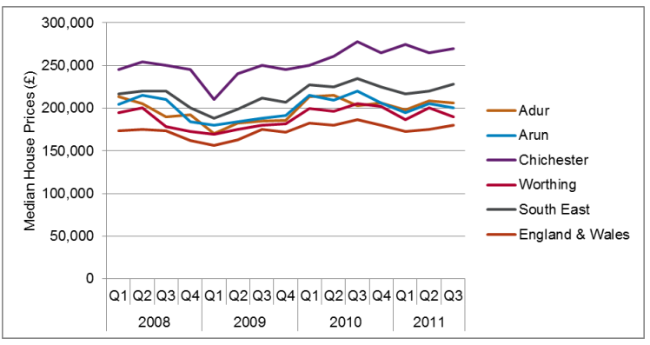
Source: HMLR/SHMA 2012

Housing transactions: volume
- Figure 10 depicts the relative proportions of different housing typologies sold in West Wittering between 2007 and 2016. This graph represents the same Land Registry data discussed in the previous section separated out by housing type. This graph shows the effects of the national recession, it is clear that transaction volumes had not, in 2016, returned to pre-recession levels.
Figure 10: Sales volumes of different housing types in West Wittering, 2007-2016

Source: Land Registry PPD, AECOM calculations
- Another approach to benchmarking whether sales volumes represent a clear market signal indicating inflated or depressed demand across different housing types is to compare the proportion of sales of each type of housing (excluding any new builds, which would introduce supply side factors) with the proportion of the existing housing stock that falls into each category. This allows conclusions to be drawn about whether the sale of homes of each type is occurring proportional to their availability, or there whether the high turnover of stock suggests strong, and possibly unmet, demand.
- This comparison is presented in Table 24, with figures for the housing stock in Chichester District as a whole presented alongside for reference. The table shows clearly that the percentage of sales and stock are roughly the same for detached housing and flats. Detached housing comprised 64% of all transactions between 2007 and 2016 and accounts for 63% of the housing stock. Semi-detached housing comprised 23% of all transactions over the period while only accounting for 20% of the housing stock. This data indicate that semi-detached housing has a relatively higher turnover rate in the area than the other house types. It suggests that semi-detached houses are in high demand, but also frequently traded in West Wittering. Table 24 also shows that fewer terraced houses are being sold than are represented in the existing stock.
Table 24: Sales volumes versus stock of different housing types in West Wittering and Chichester
 | SALES (2007-2016) | STOCK (2011) | STOCK (2011)
 | West Wittering | West Wittering | Chichester
Detached | 64% | 63% | 37%
Semi-Detached | 23% | 20% | 27%
Terraced | 5% | 8% | 18%
Flats | 8% | 8% | 16%
Source: Census 2001/2011, Land Registry PPD, AECOM Calculations

Migration
- Table 25 demonstrates that West Wittering has experienced population decrease of 3% between 2001 and 2011 while Chichester population increased by 7% over the same period. This would suggest a low housing demand in the NPA. Moreover, as shown in Table 26, the percentage of people born outside of the UK is very low in West Wittering (6.1%). This is less than the figure for Chichester as a whole, approximately 8%, and, of those born outside of the UK, 78% have been living in West Wittering for more than 10 years. Therefore, migration is not seen as a significant driver of increased housing demand in West Wittering.
Table 25: Population by age group, 2001, 2011
 | 2001 | 2001 | 2011 | 2011
Age group | West Wittering | Chichester | West Wittering | Chichester
0-15 | 309 | 18,900 | 293 | 18,633
16-24 | 199 | 9,900 | 167 | 11,458
25-44 | 407 | 24,938 | 378 | 23,973
45-64 | 785 | 28,201 | 726 | 31,836
65-84 | 920 | 20,990 | 927 | 23,602
85 and over | 172 | 3,521 | 209 | 4,292
All | 2,792 | 106,450 | 2,700 | 113,794
Percentage Growth |  |  | -3% | 7%
Source: Census 2001/2011, AECOM calculations
Table 26: Country of birth and length of residence, 2011
Place of birth | Population breakdown | West Wittering | Chichester | England
Born in the UK | Total | 93.9% | 91.9% | 86.2%
Born outside the UK | Total | 6.1% | 8.1% | 13.8%
 | EU | 2.7% | 3.4% | 3.7%
 | Other | 3.4% | 4.7% | 9.4%
Source: Census 2001/2011, AECOM calculations
Table 27: Length of residence of those born outside of the UK
Length of residence in the UK | West Wittering | Chichester
Less than 2 years | 8% | 11%
2-5 years | 10% | 13%
5-10 years | 4% | 18%
10 years or more | 78% | 58%
Source: Census 2001/2011, AECOM calculations

Overcrowding and concealed families
- Another indicator of demand in the housing market is shown by the prevalence of overcrowding in the NPA. This is because demand for housing in the area can manifest itself in the over-occupation of housing stock.
- One of the most reliable indicators of overcrowding is the ‘persons per room’ data collected at the household level during the Census. The relative proportion of households occupying different amounts of space in the NPA and the District is shown in Table 28, which demonstrates that West Wittering households do not experience overcrowding.

Table 28: Trends in number of persons per room in West Wittering, 2001-2011
Occupancy Rating | 2001 | 2001 | 2011 | 2011
 | West Wittering | Chichester | West Wittering | Chichester
Up to 0.5 persons per room | 1171 | 35581 | 1184 | 39081
Over 0.5 and up to 1.0 persons per room | 166 | 9805 | 166 | 10321
Over 1.0 and up to 1.5 persons per room | 6 | 325 | 2 | 377
Over 1.5 persons per room | 0 | 85 | 0 | 69
Source: Census 2001/2011, AECOM calculations
- A second indicator of overcrowding is the prevalence of concealed families within the NPA. A concealed family is one living in a multi-family household in addition to the primary family, such as a young couple living with parents. ONS data shows that there are 10 concealed families in West Wittering, or 1.2% of all families, slightly lower than the average for Chichester (1.3%) and for England as a whole (1.9%), as shown in Table 29. This is not seen as highly significant, although concealed families do indicate that there is unmet additional demand for housing in the area from those already living there, that is, local demand.
Table 29: Concealed families in West Wittering, 2011
Concealed families | West Wittering | Chichester | England
All families: total | 837 | 32,930 | 14,885,145
Concealed families: total | 10 | 428 | 275,954
Concealed families as % of total | 1.2% | 1.3% | 1.9%
Source: Census 2011, AECOM Calculations

Rate of development
- Table 30 shows the net housing completions to 31 March 2016 in West Wittering and Chichester City. The data shows there was an important increase in housing completions in 2015/2016 as 90% of the total net completions since 2012 were built over this period. This rate of development shows that actual supply is in line with planned supply.
Table 30: West Wittering and Chichester City net housing completions to 31 March 2016
 | Number of homes planned to 2029 | Net housing completions 2015/16 | Total net completions since 1 April 2012 | Remaining Parish housing yet to be delivered
West Wittering | 50 | 45 | 50 | 0
Chichester city | 235 | 8 | 17 | 218
Source: Chichester District Council Authority’s Monitoring Report 2015-2016
- In Figure 11 below we reproduce Figure 2 from the local authority’s Housing Monitoring Report; this confirms the finding set out in the previous paragraph that, broadly speaking, the District is has been able to make good progress in meeting its housing supply targets.
Figure 11: Actual/projected housing completions against Local Plan housing target 2012-2029
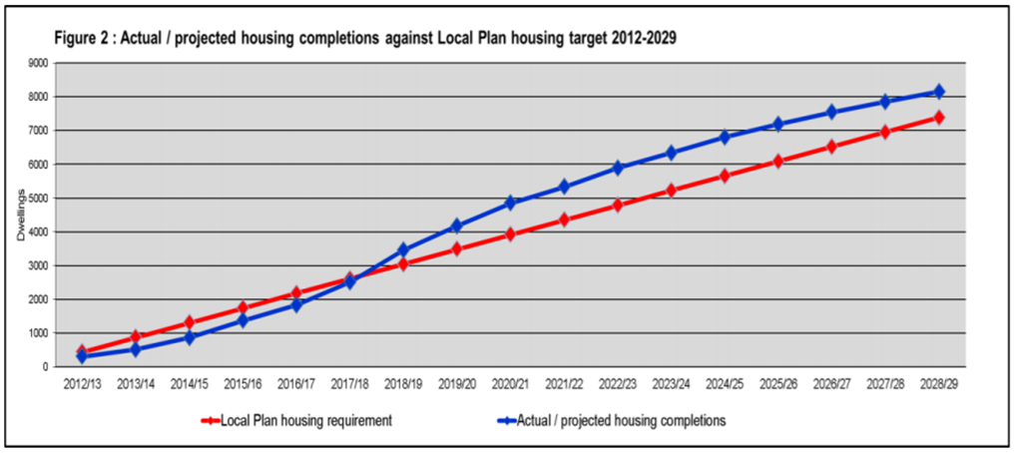
Source: Chichester District Council Authority’s Monitoring Report 2015-2016, p.47

Conclusions

Overview
Table 31: Summary of factors specific to West Wittering with a potential impact on neighbourhood plan housing quantity
Factor | Source(s) (see Chapter 5) | Possible impact on housing needed | Conclusion
Employment trends | LEPSEP, CLP, Census 2001/11 | ↑↑ | The wider economic area has been shown to have numerous global and competitive companies across a wide range of sectors, with a potential for growth.  Furthermore, future investment in transport infrastructure has been shown to have a likely impact on West Wittering in terms of demand for housing, as is potential growth in intrinsic businesses based inside the NPA. Therefore two up arrows have been deemed appropriate.
Housing transactions (prices) | PPG, Land Registry Price Paid Data for 2007-2016, SHMA | ↑↑ | The West Wittering NPA has been shown to have experienced an 18% increase in price paid for properties of all types over a ten year period.  The price paid varies per housing type (detached, semi-detached, terraced and flats) but has remained relatively high across all types. Although price growth in West Wittering was less than in the District as a whole, this was from a higher base, and therefore, two up arrows have been deemed appropriate.
Housing Transactions (volume) | Land Registry Price Paid Data for 2007-2016, Census 2001/2011 data, SHMA | ↑ | The evidence gathered suggests there is a high demand in the NPA for semi-detached housing relative to supply (the number of sales of semi-detached dwellings as a proportion of all sales exceeds the proportion they represent of the housing stock). This ‘high demand’ scenario justifies one up arrow.
Migration | Census data 2001/2011 | ↔ | Migration is not seen as a significant factor in determining housing need given that just 22% of the 6.1% of West Wittering residents born outside of the UK arrived in the last 10 years.
Overcrowding and concealment | Census Data 2001/2011 | ↔ | There is no evidence of overcrowding in West Wittering and although there is some evidence of concealed families, these are not deemed particularly significant given the levels seen in Chichester District as a whole.
Rate of development | Chichester District Council Authority’s Monitoring Report 2015-2016, SHMA | ↔ | Chichester District has consistently met, or exceeded its housing target in recent years. Furthermore, the rate of development in West Wittering shows that actual supply is in line with planned supply. Therefore it is reasonable to suggest that the rate of development indicates there is only a small potential for future under-delivery and, as such, a neutral arrow is considered appropriate.

Table 32: Summary of local factors specific to West Wittering with a potential impact on neighbourhood plan housing characteristics
Factor | Source(s) (see Chapter 3) | Possible impact on housing needed | Conclusion
Affordable Housing (AH) | Land Registry price paid data, CWSS12, AHDNS14, Local Agents survey | According to data presented in CWSS12, 70% of all households in Chichester South (a sub-area of the HMA in which West Wittering is located) can access private rented housing, and 50% are able to buy an entry-level (two bedroom) dwelling priced at £160,000.  Local agents reported at the end of 2017 that prices for entry level dwellings (two bedroom) may be substantially greater than those reported in the CWSS12, and may have reached around £280,000.  A Median Affordability Ratio (MAR) of 3.9 is recorded for Chichester South.  The Lower Quartile Affordability Ratio (LQAR) for Chichester is reported to be 10.41.  Between 2007 and 2016, house prices were reported to have increased by 18% in West Wittering. | Based on evidence of need drawn from Chichester’s Housing Waiting List Register (that shows nine households expressing an interest in occupying housing in West Wittering), there is no basis on which to seek a different proportion of affordable housing from new residential development coming forward over the Plan period than Policy 34 of CLP.  However, given that the waiting list may under-report need and the conclusions in this study relating to affordability of housing to those on low incomes, WWPC should adopt an assertive attitude regarding the delivery of affordable housing.  The high LQAR suggests those households on the lowest incomes will struggle to access housing of a suitable size; it is therefore appropriate that the majority of AH fall into the ‘social rented’ category.  Given the relatively high cost of housing in West Wittering (based on estate agent feedback) we do not see a role for Discounted for Sale Dwellings (for example starter homes) given that, once the 20% discount has been taken into account, prices are likely to remain beyond the reach of first time buyers.  Notwithstanding this, we do see a role for other forms of intermediate housing, for example shared equity dwellings.
Demand/need for smaller dwellings | Census 2001/2011, CWSS12 | Census data shows a high proportion of the population living alone (37.5%) compared with the District as a whole (32%); this group has grown substantially over the inter-censual period, recording an increase of 59 households over the period, the majority of whom were under 65.  4% of households occupy dwellings of 1-3 habitable rooms.  In Chichester South, the CWSS12 suggests roughly a third of all new residential development for the open market should be of 1-3 habitable rooms in size.  For affordable homes, the CWSS12 suggests a larger proportion should be concentrated at the smaller end of the scale than for open market dwellings, with 66.8% of all new AH dwellings being 1-3 habitable rooms in size. | The low proportion of households living in small dwellings must lead us to query whether the housing stock is suited to community need given, firstly, the changes that have been observed over the inter-censual period, in particular the growth in one person households and, secondly, the affordability issues faced by those on lower incomes.  Evidence from the CWSS12 provides clear support for smaller dwellings, and may be used as the justification for developing policy in this direction.
Demographic change | Census 2001/2011 | The 2011 Census identified an under-representation of those aged under 44 in the NPA, with large disparities with District and national geographies.  Over the inter-censual period, the representation of families declined, with the largest fall being those with dependent children (10.2%).  42% of residents were aged 65+ at the time of the last Census.  Data for the District provides a strong indication that the growth in one-person households as a share of the overall population will continue to increase over the Plan period.  Using District level data as a guide to future trends, the characteristics identified in Census are likely to become more pronounced over the Plan period. | The relatively low number of adults aged under 44, and the fall in families threaten to undermine the vitality and viability of the settlement. If this continues, it is likely to reduce demand for infrastructure targeted at these groups, for example primary schools, as well as businesses and services for the general population.
Dwelling type | Census 2001/2011 | West Wittering shows a clear preponderance of detached dwellings, in contrast to Chichester which shows a more even balance between houses of different types. | The dominance of detached dwellings is consistent with the finding that the housing market is beyond the reach of many and there is a fundamental misalignment between the existing housing stock and the type and size of dwellings required by the community in future years.
Family-sized housing | CWSS12 | In Chichester South, the CWSS12 suggests medium sized homes of three bedrooms (4-5 habitable rooms) should constitute 48.5% of all market dwellings, and 18.2% should be apportioned to larger homes.  In Chichester South, the CWSS12 suggests 30.1% of affordable homes should be medium sized homes of three bedrooms (4-5 habitable rooms), and only 3% of larger size. | There is a strong argument for the provision of family housing within the overall mix. The evidence assembled may be used to justify policy that seeks a balanced community in terms of age, household composition and income group.
Housing for independent living for older people | CWSS12, Census, Housing Learning and Improvement Network | The District data shows a substantial increase in the population of those aged 65+.  Given that the population of the NPA is already strongly ageing, a reasonable conclusion would be that trends forecast for the District are likely to be more extreme in West Wittering. | Using the Housing LIN approach, over the Plan period, this HNA has identified a need in the Parish for:  10 additional conventional sheltered housing units  20 additional leasehold sheltered housing units  4 additional ‘enhanced’ sheltered units, split 50:50 between those for rent and those for sale  3 additional extra care housing units for rent  6 additional extra care housing units for sale  1 additional specialist dementia care home  There is no obligation on the Parish to satisfy the need for 44 specialist dwellings for the elderly, and they may be better provided at settlements that can provide better access to services; however, the need should be borne in mind in formulating the plan’s housing policies.

Recommendations for next steps
- This neighbourhood plan housing needs advice has aimed to provide WWPC with evidence on housing trends from a range of sources. We recommend that the Parish should, as a next step, discuss the contents and conclusions with CDC with a view to agreeing and formulating draft housing policies, in particular the appropriate approach to identifying the level of new housing need in the NP area, bearing the following in mind:
- Neighbourhood Planning Basic Condition A, that it has regard to national policies and advice contained in guidance issued by the Secretary of State; Condition D, that the making of the neighbourhood plan contributes to the achievement of sustainable development; and Condition E, which is the need for the neighbourhood plan to be in general conformity with the adopted strategic development plan;
- the views of CDC – in particular in relation to the housing need figure that should be adopted;
- the views of local residents;
- the views of other relevant local stakeholders, including housing developers;
- the numerous supply-side considerations, including local environmental constraints, the location and characteristics of suitable land, and any capacity work carried out by the CDC, including but not limited to the SHLAA;
- the recommendations and findings of this study; and
- the impact of the new Government proposed standard methodology on calculating housing need for the District and its neighbourhoods.
- Recent changes to the planning system, forthcoming changes to the NPPF, as well as the implementation of the Housing and Planning Act, will continue to affect housing policies at a local authority and, by extension, a neighbourhood level.
- This advice note has been provided in good faith by AECOM on the basis of housing data and national guidance current at the time of writing (alongside other relevant and available information).
- Bearing this in mind, we recommend that the steering group should monitor carefully strategies and documents with an impact on housing policy produced by the LPA or any other relevant body and review the neighbourhood plan accordingly to ensure that general conformity is maintained.
- At the same time, monitoring on-going demographic or other trends over the period in which the neighbourhood plan is being developed (factors summarised in Table 1) would help ensure the relevance and credibility of its policies.

AECOM (NYSE: ACM) is a global provider of professional technical and management support services to a broad range of markets, including transportation, facilities, environmental, energy, water and government. With approximately 45,000 employees around the world, AECOM is a leader in all of the key markets that it serves. AECOM provides a blend of global reach, local knowledge, innovation, and collaborative technical excellence in delivering solutions that enhance and sustain the world’s built, natural, and social environments. A Fortune 500 company, AECOM serves Clients in more than 100 countries and has annual revenue in excess of $6 billion.

More information on AECOM and its services can be found at www.aecom.com.

aecom.com

Chichester Local Plan, page 56
See Planning Practice Guidance Paragraph: 006 Reference ID: 2a-006-20140306
See Planning Practice Guidance, Paragraph: 004 Reference ID: 2a-004-20140306 Revision date: 06 03 2014
Such an approach, clearly separating housing need assessment from dwelling capacity assessment, was endorsed by the Government for calculating housing need at local authority level in the ministerial statement and press release ‘Councils must protect our precious green belt land’ (MHCLG, 4 October 2014, available at https://www.gov.uk/government/news/councils-must-protect-our-precious-green-belt-land)
Housing LIN (2011) Strategic Housing for Older People: Planning, designing and delivering housing that older people want, available online at: http://www.housinglin.org.uk/_library/Resources/Housing/SHOP/SHOPResourcePack.pdf
CWSS12 page 42
Planning Practice Guidance Paragraph: 010 Reference ID: 2a-010-20140306 Revision date: 06 03 2014
Planning Practice Guidance Paragraph: 008 Reference ID: 2a-008-20140306 Revision date: 06 03 2014
CWSS12 page 44
The OAN includes the baseline demographic need, plus any adjustments made to official forecasts to account for projected rates of household formation post 2021, past suppression of the formation of new households, the effect of past under-supply, employment forecasts, market signals and affordable housing need (as set out in paragraph ID2a-004 of the PPG). This is sometimes described as ‘policy off’ because it does not take account of final policy responses as a result of taking into account capacity, environmental and infrastructure constraints.
Review of Objectively Assessed Housing Need in light of 2012-based Subnational Population Projections, Chichester District Council, August 2014, page 8
See 2014-based MHCLG Household Projections live tables at https://www.gov.uk/government/statistical-data-sets/live-tables-on-household-projections
Email from AREA Borough Council, 14/02/17
MHCLG, planning for the right homes in the right places: consultation proposals, page 28
MHCLG, planning for the right homes in the right places: consultation proposals, page 31
PPG Paragraph: 021 Reference ID: 2a-021-20160401
Housing and Planning Act 2016, part 6, section 159 (4)
Section 159(2) of the Act inserts ‘(3ZB) No regulations may be made under section 106ZB [which contains the updated definition of affordable housing] unless a draft of the instrument containing the regulations has been laid before, and approved by a resolution of, each House of Parliament’
MHCLG (2017) Fixing our Broken Housing Market (para A.120)
Ibid (p100)
ROANH14, page 24
CWSS12, page 44
AHDNS14, page 22
Henry Adams, Estate Agent Questionnaire, 15/12/17
Email dated 3rd October from Holly Nicol, Rural Housing Enabler, Housing Delivery, Chichester District Council
Sheltered housing (also known as retirement housing) means having your own flat or bungalow in a block, or on a small estate, where all the other residents are older people (usually over 55). With a few exceptions, all developments (or 'schemes') provide independent, self-contained homes with their own front doors. There are many different types of scheme, both to rent and to buy. They usually contain between 15 and 40 properties, and range in size from studio flats (or 'bedsits') through to 2 and 3 bedroomed. Properties in most schemes are designed to make life a little easier for older people - with features like raised electric sockets, lowered worktops, walk-in showers, and so on. Some will usually be designed to accommodate wheelchair users. And they are usually linked to an emergency alarm service (sometimes called 'community alarm service') to call help if needed. Many schemes also have their own 'manager' or 'warden', either living on-site or nearby, whose job is to manage the scheme and help arrange any services residents need. Managed schemes will also usually have some shared or communal facilities such as a lounge for residents to meet, a laundry, a guest flat and a garden. Source: http://www.housingcare.org/jargon-sheltered-housing.aspx (accessed 11/04/17)
New forms of sheltered housing and retirement housing have been pioneered in recent years, to cater for older people who are becoming more frail and less able to do everything for themselves. Extra Care Housing is housing designed with the needs of frailer older people in mind and with varying levels of care and support available on site. People who live in Extra Care Housing have their own self-contained homes, their own front doors and a legal right to occupy the property. Extra Care Housing is also known as very or enhanced sheltered housing, assisted living, or simply as 'housing with care'. It comes in many built forms, including blocks of flats, bungalow estates and retirement villages. It is a popular choice among older people because it can sometimes provide an alternative to a care home. In addition to the communal facilities often found in sheltered housing (residents' lounge, guest suite, laundry), Extra Care often includes a restaurant or dining room, health & fitness facilities, hobby rooms and even computer rooms. Domestic support and personal care are available, usually provided by on-site staff. Properties can be rented, owned or part owned/part rented. There is a limited (though increasing) amount of Extra Care Housing in most areas and most providers set eligibility criteria which prospective residents have to meet. http://www.housingcare.org/jargon-extra-care-housing.aspx (accessed 11/04/17)
Housing LIN (2011) Strategic Housing for Older People: Planning, designing and delivering housing that older people want, available online at: http://www.housinglin.org.uk/_library/Resources/Housing/SHOP/SHOPResourcePack.pdf
http://www.featherstonecohousing.co.uk/ (visited 12/04/17)
http://www.lilac.coop/ (visited 12/04/17)
RIBA, Silver Linings, The Active Third Age and the City, Page 17-18
http://www.lifetimehomes.org.uk/pages/about-us.html
Housing LIN, New Approaches to Housing for Older People, June 2014, page 6
Gobber, S, A Bright Grey Future, Urban Design Group Journal, Spring 2016, page 29
HMG, Fixing our broken housing market, page 29
RIBA/Age UK, An Alternative Age-Friendly Handbook, page 54/55
RIBA/Age UK, An Alternative Age-Friendly Handbook, page 16
World Health Organisation: Global age-friendly cities: a guide, page 32
Ibid, page 33
Ibid, page 35
Alzheimer’s Society, Dementia-friendly housing charter, page 13
NPPF, para 50
http://planningguidance.communities.gov.uk/blog/guidance/housing-and-economic-development-needs-assessments/methodology-assessing-housing-need/#paragraph_019
http://planningguidance.communities.gov.uk/blog/guidance/housing-and-economic-development-needs-assessments/methodology-assessing-housing-need/#paragraph_020
LEPSEP, pp.32.
CLP, pp.17.
CLP, pp.42.
CLP, pp.41.
CLP, pp.19.
LEPSEP, pp.23.
CLP, pp.23.
LEPSEP, pp.68.
SHMA, pp.104.
Ibid.
http://webarchive.nationalarchives.gov.uk/20160105222245/http://www.ons.gov.uk/ons/rel/census/2011-census-analysis/what-does-the-2011-census-tell-us-about-concealed-families-living-in-multi-family-households-in-england-and-wales-/sty-what-does-the-2011-census-tell-us-about-concealed-families.html (visited 13/10/17)
Housing LIN (2011) Strategic Housing for Older People: Planning, designing and delivering housing that older people want, available online at: http://www.housinglin.org.uk/_library/Resources/Housing/SHOP/SHOPResourcePack.pdf

