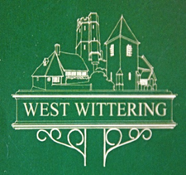

WEST WITTERING NEIGHBOURHOOD PLAN

Submitted for Consultation with Statutory Authorities
by West Wittering Parish Council

SCOPING REPORT FOR SUSTAINABILITY APPRAISAL

February 2017

CONTENTS

 |  | Page Number
1.0 | Introduction | 3
2.0 | Consultation and Comments | 7
3.0 | Background to the West Wittering Neighbourhood Plan | 8
4.0 | Other Plans and Programmes (Stage 1) | 10
5.0 | Baseline Information (Stage 2) | 14
6.0 | Sustainability Issues (Stage 3) | 26
7.0 | Appraisal Framework (Stage 4) | 34
8.0 | Next Steps | 36

APPENDICES

Appendix A Screening Opinion letter
Appendix B Key policy documents and strategies

1.0 INTRODUCTION

  - West Wittering Parish Council is developing a Neighbourhood Development Plan in order to guide development in the Parish until xxx. As sustainability is an important consideration in land use planning, a Sustainability Appraisal (SA) will be undertaken on the contents of the Plan. A Neighbourhood Plan, once adopted, becomes a formal part of the planning system and will be a Local Development Plan document. The West Wittering Parish Neighbourhood Plan (WWNP) is an important planning tool for shaping the development and growth of the village and Parish.

What is a Sustainability Appraisal?

1.2 A Strategic Environmental Assessment (SEA) involves the evaluation of the environmental impacts of a plan such as the Neighbourhood Development Plan. The requirement for SEA is set out in the European Directive 2001/42/EC adopted into UK law as the “Environmental Assessment of Plans or Programmes Regulations 2004”.

1.3 A Sustainability Appraisal (SA) is conducted in conformity with the SEA Directive. However, while an SEA is concerned with environmental effects, the sustainability appraisal is an iterative process that considers the environmental, social and economic consequences of a plan and its policies, and seeks to identify ways of achieving a proper balance between these three considerations. For simplification, this report is referred to as the Sustainability Appraisal throughout.

1.4 An SA is a systematic process to promote sustainable development by assessing the extent to which a Plan, when judged against reasonable alternatives, will help to achieve relevant environmental, economic and social objectives. It is also a means of identifying and mitigating any potential adverse impacts that the Plan might have. This can ensure that the policies in the Plan are the most appropriate, given the reasonable alternatives.

1.5 The first stage of the process is Screening. This is to determine if the Neighbourhood Plan is to have significant environmental effects. A Screening Opinion by Chichester District Council was sent to the Parish Council on 6th December 2016. Following consultation with the statutory environmental bodies (English Heritage, Natural England and Environment Agency) it was concluded that the Neighbourhood Development Plan would have significant environmental effects and that a full SEA will be need to be prepared. The Screening response is attached as Appendix A. The second stage is producing the Scoping Report and this is set out in the box below:

Scoping Report work stages

Setting the context and objectives, establishing the baseline and deciding on the scope

Stage 1. Identify other relevant policies, plans and programmes, and sustainability objectives.
Stage 2. Collect baseline information.
Stage 3. Identify sustainability issues and problems.
Stage 4. Develop the strategic environmental assessment framework.
Stage 5. Consult the environmental assessment consultation bodies on the scoping report.

Neighbourhood Development Planning

1.6 Neighbourhood development planning is a new way for communities to decide the future of the places they live and work. The Government states that neighbourhood development planning empowers communities to shape the development and growth of a local area through the production of a neighbourhood development plan, a neighbourhood development order or a community right to build order.

1.7 Neighbourhood plans are also required to demonstrate that they are legally compliant and are compatible with EU obligations (as incorporated into UK law). An important component of this is compliance with the Strategic Environmental Assessment Directive by considering whether there are likely to be any significant environmental effects as a result of implementing the plan.

1.8 The National Planning Policy Framework 2012 (NPPF) states that the aim of the planning system is to deliver sustainable development. This has been carried through in the Neighbourhood Planning Regulations, which requires that neighbourhood development plans contribute to the achievement of sustainable development. Although not a statutory requirement, a sustainability appraisal of a neighbourhood plan is a positive step to meeting this basic condition. It provides a useful tool to the development and consideration of the policies and overall strategy of the neighbourhood plan. It enables a parish council to give full consideration to sustainability issues affecting the settlement/parish area and provides the means for assessing the options and mitigating against any negative impacts where possible. Undertaking this process can improve the overall sustainability of the neighbourhood plan. This document comprises the Sustainability Appraisal report (incorporating a Strategic Environmental Assessment – SEA). It therefore considers environmental, economic and social impacts.

What is Sustainable Development?

1.9 Sustainable development is defined as “development that meets the needs of the present without compromising the ability of future generations to meet their own needs”. It is about ensuring better quality of life for everyone, now and for generations to come. In doing so, social, environmental and economic issues and challenges should be considered in an integrated and balanced way.

1.10 The NPPF sets out that the purpose of the planning system is to contribute to the achievement of sustainable development and policies in paragraph 18 to 219 of the NPPF, taken as a whole, constitute the Government’s view of what sustainable development in England means in practice for the planning system.

1.11 In paragraph 7, the NPPF states the Government’s intentions with regards to sustainable development, in particular the need for the planning system to perform a number of roles:
ECONOMIC ROLE – contributing to building a strong, responsive and competitive economy, by ensuring that sufficient land and the right type is available in the right places and at the right time to support growth and innovation; and by identifying and coordinating development requirements, including the provision of infrastructure.
SOCIAL ROLE – supporting strong, vibrant and healthy communities, by providing the supply of housing required to meet the needs of the present and future generations; and by creating a high quality built environment, with accessible local services that reflect the community’s needs and support its health, social and cultural well-being.
ENVIRONMENTAL ROLE – contributing to protecting and enhancing our natural, built and historic environment; and, as part of this, helping to improve biodiversity, use natural resources prudently, minimise waste and pollution, and mitigate and adapt to climate change including moving to a low carbon economy.
2.0 CONSULTATION AND COMMENTS

2.1 The Scoping Report is the first stage of the SA process. It identifies the sustainability issues within West Wittering and sets out the sustainability objectives for the SA. These objectives build upon the strategic and sustainability objectives within the Chichester Local Plan: Key Policies 2014-2029 (and accompanying Sustainability Appraisal), expanding upon these to provide a more local focus on the needs and aspirations of the West Wittering community.

2.2 The Scoping Report will be the subject of consultation with a number of agencies and stakeholders. A full list is set out below. The comments and responses will feed into the draft Neighbourhood Plan and Sustainability Appraisal and may result in further issues being identified.

Chichester District Council
West Sussex County Council
Environment Agency
Natural England
Historic England
Chichester Harbour Conservancy

How to Comment on this Report

2.3 This Scoping Report is available for comment as part of a 5-week consultation period from xx. All comments should be sent to

3.0 BACKGROUND TO THE WEST WITTERING NEIGHBOURHOOD PLAN

3.1 Chichester District Council designated West Wittering parish as a neighbourhood area in March 2013 in order to allow the parish council the opportunity to produce a neighbourhood plan (NP). The early stages of the plan are underway. The map below shows the designated area.

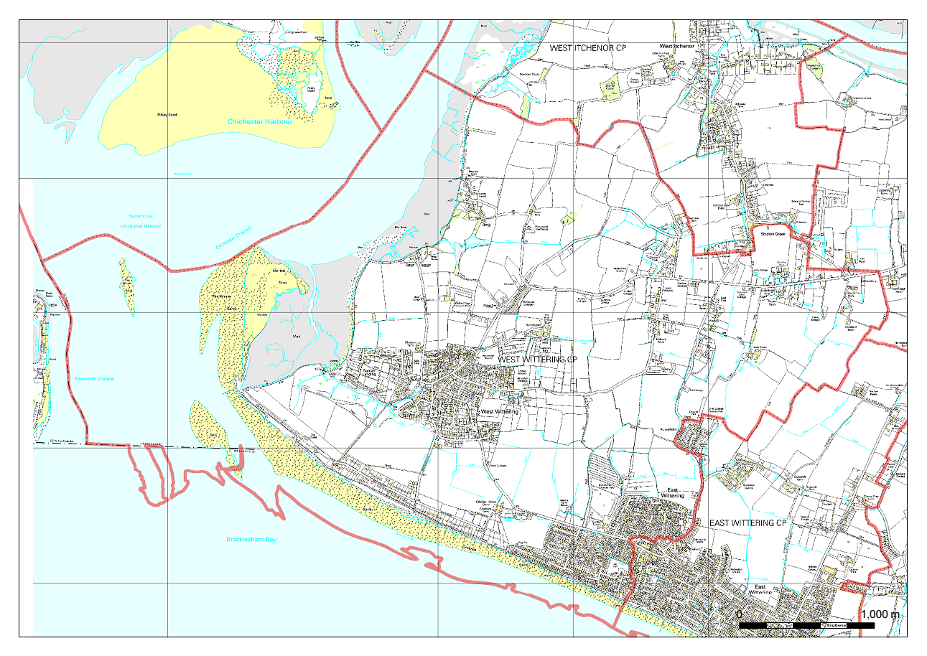
Map 1 – West Wittering Neighbourhood Plan Designated Area.

3.2 The NP steering group have developed a draft vision and a set of strategic objectives for the plan. These may be further refined as the NP evolves. At present they are:

VISION STATEMENT
West Wittering is a village with two distinct centres fortunate to be set between a hugely popular beach, protected farmland and the quiet reserves of Chichester Harbour. It is the aim of the Neighbourhood Plan to continue the work of previous generations to protect the fragile character of the village for future generations. It will work towards nurturing local businesses, reducing traffic congestion, preventing flooding, creating new cycle ways and supporting local shops and tourism. The activities related to the village’s social centres, sports and hobby clubs, faith groups and special interests will all be encouraged as an essential part of the fabric of village life.

3.3 The draft NP strategic objectives are:

Housing and Infrastructure
1. To encourage and support development which meets the needs of residents and visitors with special consideration for young people with strong village connections and those requiring assisted living.
2. To ensure infrastructure services are consistent with existing and future development with a focus on transport improvements.
Business and Employment
3. To encourage and support existing and new businesses in order to provide local employment opportunities, including those related to tourism, particularly high-quality accommodation.
4. To identify development opportunities for small businesses e.g. business hub services.
5. To support improved broadband and mobile communication facilities
Heritage and Environment
6. To support new development which is consistent with and will not harm the rural character of the village.
7. To develop a cycle network and improve the existing footpath network.
Communication and Marketing
8. To engage with all residents effectively to achieve a highly-inclusive village community.

4.0 STAGE 1 – POLICIES, PLANS AND PROGRAMMES

4.1 Stage 1 as set out in paragraph 1.5 of this Scoping Report is to identify other relevant policies, plans and programmes, and sustainability objectives. The NP is influenced by other plans and programmes and in many cases, key environmental issues will have already been dealt with in other documents and environmental assessments that have been undertaken.

4.2 The West Wittering Neighbourhood Plan will need to comply with both national and local planning policies. A review of the key local policy documents and strategies has been undertaken for the WWNP. The aims and objectives from these policy documents, together with the sustainability issues for West Wittering (chapter 6 of this report) have been used to develop the West Wittering Neighbourhood Plan sustainability framework set out in chapter 7.

4.3 Neighbourhood plans form the bottom tier of the planning system and so are influenced by various higher level plans, policies and guidance. A full list of relevant plans, policies and programmes that will be considered and influence the content of the WWNP Neighbourhood Plan are set out at Appendix B. A summary of the key plans and programmes influencing the NP is identified below, together with the main objectives.

4.4 National Planning Policy Framework 2012 (NPPF) - This sets out the Government’s planning policies for England and how they are expected to be applied. At its heart is a presumption in favour of sustainable development. The application of the presumption will have implications for how communities engage in neighbourhood planning. Critically, it will mean that neighbourhoods should:
- develop plans that support the strategic development needs set out in Local Plans, including policies for housing and economic development;
- plan positively to support local development, shaping and directing development in their area that is outside the strategic elements of the Local Plan; and
- identify opportunities to use Neighbourhood Development Orders to enable developments that are consistent with their neighbourhood plan to proceed.

4.5 The ambition of the neighbourhood should be aligned with the strategic needs and priorities of the wider local area. Neighbourhood plans must be in general conformity with the strategic policies of the Local Plan. Neighbourhood plans should reflect these policies and neighbourhoods should plan positively to support them.

4.6 On the 14 July 2015 Chichester District Council adopted the new Chichester Local Plan: Key Policies 2014-2029. This replaces the previous Chichester District Local Plan: First Review (1999) in its entirety. The Local Plan covers those areas in the district that do not fall within the South Downs National Park

4.7 The development strategy seeks to deliver the Local Plan’s vision and objectives and to meet the wider needs of places and communities across the Plan area. The strategy aims to meet identified needs as far as possible, in a manner compatible with the special environmental qualities of the area and having regard to infrastructure requirements and deliverability. This approach fulfils the requirements for sustainable development as set out in the NPPF.

4.8 A key theme running through the whole Plan is the need to conserve and enhance the quality of the environment and heritage of the area, in particular designated sites and assets of national and international importance. The Local Plan strategy aims to steer major development away from the most environmentally sensitive areas and towards locations that have the widest access to employment opportunities and community facilities, or where development can contribute to addressing an under provision of such facilities. New development is focused mainly in the east-west corridor between Southbourne and Tangmere; especially around Chichester city itself.

4.9 West Wittering is referenced in Policy 2 - Development Strategy and Settlement Hierarchy where it is allocated as a service village. These will be will be the focus for new development and facilities. Policy 5 - Parish Housing Sites 2012- 2029 provides an indicative housing number of 50 for West Wittering. The map below is copied from the Local Plan and provides a high level context to the environmental designations in the general areas around West Wittering.

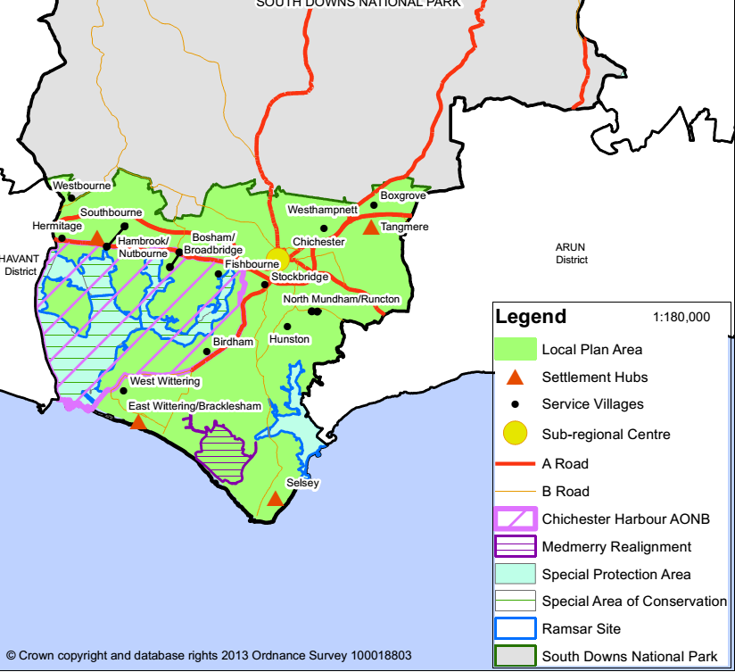

Map 2: Key Diagram (southern part) copied from Chichester Local Plan

4.10 The District Council is producing a Site Allocation Preferred Approach Development Plan Document which will help deliver the housing numbers and employment as set out in the adopted Chichester Local Plan: Key Policies 2014-2029. Consultation, which ran from 7th January to 18th February 2016, was the first formal stage in the preparation of this development plan document. Due to changes in the progress of some neighbourhood plans and further information provided on a previously discounted site, a further consultation was undertaken in July-September this year. The DPD has been published prior to its submission to the Secretary of State to allow for representations to be made on its soundness and legal compliance. The representation period for the Site Allocation Proposed Submission Development Plan Document finished on 26th January 2017. This did not affect the Parish of West Wittering.

4.11 This Site Allocation document states that Land at Chaucer Drive, West Wittering has provided the 50 houses that the Local Plan allocates for the settlement and therefore there are no further sites allocated.

4.12 Chapter 11 of the Site Allocation document refers to West Wittering. The only matter addressed relates to the settlement boundary. Policy 2 of the Chichester Local Plan indicates that settlement boundaries will be reviewed through “the preparation of Development Plan Documents and/or Neighbourhood Plans”. An assessment was undertaken of the West Wittering settlement boundary as part of work on the Site Allocations and the boundary has been amended to take account of the permitted exception site development at West Wittering.

4.13 Further plans and policies that will influence the SA and the West Wittering Neighbourhood Plan are set out in Appendix B.

5.0 BASELINE INFORMATION (STAGE 2)

5.1 This provides the basis for predicting and monitoring environmental effects and helps to identify environmental problems and alternative ways of dealing with them. In order to be able to identify the impact the neighbourhood plan will have on sustainable development, it is important to have an understanding of the baseline conditions that exist within the Parish.

Parish Character

5.2 The parish of West Wittering is located on the Manhood Peninsula in the southern portion of Chichester District in West Sussex. To the north is West Itchenor Parish, to the north east is Birdham Parish and its eastern boundary meets that of the Parish of East Wittering. Bracklesham Bay and the English Channel are located directly to the south, with Chichester harbour to the west.

5.3 The primary settlement is the village of West Wittering, which is located in the south west of the Parish. There is encroachment into the parish from the village of East Wittering, which overlaps the parish boundary in the south eastern corner.

5.4 A single B-road (B2179) runs through the Parish and this constitutes the primary transport link both into and out of the area. This provides connectivity to the City of Chichester and the main arterial A27 road located approximately 7 miles to the north. It also connects West Wittering to East Wittering, which is located approximately 1.5 miles to the east.

5.5 There are no railway stations in West Wittering Parish. The nearest mainline railway station is located in Chichester approximately 7 miles to the north. This provides rail links to Brighton in the east (with links to Gatwick and London) and Southampton to the west.

Geographic and historic background

5.6 West Wittering is a rural seaside village; one third of which is an Area of Outstanding Natural Beauty (ANOB). It is bordered on two sides by water on the western extremity of the Manhood Peninsular. The main settlement forms two sections separated by a significant green gap of farmland. The western part contains most of the historic property, the centre of which is a designated Conservation Area containing many listed buildings. The eastern section contains more modern post war property.

5.7 The area is also rich in biodiversity and recognised as internationally important habitat for birds, flora and fauna. As a result, parts of the area are protected from any inappropriate development because of their European designations which are there as a result of recognition of their importance for wildlife.

5.8 There is historic evidence of human activity in this area since the Paleolithic period with evidence of activity from Roman times. The earliest Church records show a church on the current site dating back to about 740. There is also recorded evidence of extensive agricultural activity in the area dating from 1778.

5.9 In more recent times there has been development pressure in the area and in order to protect the agricultural land from development, including the area abutting the beach, some of the land has been purchased by private companies with the aim of preventing inappropriate development.

5.10 The area has long been a destination for holiday makers and day trippers to the beach. This has had the effect on the village of creating traffic and parking issues and the rise in the number of second homes. West Wittering relies on one main road (A286 turning into the B2179) to the village from the A27

Settlement Pattern

5.11 West Wittering has a settlement pattern which is dispersed. The two main areas of housing are in the western historic part of the village and the more modern post war eastern part of the village. These two areas are separated by a significant green gap of farmland giving the two areas distinctive character differences and clear edges to those parts of the village envelope. There is further housing development along the edge of the sea which stretches from the west of the village to the east again with a gap of green space between the two areas of seafront housing.

5.12 Because of its agricultural heritage the area also has several dispersed dwellings comprising farmhouses and agricultural buildings. Overall the area has retained its rural feel and openness.

The Village Today

5.13 West Wittering, bordered on two sides by water, is situated at the western extremity of the Manhood peninsula facing Hayling Island across the entrance to Chichester Harbour. It is 7 miles south west of the city of Chichester in the county of West Sussex. The only main road access to the peninsula is from the A27 Chichester bypass and the A286 (which becomes the B2179).

5.14 West Wittering has more than 1,600 dwellings, a significant number of which are second homes. There are also several holiday parks, the overall effect being that the population of the village can vary hugely depending on the season with the population of the village doubling at the height of the summer season. This seasonal fluctuation in resident and visitor numbers creates a large demand for seasonal workers. The visitors also bring welcome revenue to help support the local shops and restaurants. They also create a demand for low cost accommodation for the seasonal workers which the village struggles to meet.

5.15 The village is well served by its several community buildings which are supported by local people who are able to participate in the many clubs and activities on offer. There are also several green spaces within the village offering sporting facilities including football tennis cricket croquet and petanque as well as play areas for children. There is also an extremely active sailing club. The network of footpaths and cycleways also offer excellent recreational opportunities for local people and visitors.

5.16 The village has its own primary school but its children have to travel to Chichester for secondary education. The village does have an excellent bus service into Chichester.

5.17 The village is extremely attractive to retired people and therefore the resident population of the village, whilst thriving, needs to encourage young people to set up home in the village to maintain a healthy balance of age groups. The high cost of housing and the lack of affordable housing property for rent is therefore a key concern.

5.18 The Parish is predominantly rural and is characterised by its close proximity to the English Channel and Chichester Harbour. Its landscape and relatively isolated geographical nature make it particularly popular amongst retirees and those seeking a getaway. However, these same features potentially hinder delivery of services to the locality and travel by residents to access services located elsewhere.

5.19 Development is primarily concentrated in the settlements of West Wittering, with additional development along the Strand in the south (adjacent to the beach) and encroaching from the village of East Wittering in the south east corner of the parish.

5.20 A limited range of services are available in West Wittering, as befits both its small geographical and population size. These includes a parish church, primary school. football and cricket clubs and a Village (Memorial) Hall. There are also a limited range of shops and services, many of which focus on tourists who visit the area to utilise the beach and landscape. The beach and sand dunes, together with the ease of access to the sea make the parish a popular visitor destination, especially during peak season.

Selected Parish Statistics

5.21 The following statistics and evidence are used to provide an overview of the status of the community in the Neighbourhood Plan area. The statistics are primarily drawn from the 2011 Census, as the Census represents the only occasion at which multiple and comparable parish-scale datasets are produced. Other sources of data or information are acknowledged where applicable.

Demographics

5.22 The usual resident population of the Parish is 2,700 people (1,233 male, 1,467 female). Of these:
- 293 People aged 15 and under (10.9% of Parish population compared to 16.4% across the District and 19% across England);
- 1,271 People aged 16 to 64 (47.1 % of Parish population compared to 59.1% across the District and 65% across England);
- 1,136 People aged 65 and over (42.1% of Parish population compared to 24.5% across the District and 16% across England)

Table 1 - Age structure of Parish

Age band | Parish Number 2011 | Parish  %  2011 | Parish Number 2001 | Parish  %  2001 | District Number 2011 | District  %  2011
0 to 4 | 79 | 2.9 | 100 | 3.6 | 5,652 | 5.0
5 to 7 | 48 | 1.8 | 47 | 1.7 | 3,375 | 3.0
8 to 9 | 30 | 1.1 | 33 | 1.2 | 2,255 | 2.0
10 to 14 | 118 | 4.4 | 108 | 3.9 | 6,092 | 5.4
15 | 18 | 0.7 | 22 | 0.8 | 1,259 | 1.1
16 to 17 | 29 | 1.1 | 46 | 1.6 | 2,368 | 2.1
18 to 19 | 45 | 1.7 | 51 | 1.8 | 2,890 | 2.5
20 to 24 | 93 | 3.4 | 102 | 3.7 | 6,200 | 5.4
25 to 29 | 68 | 2.5 | 65 | 2.3 | 5,150 | 4.5
30 to 44 | 310 | 11.5 | 341 | 12.2 | 18,823 | 16.5
45 to 59 | 501 | 18.6 | 582 | 20.8 | 23,286 | 20.5
60 to 64 | 225 | 8.3 | 203 | 7.3 | 8,550 | 7.5
65 to 74 | 529 | 19.6 | 479 | 17.1 | 13,770 | 12.1
75 to 84 | 398 | 14.7 | 441 | 15.8 | 9,832 | 8.6
85 to 89 | 135 | 5.0 | 118 | 4.2 | 2,761 | 2.4
90 and over | 74 | 2.7 | 56 | 2.0 | 1,531 | 1.3
All Usual Residents | 2,700 | 100.0 | 2,794 | 100.0 | 113,794 | 100.0

Economic status of residents

5.23 Of the 2,700 usual residents of the Parish, 1,800 were aged between 16 and 74 and 1,072 (59.6%) of whom were economically active*:

Category | Parish Number | Parish  % | District Number | District  %
Employed full-time | 427 | 23.7 | 27,847 | 34.4
Employed part-time | 254 | 14.1 | 11,384 | 14.0
Self-employed | 314 | 17.4 | 11,774 | 14.5
Unemployed | 48 | 2.7 | 2,267 | 2.8
Full-time students | 29 | 1.6 | 2,830 | 3.5

*Economically Active - All people usually resident in the area at the time of the 2011 Census aged 16 to 74 and who were economically active (either in employment, or not in employment but seeking work and ready to start work within two weeks, or waiting to start a job already obtained). As defined by ONS (2014).

5.24 728 (40.4%) of whom were economically inactive*:

Category | Parish  Number | Parish  % | District  Number | District  %
Retired | 537 | 29.8 | 14,773 | 18.2
Students | 39 | 2.2 | 3,590 | 4.4
Looking after home or family | 77 | 4.3 | 3,395 | 4.2
Long-term sick or disabled | 40 | 2.2 | 1,944 | 2.4
Other | 35 | 1.9 | 1,233 | 1.5

*Economically Inactive - All people usually resident in the area at the time of the 2011 Census aged 16 to 74, who were economically inactive (anyone who was not in employment and did not meet the criteria to be classified as unemployed). As defined by ONS (2014)

Occupations

5.25 Of the 1,023 residents in the Parish in employment and aged between 16 and 74:

Category | Parish  Number | Parish  % | District  Number | District  %
Managers, Directors and Senior Officials | 180 | 17.6 | 7,586 | 14.2
Professional Occupations | 166 | 16.2 | 9,983 | 18.7
Associate Professional and Technical Occupations | 124 | 12.1 | 6,957 | 13.1
Administrative and Secretarial Occupations | 108 | 10.6 | 5,219 | 9.8
Skilled Trades Occupations | 140 | 13.7 | 6,862 | 12.9
Caring, Leisure and Other Service Occupations | 82 | 8.0 | 5,170 | 9.7
Sales and Customer Service Occupations | 68 | 6.6 | 3,711 | 7.0
Process, Plant and Machine Operatives | 56 | 5.5 | 2,477 | 4.6
Elementary Occupations | 99 | 9.7 | 5,320 | 10.0

Qualifications & Skills

5.26 Of the 2,407 usual residents in the parish aged 16 and over:

Category | Parish  Number | Parish  % | District  Number | District  %
No qualifications | 576 | 23.9 | 18,566 | 19.5
Level 1 qualifications | 282 | 11.7 | 11,035 | 11.6
Level 2 qualifications | 387 | 16.1 | 15,164 | 15.9
Apprenticeship qualifications | 106 | 4.4 | 3,252 | 3.4
Level 3 qualifications | 235 | 9.8 | 12,149 | 12.8
Level 4 and above qualifications | 734 | 30.5 | 30,820 | 32.4
Other qualifications | 87 | 3.6 | 4,175 | 4.4

Housing

5.27 There are 1,352 households located within the Parish. Of these:

Category | Parish  Number | Parish  % | District Number | District  %
Owner-occupied households, owned outright | 816 | 60.4 | 20,210 | 40.5
Owner-occupied households, owner with a mortgage or loan | 278 | 20.6 | 13,271 | 26.6
Shared Ownership | 4 | 0.3 | 455 | 0.9
Social Rented from Council | 5 | 0.4 | 1,084 | 2.2
Social Rented Other | 66 | 4.9 | 6,323 | 12.7
Privately Rented | 151 | 11.2 | 7,423 | 14.9
Living Rent Free | 32 | 2.4 | 1,082 | 2.2

*A household is defined as one person living alone, or a group of people (not necessarily related) living at the same address who share cooking facilities and share a living room, sitting room or dining area. As defined by ONS (2014).

5.28 There are 1,740 dwellings located within the Parish. Of these:

Category | Parish  Number | Parish  % | District Number | District  %
Detached | 1,103 | 63.4 | 20,136 | 37.4
Semi-Detached | 340 | 19.5 | 14,688 | 27.3
Terraced | 145 | 8.3 | 9,910 | 18.4
Purpose built flat, maisonette or apartment | 118 | 6.8 | 6,947 | 12.9
Flat, maisonette or apartment – part of converted/shared house | 15 | 0.9 | 1,167 | 2.2
Flat, maisonette or apartment – in commercial building | 13 | 0.7 | 555 | 1.0
Caravan or other mobile or temporary structure | 6 | 0.3 | 473 | 0.9

*A dwelling is a unit of accommodation with all rooms, including kitchen, bathroom and toilet behind a door that only that household can use. As defined by ONS (2014).

Transport

5.29 Of the 1,352 households:

Category | Parish  Number | Parish  % | District Number | District  %
Households with no car or van | 218 | 16.1 | 7,781 | 15.6
Households with 1 car or van | 588 | 43.5 | 20,934 | 42.0
Households with 2 cars or vans | 403 | 29.8 | 15,342 | 30.8
Households with 3 cars or vans | 97 | 7.2 | 3,984 | 8.0
Households with 4 or more cars or vans | 46 | 3.4 | 1,807 | 3.6

Biodiversity

5.30 The information set out below is gathered from Magic (www.magic.gov.uk), a government operated website which brings together datasets from a number of different government agencies.
- No part of the parish is located in an area designated as a National Park.
- One third of the parish is designated as an Area of Outstanding Natural Beauty.

5.31 Two Sites of Special Scientific Interest (SSSI) exist within the parish:
- Bracklesham Bay SSSI – which runs from the border with East Wittering Parish westwards to a point just west of Berrybarn Lane. It extends approximately 2-300 meters out to sea in a zone extending from just above the mean high water mark;
- Chichester Harbour SSSI, Ramsar, SPA, SAC - extends along the entire western edge of the parish, including East Head and The Spit to a line between Snow Hill Caravan Site and the Chalet. It covers all areas on the seaward side of the mean high water mark.

5.32 Redlands Meadow, Redlands Lane is designated a Site of Nature Conservation Interest (SNCI). West Wittering Beach is also a SNCI. There are no national or local nature reserves within the Parish. The Parish contains areas identified by Natural England as Priority Habitats and are subject to Habitat Action Plans:

Maritime:
    - Maritime Cliffs and Slopes Priority Habitat – extending in a narrow strip (up to 60m wide) in the area inland of the mean high water mark, running from Marine Drive West in the east of the Parish along the coast to the car park located to the west of the Chalet.
    - Coastal and Floodplain Grazing Marsh Priority Habitat – 4 main areas. 1 area (0.03 hectares) located on the coast directly to the north of Wyke House. 1 area (0.34 hectares) located south west of Snow Hill. 1 area (0.65 hectares) located directly south of the sailing club at Coastguard Lane. 1 area (0.03 hectares) located at the base of The Spit on the landward side.
    - Coastal vegetated Shingle Priority Habitat – 1 area (0.76 hectares) located north-west of East Head.
    - Coastal Sand Dunes Priority Habitat – 1 area (3.4 hectares) covering the eastern portion of The Spit.
    - Mudflats Priority Habitat – 2 main areas: 1 area (3.3 hectares) to the south west of Ella Nore and 1 area (1.6 hectares) extending northwards from Regnum Court along the coast.

Grassland:
    - Purple Moor Grass and Rush Pastures Priority Habitat – 1 area (3.36 hectares) located in a strip inland of The Chalet, extending westwards from the end of West Strand approximately 500 metres on a north-westerly direction.
    - Coastal and Floodplain Grazing Marsh Priority Habitat – Multiple adjoining areas (approximately 5 hectares in size), located to the south of Roman Landing from Snow Hill in the west to the pumping station in the east.

Woodland:
    - Deciduous Woodland Priority Habitat – 5 areas. 2 areas adjacent to each other (approximately 0.8 hectares) located approximately 200 metres east of Court Barn. 3 areas adjacent to each other (approximately 1 hectare) located directly south of the school on Pound Road.
    - Traditional Orchards Priority Habitat – 1 area (0.9 hectares) located to the north of Redlands Lane adjacent to the boundary with West Itchenor Parish.
    - Tree Preservation Orders (TPO) – whilst there are numerous individual and group TPOs within the Parish, it is worth noting the two woodland TPOs – woodland at Redlands Lane (ref 02/01147/TPO) and near South Cottage, Rookwood Lane (ref 77/01131/TPO).

5.33 The following areas are subject to an Environmental Stewardship Agreement:
Entry Level Stewardship Scheme:
    - Multiple areas – consisting of all of the non-developed land area located to the west of East Wittering and to the south of West Wittering. Approximately 90% of the area in the north-west corner of the parish, covering land to the north of the B2179 road at Malthouse Cottages.
Entry Level plus Higher Level Stewardship Scheme:
    - Not applicable
Higher Level Stewardship Scheme:
    - Not applicable
Organic Entry Level Stewardship Scheme:
    - Not applicable
Organic Entry Level plus Higher Level Stewardship Scheme:
    - Not applicable

5.34 The following areas are in Woodland Grant Scheme 3:
- 1 area (Itchenor Park Woodlands) of 8.8 hectares, located approximately 200 metres east of Court Barn in the north-west corner of the Parish.

Heritage

5.35 The English Heritage classification of Listed Buildings shows that the Parish of West Wittering contains the following Grade I listed buildings and structures including:
- THE PARISH CHURCH OF ST PETER AND ST PAUL, POUND ROAD, West Wittering, Chichester, West Sussex
Grade II Listed:
- THE DOG AND DUCK, POUND ROAD, West Wittering, Chichester, West Sussex
- COBNOR HOUSE, POUND ROAD, West Wittering, Chichester, West Sussex
- CYMENS COTTAGE, POUND ROAD, West Wittering, Chichester, West Sussex
- REDLANDS FARMHOUSE, REDLANDS LANE, West Wittering, Chichester, West Sussex
- REDLANDS FARM COTTAGE, REDLANDS LANE, West Wittering, Chichester, West Sussex
- ROOKWOOD HOUSE, ROOKWOOD LANE, West Wittering, Chichester, West Sussex
- SEACOT, ROOKWOOD ROAD, West Wittering, Chichester, West Sussex
- JONQUIL, ROOKWOOD ROAD, West Wittering, Chichester, West Sussex
- WALNUT TREE HOUSE, ROOKWOOD ROAD, West Wittering, Chichester, West Sussex
- GUY'S FARMHOUSE, BIRDHAM ROAD, West Wittering, Chichester, West Sussex
- HUTLAND FARMHOUSE, BIRDHAM ROAD, West Wittering, Chichester, West Sussex
- PIGGERY HALL, PIGGERY HALL LANE, West Wittering, Chichester, West Sussex
- WHITE COTTAGE, BIRDHAM ROAD, West Wittering, Chichester, West Sussex
- NEWARK FARMHOUSE, BIRDHAM ROAD, West Wittering, Chichester, West Sussex
- ELMTREE COTTAGE, ELM LANE, West Wittering, Chichester, West Sussex
- BUILDING DIRECTLY NORTH WEST OF HUNTLAND FARMHOUSE, BIRDHAM ROAD, West Wittering, Chichester, West Sussex
- THE STUDIO, ROOKWOOD ROAD, West Wittering, Chichester, West Sussex
- NUNNINGTON FARMHOUSE, ROOKWOOD ROAD, West Wittering, Chichester, West Sussex
- NORE HOUSE, SNOW HILL, West Wittering, Chichester, West Sussex
- COASTGUARD COTTAGES, 1-9, SNOW HILL, West Wittering, Chichester, West Sussex
- HALE FARMHOUSE, BIRDHAM ROAD, West Wittering, Chichester, West Sussex
- WOODBINE COTTAGE, CAKEHAM ROAD, West Wittering, Chichester, West Sussex
- ELMSTEAD HOUSE, ELM LANE, West Wittering, Chichester, West Sussex
- STONES COTTAGE, POUND ROAD, West Wittering, Chichester, West Sussex
- POUNCES COTTAGE, POUND ROAD, West Wittering, Chichester, West Sussex
- RAMBLER COTTAGE, POUND ROAD, West Wittering, Chichester, West Sussex
- LITTLE PLACE, REDLANDS LANE, West Wittering, Chichester, West Sussex
- SOUTH COTTAGE, ROOKWOOD LANE, West Wittering, Chichester, West Sussex
- K6 TELEPHONE KIOSK, POUND ROAD, West Wittering, Chichester, West Sussex
Grade II* Listed:
- CAKEHAM MANOR, CAKEHAM ROAD, West Wittering, Chichester, West Sussex
Scheduled Monuments:
- Cakeham Manor (uninhabited parts) West Wittering, Chichester, West Sussex

5.36 The village centre of West Wittering is designated as a conservation area.

6.0 SUSTAINABILITY ISSUES (Stage 3)

6.1 As part of the Sustainability Appraisal it is necessary to identify the key sustainability issues facing the town. These have been informed through the following sources:

- A review of the plans and policies outlined in the Chichester Local Plan Sustainability Appraisal.
- Collection and analysis of baseline data (Section 5 of this report)
- The Focus Groups SWOT results (Strength, Weaknesses, Opportunities, Threats).
- Feedback from local community and consultation events to date.

6.2 Set out below is a summary of the key issues which need to be considered in the preparation of the Neighbourhood Plan. These have been identified through the early community engagement and the work of the steering group.

  - Protecting the character and setting of the surrounding landscape, especially the AONB.
  - Protecting the distinct identity of the village and sense of community.
  - Meeting affordable housing needs within the Parish and other identified housing need such as housing for those that wish to downsize.
  - Protection of heritage assets and their settings.
  - Ensuring highway safety and avoiding congestion.
  - Protect and enhance the character and offer of local centre facilities.
  - Protect areas of environmental quality and value and areas of European, national and local ecology and biodiversity conservation.
  - Manage the impact of tourists and second homes on the social, economic and environmental fabric of the parish.
  - Any surface water or other flood risk that the parish suffers from.
  - Improve accessibility for pedestrians, cyclists
  - Develop a green infrastructure plan that improves recreation and leisure opportunities within the parish.
  - Community facilities to be retained, maintained and improved.
  - Support an increase in local employment opportunities and other benefits to the local economy.

6.3 The Focus groups, at their visioning workshop meeting in June 2016 identified the following:

HOUSING AND INFRASTRUCTURE GROUP
Strengths: none recorded
Weaknesses: Infrastructure; roads, ditches, capacity of sewage system
Opportunities: Community Land Trust
Challenges: To provide accommodation for young people to stay and residents who want to downsize.

COMMUNICATIONS AND MARKETING GROUP
Strengths: Parish Newsletter; Facebook Page; Website; Email Account
Weaknesses: Divided between the east and west of the parish.
Opportunities: To engage with those residents; make use of the internet/social media; to generate an inclusive community.
Challenges: Finding ways of engaging everyone

HERITAGE AND ENVIRONMENT
Strengths: Rural character, conservation area, estate companies, beach and harbour, sea, wildlife, dark skies
Weaknesses: Infrastructure; public transport; drainage; telecoms – 60-year-old cables.
Opportunities: Development of cycle paths; maintaining footpaths
Challenges: to manage the traffic issues, visitors; safeguarding the area

BUSINESS AND EMPLOYMENT (INCLUDING TOURISM)
Strengths: Location; Sea; Tourism
Weaknesses: Day visitors (do not contribute much to the economy)
Opportunities: To provide high quality accommodation so that people will stay over
Challenges: How do we get them to stay? Few facilities – also e.g. meeting rooms

6.4 The Environmental Assessment of Plans and Programmes Regulations (2004) suggests that a SA should describe the ‘baseline environment’ within the plan area (the parish in this case) in terms of a number of topics. These are highlighted in the table below and provide grouped under the sustainability objective headings set out in the next chapter.

West Wittering Neighbourhood Plan: Linking Sustainability Appraisal topics to Issues and Trends

Title | Source | Data | Trends and consequences
Nature Conservation and Habitats | Chichester Local Plan Key Policies 2014 – 2029. Chapter 10 The Environment. Policy 43 and 44, 48 and 49  Chichester Local Plan Key Policies 2014 – 2029 Sustainability Appraisal 2014 and Habitats Regulation Assessment 2014.  .  Chichester Harbour Management Plan 2009-2014  Chichester Harbour AONB Design Guidelines for New Dwellings and Extensions  (2010)  Habitat Regulations  Assessment (HRA) of its emerging Site Allocation Development Plan 2016.  Interim Solent Recreation  Mitigation Strategy 2104  Work being undertaken by the WWNP Heritage and Environment focus group 2016/2017 | The Chichester Harbour AONB covers approximately 1/3 of the parish’s land area.  There are 2 Sites of Special Scientific Interest (SSSI) exist within the parish - Bracklesham Bay SSSI and Chichester Harbour SSSI which is also forms part of the Chichester and Langstone Harbours Ramsar area, the Chichester and Langstone SAC.  The Parish contains areas identified by Natural England as Priority Habitats and are subject to Habitat Action Plans, such as: Maritime Cliffs and Slopes Priority Habitat, Coastal and Floodplain Grazing Marsh Priority Habitat, Coastal Vegetated Shingle Priority Habitat, Coastal Sand Dunes Priority Habitat, Mudflats Priority Habitat, Purple Moor Grass and Rush Pastures Priority Habitat, Coastal and Floodplain Grazing Marsh Priority Habitat, Deciduous Woodland Priority Habitat, Traditional Orchards Priority Habitat.  There are areas subject to Environmental Stewardship Agreement and Schemes. There are Woodland Grant Scheme 3 areas in the parish. | Development has the potential to harm biodiversity both directly and indirectly. Direct effects include loss of land to new development, whereas indirect effects include increased traffic resulting in a decline in air quality, which can impact habitats and species some distance from a development site. Development does however have potential to create places for biodiversity. Development proposals should seek to enhance biodiversity through a range of measures, including enhancements either on or off the site.  With West Wittering containing many areas of nature conservation interest and protection including those of international designation, policies in the neighbourhood plan will need to focus on retaining and enhancing these valuable assets. Any sites allocated for development in particular will need to be appraised according to their impact on nature conservation.
Landscape | Chichester Local Plan Key Policies 2014 – 2029. Policy 43  Chichester Local Plan Key Policies 2014 – 2029 Sustainability Appraisal 2014  Chichester Harbour Management Plan 2009-2014  Landscape Capacity Assessment 2009 and Extension 2011.  Chichester Harbour AONB Design Guidelines for New Dwellings and Extensions (2010)  Work being undertaken by the WWNP Heritage and Environment focus group 2016/2017 | Designated for its national importance in terms of landscape and scenic quality, sections of the parish are within the Chichester Harbour AONB. It is a unique landscape comprising sheltered open water areas with contrasting narrow channels. The largely flat hinterland includes highly productive farmland, as well as woodlands and hedgerows that contribute to the rural character of the area. The flatness of the landscape makes the AONB particularly vulnerable to visual intrusion from inappropriate development.  In the Landscape Capacity Assessment, the parish falls within the Wittering Coastal strip character area. The key characteristics of this character area include open coastal grassland, marsh and large arable fields plus linear, coastal development of detached houses. The assessment also notes that car borne summer holiday traffic and busy car parks diminish tranquillity. | Development has the potential to harm protected landscapes. Major development will not normally be permitted. However, there may be cases where small scale development that helps to maintain economic or social well-being in or adjoining the protected landscapes may be necessary. Development close to the edge of the AONB has the potential to have adverse impacts on the qualities of these landscapes.  Policies within the neighbourhood plan will need to consider the natural beauty and public enjoyment of the AONB
Listed Buildings & Conservation Areas | Chichester Local Plan Key Policies 2014 – 2029. Policy 47  Chichester Local Plan Key Policies 2014 – 2029 Sustainability Appraisal 2014  West Wittering Conservation Area character appraisal 2006  Settlement Capacity Profiles 2013  Work being undertaken by the WWNP Heritage and Environment focus group 2016/2017 | In West Wittering there are 31 listed buildings including a Grade 1 – the Parish Church of St Peter and St Paul. There is a conservation area in the parish.  There is 1 Scheduled Monument.  The Conservation Area appraisal concludes that the most significant features are:  - Well preserved rural village located slightly inland from the sea;  - Pound Road is the principal street and connects the church to the village green;  - St Peter and St Paul’s Church, dating to the 11th century, and listed grade I;  - Survival of a 17th century cottage;  - Collection of 18th and 19th century listed buildings along Pound Road and Rookwood Road;  - Elmstead, Elms Lane, the home between 1917 and 1933 of Sir Henry Royce of Rolls Royce;  - Farm buildings in Elms Lane with thatched roofs;  - Proximity of Cakeham Manor House, with its 13th century undercroft;  - Wide variety of materials: thatch, handmade clay peg tiles for roofs and walls, flint - both as cobbles and knapped, red brick, white painted stone or render, some Mixen stone, some imported limestone on the church. | The parish has a number of listed buildings and a Scheduled Monument as well as a conservation area and therefore any new development is sensitive to the character of those heritage assets and their settings. Understanding the cultural heritage of the Parish is important as it guides settlement patterns and influences decisions about the design and materials used in development. The historic environment also has a key role to play in the local economy.  These will be key considerations in the allocation of sites and neighbourhood plan policies.
Water - Flooding | Chichester Local Plan Key Policies 2014 – 2029. Policy 42  Chichester Local Plan Key Policies 2014 – 2029 Sustainability Appraisal 2014  Strategic Flood Risk Assessment of Chichester District Council 2008  Beachy Head to Selsey Bill Shoreline Management Plan (2006)  Environment Agency map  Work being undertaken by the WWNP Housing & Infrastructure group 2016/2017 | Much of the south and south west of the parish falls within flood zone 3 (high probability). Along West Itchenor and West Wittering the shoreline is subject to some flooding and erosion. Minor works have been undertaken to prevent further damage and loss of footpath (East Solent Coastal Group, 1997). There are sand spits on East Head that help protect part of West Wittering. The defences along West Wittering are made up of a mixture of shingle and sand beaches backed by concrete walls and timber breastworks. The failure of these defences would lead to the loss of 550 properties. The timber groynes and breastwork are in poor condition, however the shingles along the defences are replenished naturally. | Assessment of any potential sites to be allocated in the neighbourhood plan will need to ensure priority is given to those with the lowest risk of flooding plus any development that would result in an increased flood risk elsewhere will need to be scrutinised. New development in areas particularly susceptible to surface water flooding will need to effectively demonstrate they can mitigate the risk of flooding without having adverse effects on surrounding areas.
Human population - housing | Chichester Local Plan Key Policies 2014 – 2029. Policy 5, 33, 34  Chichester Local Plan Key Policies 2014 – 2029 Sustainability Appraisal 2014  Assessment of Housing Development Needs Study: Sussex Coast HMA 2014  Coastal West Sussex Strategic Housing Market Assessment Update 2012  Strategic Housing Land Availability Assessment 2014  Work being undertaken by the WWNP Housing & Infrastructure group 2016/2017 | The cost of housing has risen to levels that make it increasingly difficult for young people and especially families to set up home independently and remain in the Parish. With many houses being second homes, this has caused problems within the local housing market by reducing the numbers available for local people.  There are 1,136 people aged 65 and over in the parish (42.1% of Parish population compared to 24.5% across the District and 16% across England). The steering group has already identified that there are limited opportunities for residents to find houses that they can ‘downsize’ into. | The steering group focus group will continue with their background research for the NP. Whilst a decision on allocating sites for housing has not been considered yet, if it does, the neighbourhood plan will need to carefully consider the right mix of development if it to include a variety of housing sizes, types and tenures to meet the needs of the local community if it is agreed that the plan will allocate housing sites. Other matters such as location and accessibility as well as design and layout will need to be assessed.
Human population - employment | Chichester Local Plan Key Policies 2014 – 2029. Policy 3, 26, 30  Chichester Local Plan Key Policies 2014 – 2029 Sustainability Appraisal 2014  Employment Land Review update 2013  Retail study 2010  Tourism Study 2006  Work being undertaken by the WWNP Business & Employment group 2016/2017 | The baseline information within this report provides some background on the percentage of the local population that are employed and the types of jobs that people hold.  The work of the Business & Employment group will be looking and assessing the levels of employment floor space within the parish. However, West Wittering is a popular holiday destination and jobs of a temporary nature increase with summer activities. The car park at West Wittering beach has been running as a successful commercial venture since the early 1920’s. Visitors help generate welcome revenue for the local shops, hostelries and eating places.  West Wittering has a largely agricultural past, and farming still continues to flourish, especially in the outlying areas.  West Wittering has an array of small, individually run shops, 2 pubs, several B&Bs, a beach cafe and a restaurant. | The steering group focus group will continue with their background research for the NP. The neighbourhood plan will need to consider the level and quality of employment space within the parish, the possibilities to diversify farm buildings and the whether there is a need to allocate new employment floor space as well as protect existing. There is a need to accommodate the tourism sector and provide opportunities for visitors to stay overnight. The impact of this on nature and heritage conservation will need to be taken into account. In order to support a diverse mix of resident population, facilities for young people to live and work within the parish may need to be considered.
Human Health – Community assets, green infrastructure and open space | Chichester Local Plan Key Policies 2014 – 2029. Policy 38, 52, 54  Chichester Local Plan Key Policies 2014 – 2029 Sustainability Appraisal 2014  Open Space Study 2013 | The football and cricket clubs have newly built pavilions, attracting large numbers of children and adults. The Sailing Club at Snowhill Creek is popular with local families and provides access to Chichester Harbour. The football pavilion is also used for other activities including a youth club and parish office. The cricket pavilion, as well as the Memorial Hall, is used for private functions. There are also new tennis courts for public use at the Millennium Field  The Church of St Peter and St Paul is well supported  There is already an extensive network of social and leisure groups functioning in the community  There is a large Health Centre serving the Witterings and surrounding villages, a care home, an assisted living home and a sports/country club. Sporting facilities include sailing, windsurfing, tennis, horse riding, football, cricket, croquet and pétanque. | Communities will only be sustainable if they are fully inclusive and deliver the necessary standards of services and facilities. The neighbourhood plan should consider the needs of the community and options for the retention and improvement of facilities as well as ensure the existing ones are not lost through development.
Infrastructure - transport | Chichester Local Plan Key Policies 2014 – 2029. Policy 39  Chichester Local Plan Key Policies 2014 – 2029 Sustainability Appraisal 2014  Transport Study 2013 | West Wittering relies on one main road (A286 turning into the B2179) to the village from the A27.  There are over 17 miles of public footpaths and one public bridleway. The majority of footpaths are inland, and tend to follow the field boundaries or drainage ditches, although the most popular path is the 5-mile long harbour and coastal footpath (No 1). This defines a large part of the parish boundary, as it follows the shoreline and turns into Chichester Harbour.  The Salterns Way (constructed in 2005) is an 18km cycle and wheelchair route from the centre of Chichester to the sand dunes of East Head. | The neighbourhood plan would need to consider the location of development in terms of accessibility to facilities and transport links as well as improvements to footpaths and infrastructure to allow better access to services.

7.0 APPRAISAL FRAMEWORK (Stage 4)

7.1 In the light of the relevant sustainability issues noted above and of the available data, the Parish Council proposes to establish the following framework of environmental, social and economic objectives and measures in order to identify any likely significant environmental, social and economic effects.

7.2 This Sustainability Appraisal seeks to test the contribution that the West Wittering Neighbourhood Plan will make towards achieving sustainable development. The first part of this process is identification of a number of objectives and indicators, presented below in the Sustainability Framework. These objectives and questions will be used to inform the neighbourhood plan by assessing the sustainability impacts of the options considered and policies taken forward in the plan. The objectives are based on the three strands of sustainability - environmental, social and economic. The Sustainability Framework has emerged through careful appraisal of higher-level plans, the collection of baseline data and local knowledge of sustainability challenges faced in the Parish.

7.4 The sustainability objectives and indicators (the Sustainability Framework) of the West Wittering Neighbourhood Plan are as follows:

Objective | Indicators | Category
1. Housing  To provide housing in sustainable locations and to provide a range of housing types and sizes to all everyone the opportunity to live in an affordable home within the Parish. | Number of new home completions;  Number of affordable dwelling completions. | Social
2. Sustainable Transport  To increase the opportunities for residents and visitors to travel by sustainable and non-car modes of transport | Number of new sustainable and public transport facilities provided in the Parish, such as bus shelters, and pedestrian crossings, etc.  Number of households within a 10-minute walk (approximately 800m) of a bus stop. | Social
3. Community and recreational facilities  To maintain and enhance community infrastructure within the Parish to include community facilities, areas of open space and recreational facilities | Quantum of new community infrastructure delivered in the Parish;  Number of households within a 10-minute walk (approximately 800m) of public  recreational space. | Environmental
4. Heritage Assets  To protect or enhance the heritage assets of the Parish to include listed buildings, conservation areas and any locally designated assets. | Number of heritage assets and their setting protected as part of development. | Environmental
5. Countryside and Landscape  To conserve and enhance the countryside of the Parish and the landscape character areas valued by the community. | Number of new residential dwellings approved within the Parish beyond the defined settlement boundaries and areas allocated for development. | Environmental
6. Flood Risk  To ensure development does not take place in areas at risk of flooding or where it may cause  flooding elsewhere | Number of properties at risk of flooding within the Parish, as defined by the Environment Agency Flood Maps. | Environmental
7. Ecology and Biodiversity  To protect and enhance the biodiversity of the Parish both areas of value to local residents and nationally and internally designated areas. | Number of enhancement schemes incorporated into development. | Environmental
8. Local Businesses  To maintain existing employment areas and support local businesses | Total amount of employment floor space created in the Parish  Amount of employment floor space lost to other uses in the Parish | Economy

8.0 NEXT STEPS

8.1 The conclusions of this consultation will be considered by the Parish Council in finalising the SA/SEA assessment framework. That framework will then inform the formulation of the Pre Submission WWNP and will be set out and employed in the accompanying Draft SA/SEA report. It is expected that draft WWNP policies will be formulated and assessed against one or more reasonable alternatives to ensure any significant environmental effects have been identified and any necessary mitigation measures are included in the policies.

APPENDIX A

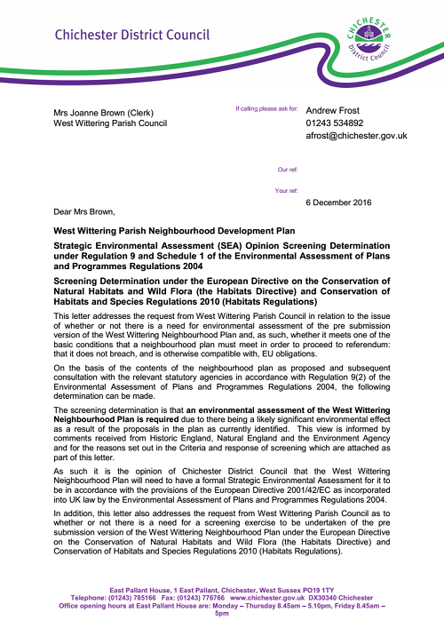
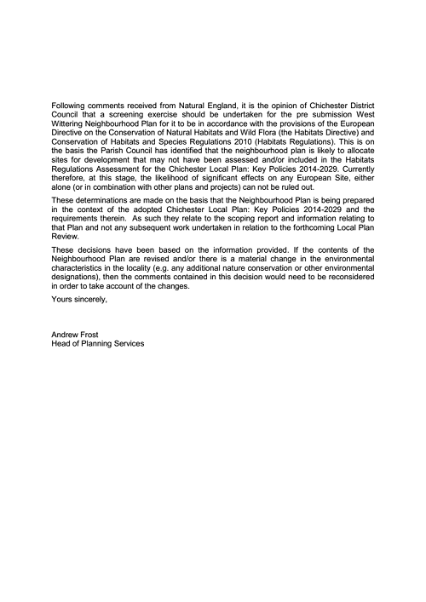

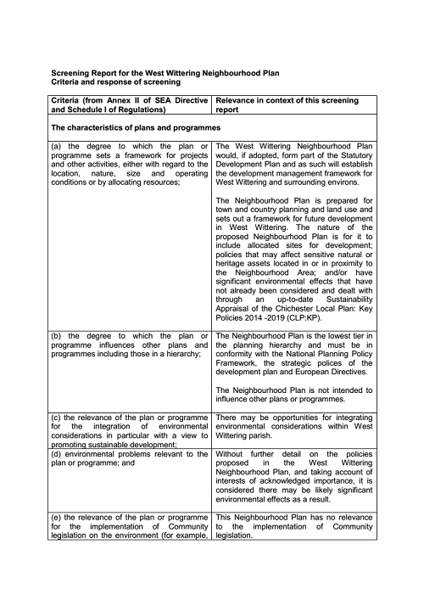

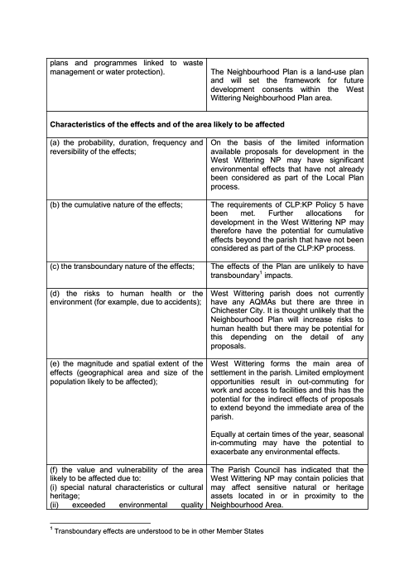

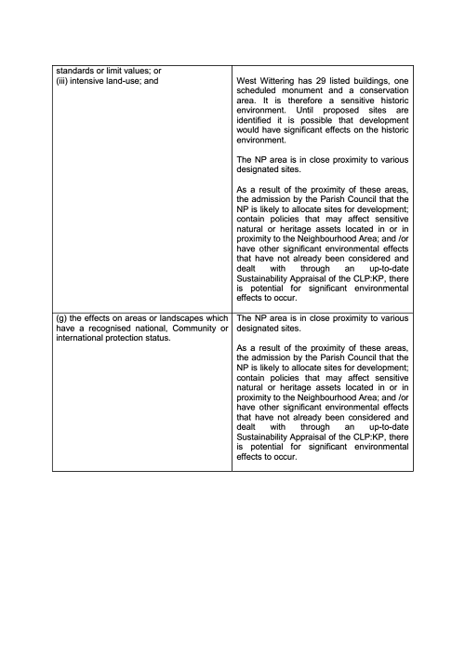
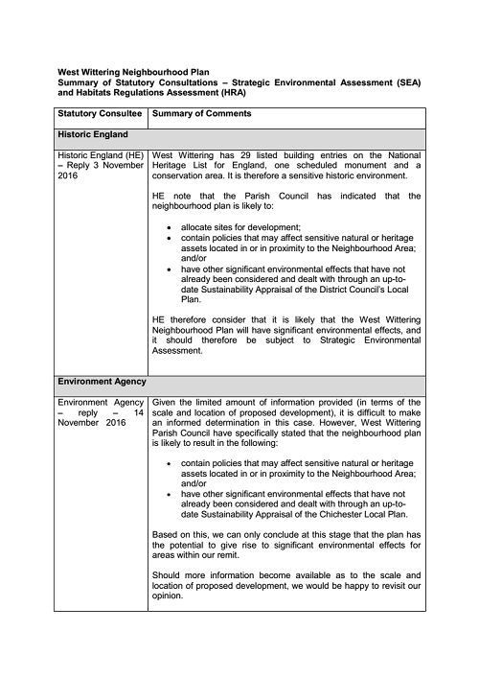
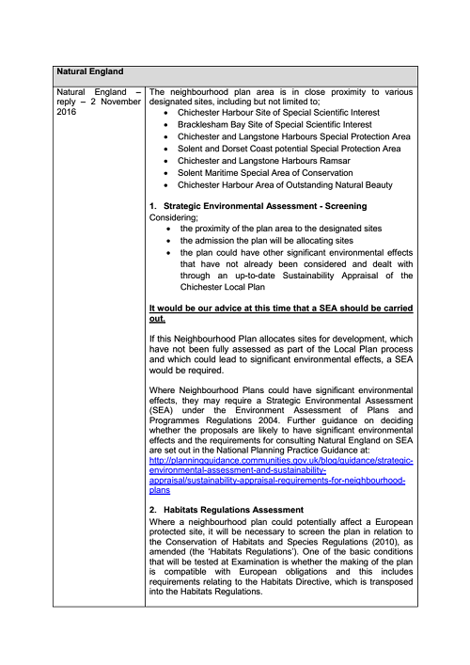

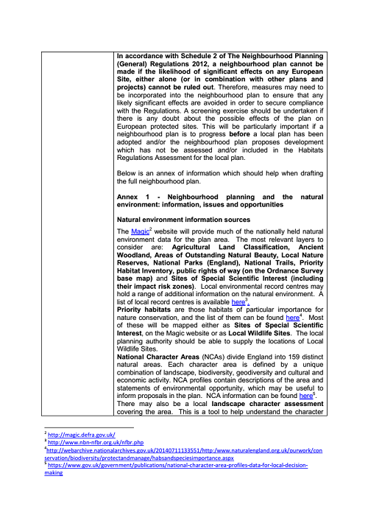
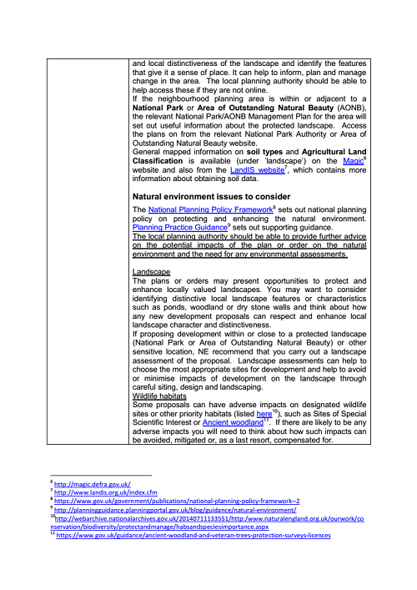
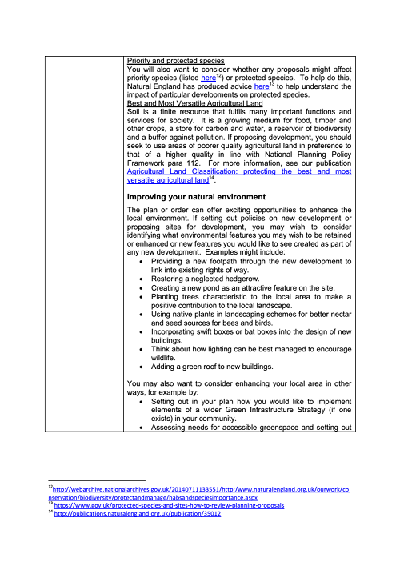
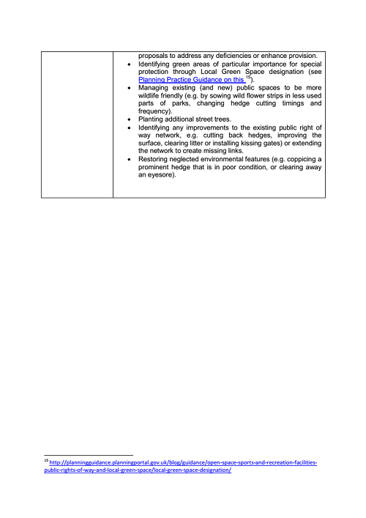

APPENDIX B

KEY POLICY DOCUMENTS AND STRATEGIES

Neighbourhood plans form the bottom tier of the planning system and so are influenced by various higher level plans, policies and guidance. These various publications have informed the Scoping Report.

- The National Planning Policy Framework (2012)
- National Planning Practice Guidance (2014)
- Chichester Local Plan Key Policies 2014 – 2029.
- Chichester Local Plan Key Policies 2014 – 2029 Sustainability Appraisal 2014 and Habitats Regulation Assessment 2014.
- Site Allocation Preferred Approach Development Plan Document – Proposed Submission 2016.
- Chichester Harbour Management Plan 2009-2014
- Chichester Harbour AONB Design Guidelines for New Dwellings and Extensions (2010)
- Habitat Regulations Assessment (HRA) of its emerging Site Allocation Development Plan 2016.
- Interim Solent Recreation Mitigation Strategy 2104
- Chichester Harbour Management Plan 2009-2014
- Landscape Capacity Assessment 2009 and Extension 2011.
- Chichester Harbour AONB Design Guidelines for New Dwellings and Extensions (2010)
- Strategic Flood Risk Assessment of Chichester District Council 2008
- Beachy Head to Selsey Bill Shoreline Management Plan (2006)
- West Wittering Conservation Area character appraisal 2006
- Settlement Capacity Profiles 2013
- Assessment of Housing Development Needs Study: Sussex Coast HMA 2014
- Coastal West Sussex Strategic Housing Market Assessment Update 2012
- Strategic Housing Land Availability Assessment 2014
- Open Space Study 2013
- Employment Land Review update 2013
- Retail study 2010
- Tourism Study 2006
- Transport Study 2013

http://planningguidance.communities.gov.uk/blog/guidance/strategic-environmental-assessment-and-sustainability-appraisal/sustainability-appraisal-requirements-for-neighbourhood-plans/
https://www.gov.uk/government/uploads/system/uploads/attachment_data/file/6077/2116950.pdf
http://www.chichester.gov.uk/CHttpHandler.ashx?id=18557&p=0
http://www.chichester.gov.uk/newlocalplan
This information has been taken from the Contextual Evidence Paper produced by Action in Rural Sussex for the NP steering group and the West Wittering NP Design Document draft Jan 2017
https://www.neighbourhood.statistics.gov.uk/dissemination/LeadTableView.do?a=7&b=11130414&c=west+wittering&d=16&e=62&g=6473893&i=1001x1003x1032x1004&m=0&r=1&s=1477927859236&enc=1&dsFamilyId=2474
https://www.neighbourhood.statistics.gov.uk/dissemination/LeadTableView.do?a=7&b=11130414&c=west+wittering&d=16&e=62&g=6473893&i=1001x1003x1032x1004&m=0&r=1&s=1477927859236&enc=1&dsFamilyId=2474
https://www.neighbourhood.statistics.gov.uk/dissemination/LeadTableView.do?a=7&b=11130414&c=west+wittering&d=16&e=62&g=6473893&i=1001x1003x1032x1004&m=0&r=1&s=1477927859236&enc=1&dsFamilyId=2541
https://www.neighbourhood.statistics.gov.uk/dissemination/LeadTableView.do?a=7&b=11130414&c=west+wittering&d=16&e=62&g=6473893&i=1001x1003x1032x1004&m=0&r=1&s=1477927859236&enc=1&dsFamilyId=2536
Level 1 qualifications cover: 1-4 O Levels/CSE/GCSEs (any grades), Entry Level, Foundation Diploma, NVQ level 1, Foundation GNVQ, Basic/Essential Skills.
Level 3 Qualifications cover: 2+ A Levels/VCEs, 4+ AS Levels, Higher School Certificate, Progression/Advanced Diploma, Welsh Baccalaureate Advance Diploma, NVQ Level 3; Advanced GNVQ, City and Guilds Advanced Craft, ONC, OND, BTEC National, RSA Advanced Diploma.
Level 4 and above qualifications cover: Degree (BA, BSc), Higher Degree (MA, PhD, PGCE), NVQ Level 4-5, HNC, HND, RSA Higher Diploma, BTEC Higher level, Professional Qualifications (Teaching, Nursing, Accountancy).
Vocational/Work-related Qualifications, Foreign Qualifications (Not stated/ level unknown).
https://www.neighbourhood.statistics.gov.uk/dissemination/LeadTableView.do?a=7&b=11130414&c=west+wittering&d=16&e=62&g=6473893&i=1001x1003x1032x1004&m=0&r=1&s=1477927859236&enc=1&dsFamilyId=2482
https://www.neighbourhood.statistics.gov.uk/dissemination/LeadTableView.do?a=7&b=11130414&c=west+wittering&d=16&e=62&g=6473893&i=1001x1003x1032x1004&m=0&r=1&s=1477927859236&enc=1&dsFamilyId=2481
https://www.neighbourhood.statistics.gov.uk/dissemination/LeadTableView.do?a=7&b=11130414&c=west+wittering&d=16&e=62&g=6473893&i=1001x1003x1032x1004&m=0&r=1&s=1477927859236&enc=1&dsFamilyId=2483
http://magic.defra.gov.uk/
http://magic.defra.gov.uk/
https://historicengland.org.uk/listing/the-list/
Matters relating to air, climate, soils are not included in this table but can be added to at a later stage if it is felt these should be scoped into the SA. Human health is addressed through open space and recreation and human population through housing and employment.

