Insert logo

West Wittering Neighbourhood Plan

Local Green Spaces Report

Introduction (see example below in red)

Within our Parish there are a range of open green spaces we value and wish to enhance and protect from development of any kind. Some of these are important for leisure and recreation and provide play areas for children and for organised games.
There are some nationally recognised sites of importance and others are simple areas of green space with grass and trees which may have a historical association with a past development. They visually enhance the built up areas, at the same time providing important corridors and habitat for wildlife. They help to support and improve biodiversity of the local wildlife and bring it closer to the community, reduce the risk of flooding, and improve the air quality.

What does it mean?

Within a Neighbourhood Planning process, communities can designate certain areas of land as Local Green Spaces. This is as described in the National Planning Policy Framework (NPPF) as “a way to provide special protection against development for green areas of particular importance to local communities.”

NPPF and Local Green Spaces

The National Planning Policy Framework (NPPF) paragraphs 76-78 states that specific areas of land that are demonstrably special to the local community may be protected against development through designation as Local Green Space (LGS) and can be applied through a Neighbourhood Plan. The Local Green Space designation should only be used:

- where the green space is in reasonably close proximity to the community it serves;
- where the green area is demonstrably special to a local community and holds a particular local significance, for example because of its beauty, historic significance, recreational value (including as a playing field), tranquillity or richness of its wildlife; and
- where the green area concerned is local in character and is not an extensive tract of land.
Further guidance is given in: http://planningguidance.communities.gov.uk/blog/guidance/open-space-sports-and-recreation-facilities-public-rights-of-way-and-local-green-space/local-green-space-designation/ .
Local Green spaces can only be designated when a plan is being prepared or reviewed and they should be capable of enduring beyond the end of the plan period. So unless a parish choose to do a formal review of its plan, in say 5 years’ time, or a review is triggered by a result of policy changes at the Local Authority Plan level. Once an area is designated, it should last at least to the end of the neighbourhood plan period.

Both public and private land can be designated in this way. Designating an area would “give it protection consistent with that in respect of Green Belt.” In planning terms, this is a high level of protection. Development on such land would be considered to be “inappropriate” and could only be justified on the grounds of “very special circumstances”. However as within the NPPF, “designation does not in itself confer any rights of public access over what exists at present.” So it does not mean the land which is currently private will be opened up for public access. Nor would there be any “new restrictions or obligations on landowners” by virtue of their land being designated

Our Local Green Space Criteria

- Reasonably close proximity to community (The land must not be isolated from the community and would normally be within easy walking distance of the community served.)

- Demonstrably special to a local community
  - Beauty: This relates to the visual attractiveness of the site, and its contribution to landscape, character and or setting of the settlement. LGS would need to contribute to local identity, character of the area and a sense of place, and make an important contribution to the physical form and layout of the settlement. It may link up with other open spaces and allow views through or beyond the settlement which are valued locally.

  - Historic significance: The land should provide a setting for, and allow views of, heritage assets or other locally-valued landmarks. It may be necessary to research historic records from the County Archaeologist or National or Local Records Office.

  - Recreational value: It must have local significance for recreation, perhaps through the variety of activities it supports, and be of value to the community.

  - Tranquillity: Some authorities have an existing ‘tranquillity map’ showing areas that provide an oasis of calm and a space for quiet reflection.

  - Richness of wildlife: This might include the value of its habitat, and priority areas may have been identified by the council. It may require some objective evidence, such as a designation, like a wildlife site or Local Nature Reserve.

3) Not an Extensive Tract of land

The following Green spaces were all identified through responses to the Neighbourhood Plan Survey and the work of the Environment Focus Group. All these sites were assessed against the criteria listed above.

Ref | Site Name | Criteria measure
Ref | Site Name | 1 | 2 |  |  |  |  | 3
 |  |  | a | b | c | d | e
1
2
3
4
5
6
7
8
9
10
11
12
13
14

You should provide a map of the Neighbourhood Plan area highlighting all the identified green spaces listed above. Number them according to the reference list above for ease of identification

The following xx (no.) sites have been considered for designation as a local green space.

Ref | Name | Size in hectares | Location
1
2
3
4
5
6
7
8

Provide another map indicating all the sites to be designated , with each site numbered in accordance with the list above.

Now, provide detailed individual site information – justification of why they should be designated. Expand on the criteria they passed on. Include pictures of site; select a good picture which can include people, and activities or not – the aim is to bring the site and the justification for inclusion to the reader who may not be familiar with the site.
Examples from other Neighbourhood Plans below.

Example 1: Hickmans Lane Recreation Field.

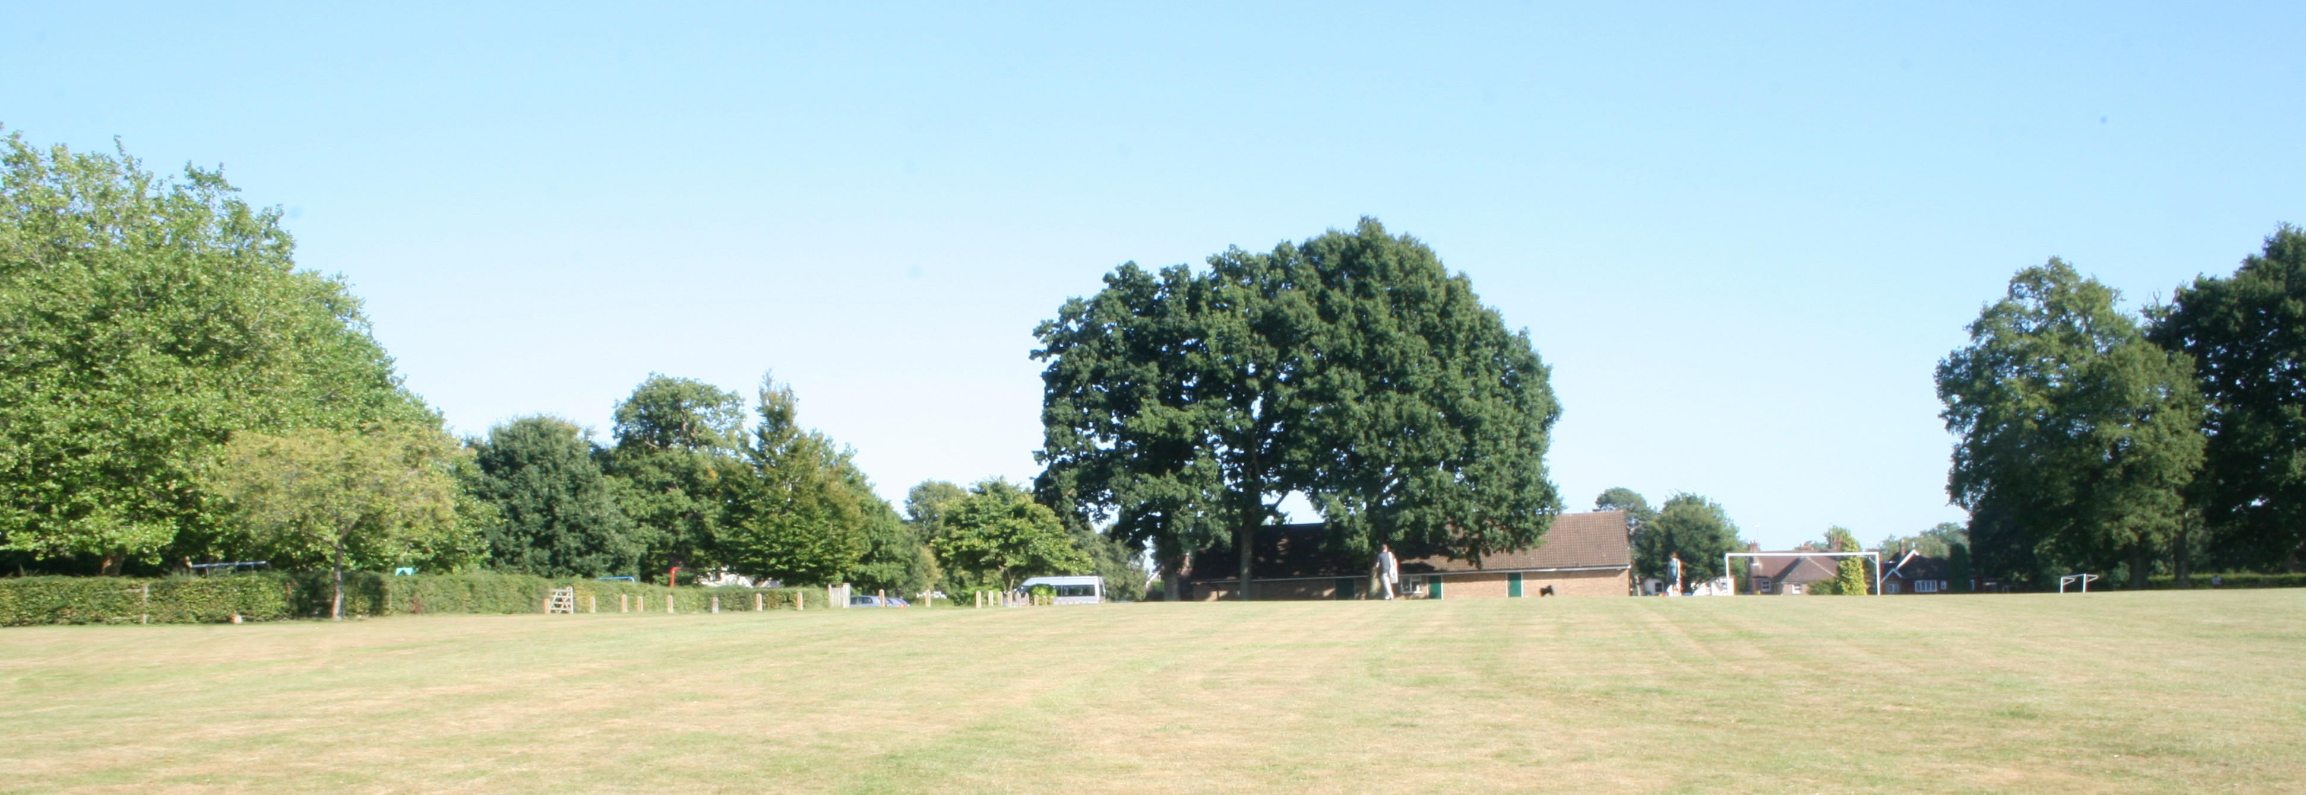

Give photo credits where known
Photo: Hickmans Lane Recreation Field looking east from the Hickmans Lane junction with Finches Park Road.

Justification

Hickmans Lane Recreation Field is managed by Mid Sussex District Council and includes a children’s playground, football pitches and cricket pitches depending on season together with a pavilion which is also used as a children’s nursery.

It is also used by some local schools as a sports playing field and the Lindfield Football Club use it for some of their matches and as a training ground for their youngsters training sessions on Saturday mornings.

2: Green space at Finches Gardens.

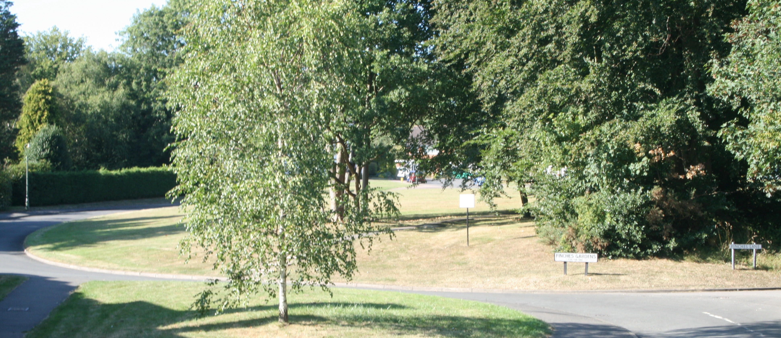

Photo: Finches Gardens as seen from Hickmans Lane.

The cluster of houses that comprise Finches Gardens are located at the top of a rise from Hickmans Lane. This was the site of the Tudor style mansion of Finches before the whole of the Finches estate was developed for private housing in 1964.

This area of rising grass and trees is an important landscape feature off Hickmans Lane and is a particular favourite place for sledging by local children during the winter.

3: The Wilderness Field.

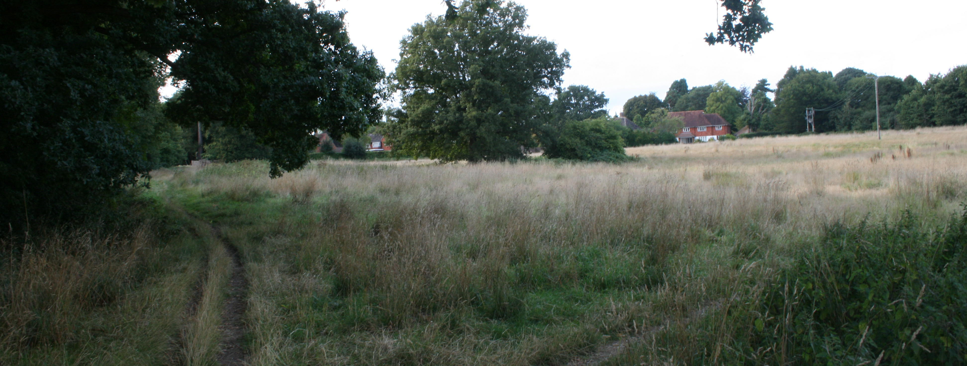

Photo: Wilderness Field from the Limes estate looking towards Wilderness.

As part of the Limes housing development a parcel of land to the north of the new houses know as Wilderness Field is to become a green recreational area. This is to be initially managed by Barretts before being handed over to Mid Sussex District Council. Development on this field would be detrimental to the setting of the houses with the Wilderness and to the views of the Grade 2 Listed Buildings that comprise Old Place.
Each sites you want to designate should have something similar to these above. With these examples, they were asked to provide more reasons, expand on justifications. etc.

