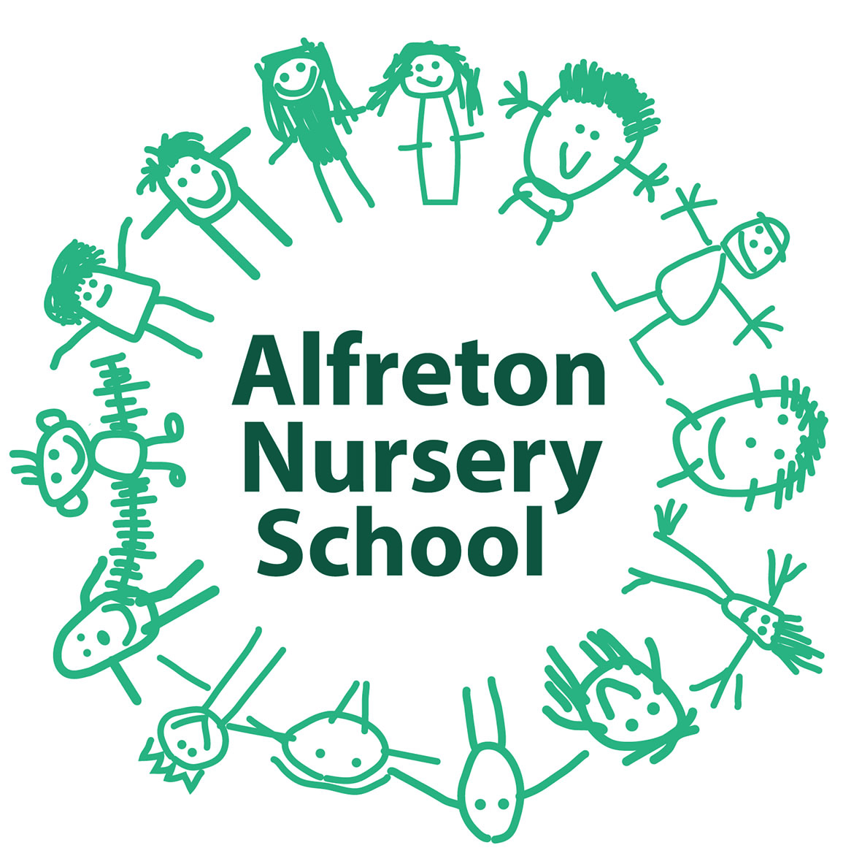

Special Educational Needs Information Report

- Aims of our provision in regards to pupils with special educational needs and/or disability

The aims of our policy & practice in relation to SEND and disability in the school are:-

- To make reasonable adjustments for those with a disability by taking action to increase access to the curriculum, the environment and to printed information for all.
- To ensure that children with SEN engage with the activities of the school alongside pupils who do not have SEN.
- To reduce barriers to progress by embedding the principles of inclusion within the EYFS.
- To use our best endeavours to secure SEN provision for pupils for who this is required that is “additional to and different from” that provided within the differentiated curriculum to better respond to the 4 broad areas of need:
- Communication & Interaction
- Cognition & Learning
- Social, Mental & Emotional Health
- Sensory/Physical

- To request, monitor & respond to parents/carers and children’s views in order to evidence high levels of confidence and partnership.
- To ensure a high level of staff expertise to meet children’s needs, through well targeted CPD.
- To support children with medical conditions to achieve full inclusion in all school activities by ensuring consultation with health and social care professionals in order to meet the medical needs of children.
- To work in cooperative and productive partnership with the Local Authority and other outside agencies to ensure there is a multi-professional approach to meeting the needs of all vulnerable learners.

- What are Special Educational Needs (SEN) or a disability?

- Special Educational Needs: a child has SENs if he/she has a learning difficulty or disability which causes for SEN provision to be made for him/her.

- A learning difficulty/disability is a significantly greater difficulty in learning than the majority of others of the same age.
- SEN provision means educational provision that is additional to, or different from, that made generally for others of the same age in a mainstream setting in England.

- Disability: Many children who have SEN may have a disability under the Equality Act 2010 – that is ‘…a physical or mental impairment that has a long term and substantial adverse effect on their ability to carry out normal day-to-day activities’. This definition includes sensory impairments such as those affecting sight or hearing, and long-term health conditions such as asthma, diabetes, epilepsy and cancer.

- The kinds of SEN for which provision at is made at Alfreton Nursery School (Schedule 1: point1)
- Children with SEN have different needs, but the general presumption is that all children with SEN, but without an Education, Health & Care Plan (EHCP) are welcome to apply for a place at Alfreton Nursery School in line with the School’s Admissions Policy. If a place is available we will undertake to use our best endeavours, in partnership with parents/carers, to make the provision required to meet the SEN of children at this school.
- For children with an EHCP parents/carers have the right to request a particular school and the Local Authority must comply with that and name the school in the EHC Plan unless:
- It would be unsuitable for age, ability, aptitude or SEN of the child or
- The attendance of the child would be incompatible with the efficient education of
others or efficient use of resources.
- Before making the decision to name our school in a child’s EHCP, the Local Authority will send the Governing Body a copy of the EHCP and then consider their comments very carefully before a final decision on placement in made. In addition, the Local Authority must also seek the agreement of school where the draft EHCP sets out any provision to be delivered on their premises that have been secured through a direct payment (personal budget).
- Parents of a child with an EHCP also have the right to seek a place at a Special School if they consider that their child’s needs can be better met in a specialist provision.

- How does our School know if children need extra help (SE7 1 Q1) (Schedule 1: Point 2)

We know when a child needs help if:

- Concerns are raised by parents/carers, external agencies, teachers, the child’s previous school, regarding concerns relating to inadequate levels of progress or inclusion.
- Screening such as that completed on entry or as a result of a concern being raised indicates gap in knowledge and or skills.
- Whole school tracking of attainment outcomes indicates lack of expected rate of progress.
- Observation of the child indicates that they have additional needs.

- What should a parent/carer to if they think their child may have Special Educational Needs? (SE7 1 Q1) (Schedule 1: Points 2 and 4)

- If parents/carers have concerns related to their child’s learning or inclusion then please initially discuss these with your child’s teacher or Head Teacher. This may then result in a referral to the school SENCO whose name is Angela Stanton and whose contact details are headteacher@alfreton.derbyshire.sch.uk, 01773 520031.
- Parents/carers may also contact the SENCO/Head Teacher directly if they feel this is more appropriate.
- All parents/carers will be listened to. Their views and their aspirations for their child will be central to the assessment and provision that is provided by the school.

- How will the school support a child with SEND? (SE7 Q2) (Schedule 1: Points 2, 3, 6, 8 and 10)

- All children will be provided with high quality teaching that is differentiated to meet the needs of all learners. Quality of classroom teaching provided to children with SEND is monitored through a number of processes that include:

- Classroom observation by the SMT, the SENCO, TAs and external verifiers
- On-going assessment of progress made by children with SEND
- Work sampling and scrutiny of planning to ensure effective matching of work to child’s needs.
- Teacher/TA meetings with the SENCO to provide advice and guidance on meeting the needs of children with SEND.
- Child and parent/carer feedback and the quality and effectiveness of interventions provided.
- Attendance and behaviour records.

- Children with a disability will be provided with reasonable adjustments such as auxiliary aids and services to overcome any disadvantage experienced in school and increase their access to the taught curriculum.
- All children have individual targets set in line with national expectations to ensure ambition. Parents/carers are informed of these by the reporting system and also at events such as parent/carer meetings.
- Children’s attainment is tracked using the whole school tracking system and those failing to make expected progress are identified very quickly. These children are then discussed in termly progress meetings that are undertaken between the SMT.
- Additional action to increase the rate of progress will then be identified and recorded that will include a review of the impact and differentiated teaching being provided to the child and, if required, provision to the teacher of additional strategies to further support the success of the child.
- Where it is decided during this early discussion that SEN provision is required, to support increased rates of inclusion, parents/carers will be informed that the school considers their child may require SEN support and their partnership sought in order to improve attainments.
- Action related to SEN support will follow an assess, plan, do and review model:

- Assess: Data on the child held by the school will be collated by the SENCO in order to make an accurate assessment on the child’s needs. Parents/carers will also be invited to this discussion to support the identification of action to improve outcomes.
- Plan: If review of the action taken indicates that “additional to and different from” support will be required, then the views of all involved, including the parents/carers and the child will be obtained and appropriate evidence based interventions identified, recorded and implemented by the teachers and TAs with advice from the SENCO.
- Do: SEN support will be recoded on a plan. It will identify a clear set of expected outcomes which will include stretching and relevant academic and developmental targets that take into account parents/carers aspirations for their child. Parents/carers and the child will also be consulted on the action they can take to support attainment of the desired outcomes. This will be recorded and a date made for reviewing attainment.
- Review: Progress towards these outcomes will be tracked and reviewed termly with the parents/carers and their child.

If progress rates are judged inadequate, despite the delivery of high quality interventions, advice will always be sought from external agencies regarding strategies to best meet the needs of a child. This will only be undertaken after parent permission has been made and may include referral to:
- Local Authority support services.
- Specialists in other schools eg Teaching Schools, Special Schools
- Social Care
- Health partners ie Health Visitor, Speech & Language

NB for a very small percentage of children whose needs are significant and complex and the SEN support required to meet their needs cannot reasonably be provided from within the school’s own resources, a request will be made to the Local Authority to conduct and assessment of education, health and care needs. This may result in an EHC Plan being provided.

- How will children be involved in decisions regarding provision that will better meet their needs (Schedule 1:8)

Due to the very young age of the children at Alfreton Nursery School, we will always endeavour to include their voices through use of video, tracking and discussions with parents. Through staff observations of children’s well-being and behaviour (tracked through Ferre Laevers) staff are guardians for the children’s voice.
- How will the curriculum be matched to each child’s needs (SE7 Q3) (Schedule 1.3)

- Teachers plan using children’s achievement levels, differentiating tasks to ensure progress for every child in the school.
- When a child has been identified as having SEN, the curriculum and learning environment may be further adapted by the staff to reduce barriers to learning and enable them to access the curriculum more easily.
- These adaptations may include strategies suggested by the SENCO and/or external specialists.
- In addition, if it is considered appropriate, pupils may be provided with specialised equipment, or resources such as ICT and/or additional adult help. All actions taken by the SENCO will be recorded and shared with parents/carers.

- How will parents/carers know how their child is doing? (SE7 Q4) (Schedule 1: Point 7)

- Attainments towards identified outcomes will be shared with parents/carers temly.
- Parents/carers may also find the online learning platform a useful tool to communicate with school on a regular basis. Daily informal up-dates occur naturally.
- Parents/carers regularly discuss their child’s progress with the SENCO and may arrange to see the SENCO or other members of staff at any time when they feel concerned or have information they feel they would like to share that could impact on their child’s success. All parents/carers have access to our online learning platform ‘Tapestry’ with individual logins and passwords. This enables a two way conversation between school and home.

- How will parents/carers be helped to support their child’s learning (SE7 Q4) (Schedule 1: Point 7)

- Please look at the school’s website, it can be found at www.alfreton.derbyshire.sch.uk and includes links to websites and resources that we have round useful in supporting parents to help their child learn at home http://www.alfreton.derbyshire.sch.uk/useful-links. We communicate regularly with parents through our social media pages and letters home regarding local learning opportunities. Our on-site children’s centre also offers additional activities and support.
- The SENCO may also suggest additional ways of supporting your child’s learning.
- If you have ideas on support that you would like to have access to in order to further support your child’s learning please contact the SENCO who will locate information and guidance for you in this area.

- How will the school evaluate the effectiveness of the SEN provision made for pupils (Schedule 1:
Point 3)

The effectiveness of SEN provision will be measured using qualitative and quantitative data. Qualitative data will gather the views of parents/carers and children on how successful the provision has been in enabling them to obtain their outcomes. Quantitative data will examine both progress and attainment levels compared to those achieved nationally with pupils of the same level prior learning level. This data will be shared regularly with Governors through the Head Teacher’s report and be judged by external moderators ie IQM and Ofsted.

- What support will there be for children’s overall well-being (SE7 Q5) (Schedule 1: Point 3)

The school offers a wide variety of pastoral support for children this includes:

- An evaluated PSED curriculum that aims to provide children with the knowledge, understanding and skills they need to enhance their emotional and social knowledge well-being. Please visit our website to see aspects of this area of the curriculum.
- Ferre Laevers monitoring for all children measures well-being and engagement with learning.
- All staff and some Governors have been trained on Attachment and Trauma theory.
- There is a named Governor responsible for overseeing PSED in the curriculum.
- Small group evidence led interventions to support children’s well-being are delivered to targeted children and groups. These are identified on provision maps and aim to support improved interaction skills, emotional resilience and wellbeing.
- The school has gained healthy school status, ECO Schools (Green Flag), Unicef’s Rights Respecting School Award, Forest Schools and we are currently working towards the Inclusion Quality Mark (IQM)
- The school has an Inclusion and Behaviour Policy available on the school website.

- Pupils with medical needs (statutory duty under the Children and Families Act) (SE7 5)

- Children with medical needs will be provided with a detailed Individual Health & Care Plan, compiled in partnership with school, parents/carers and medical practitioners.
- Staff who volunteer to administer and supervise medications, will complete formal training and be verified by medical practitioners as being competent.
- All medicine administration procedures are guided by LA Policy and DfE Guidelines included within Supporting Pupils with at Schools with Medical Conditions (DfE) 2014 and identified in the school’s Administration of Medicines Policy.

- What specialist services are available at the school? (SE7 Q6)

- The school has access to a range of specialist support; Educational Psychologist, specialist teachers, Health Visitor, Speech Therapist

- What training to the staff supporting children with SEND undertake? (SE7 Q7) (Schedule 1. Point 5

One teacher and 1 TA has Level 3 specialist training for Every Child a Talker (ECAT). One TA has specialist training for Every Child a Mover (ECAM). The SENCO regularly updates her SENCO training which is disseminated to all staff. All staff are trained and practice monitoring and evaluating children’s emotional well-being and involvement in learning through Ferre Laevers. All staff are Attachment and Trauma Aware. Our Teaching School Alliance includes a Special School, SEN Units with specialist teaching.

Depending on the needs of children within the school, staff ensure their practice is up-dated through appropriate and regular training.

TAs are trained in Attention Autism.

Regular nurture groups support the emotional needs of all children during the week.

- How will my child be included in activities outside the school including school trips? (SE7 Q8) (Schedule 1. Point 3)

- Risk assessments are carried out and procedures are put in place to ensure all children to participate in all school activities.
- The school ensures it has sufficient staff expertise to ensure no children with SEND is excluded from any activities.

- How accessible is the school environment? (SE7 Q9) (Schedule 1: Point 3)

- Disabled parking spot marked and located next to the school reception
- Ramp provided to access front entrance to ensure the site is accessible to all.
- One toilet has been adapted to ensure accessibility for visitors with a disability
- Hand rails have been fitted in the main adult toilet.
- Children’s toilets have an adapted cubicle.
- We have a mechanical rise and fall changing bed for children in wheelchairs to access changing.
- We have a hoist in the sensory room and one of the toilets.
- Adult and child sized wheelchairs can access all areas within school.

Our Accessibility Plan (statutory requirement) which describes the actions the school has taken to increase access to the environment, the curriculum and to printed information is available via the school website.

- How will the school support my child when joining or transferring to a new school (SE7 Q10) (Schedule 1: Point 12)

A number of strategies are in place to enable effective transition these include:

On Entry
- A planned introduction programme is delivered to support children starting in Nursery.
- A range of information is available to support parents/carers in enabling their child to settle into the school routine.
- The SENCO meets with all new parents of pupils who are known to have SEND to allow concerns to be raised and solutions to any perceived challenges to be located prior to entry.
- If children are transferring from another setting the previous school/setting records will be requested and a meeting set up with parents/carers to identify and reduce any concerns.

Transition to the next school (Schedule 1: Point 12)
Primary
- The transition programme in place for children provides a number of opportunities for children/parents to meet staff in the new school. These opportunities are further enhanced for pupils with SEND.
- Parents/carers will be encouraged to consider options for the next phase of education and the school will involve outside agencies as appropriate to ensure information provided is comprehensive but accessible.
- Accompanied visits to other providers may be arranged as appropriate.
- For children transferring to local schools the SENCOs of both schools will meet to discuss the needs of children with SEN to ensure a smooth transition.

How are the school’s resources allocated and matched to children’s SEN? (SE7 Q11) (Schedule 1: Point 6)

- The school receives funding to respond to the needs of children with SEND from a number of sources that includes:

- A proportion of the funds allocated per pupil to the school to provide for their education.
- Our school has an enhanced resource to support children’s additional needs.
- For children with the most complex needs, the school may apply for ETAEYs funding from the Local Authority.
- School will apply for EHC Plans for individual children that meet the criteria.

- This funding is then used to provide the equipment and facilities to support children with SEN and disabilities through support that might include:

- Targeted differentiation to increase access to the EYFS
- Adult support aimed at increasing skills in specific areas
- Small group work
- Specific support, advice and guidance provided to parents/carers and families.
- Provision of specialist resources or equipment eg use of ICT, sensory room equipment
- Support from other specialist practitioners to improve inclusion eg Autism Outreach, SSSEN

In addition
- The Early Years Pupil Premium funding provides additional funding. The deployment of this funding is published on the school website.
- If parents/carers wish to discuss the options available for their child they are welcome to make an appointment to see the SENCO.

- How is the decision made about how much each child will receive? (SE7 12) (Schedule 1: Point 7)

- For children with SEN but without an EHCP the decision regarding the support provided will be taken at joint meetings with the SENCO, parents/carers and other professionals.
- For children with an EHCP, this decision will be reached in agreement with parents/carers when the EHCP is being produced or at an Annual Review.

- How will I be involved in discussions about and planning for my child’s education? (SE7 Q13) (Schedule 1: Point 7)

This will be through:

- Discussions with the Class Teacher, TAs and SENCO.
- During parent meetings
- Meetings with support and external agencies.

- Who can I contact for further information or if I have any concerns? (SE7 Q14)
(Schedule 1: Point 9)

If you wish to discuss your child’s SEN or are unhappy about any issues regarding the school’s response to meeting these needs please contact the following:
- Your child’s teacher
- The SENCO/Head Teacher
- For complaints please contact the school Governor with responsibility for SEN, her name is Gill O’Hagan. She can be contacted via the school office on 01773 520031.

- Support Services for parents/carers of children with SEN include (Schedule 1: Point 8)

- Information, Advice and Support Agency Network offers independent advice and support to parents/carers of all children with SEND and will direct visitors to their nearest IAS service http://cyp.iassnetwork.org.uk/
- For parents/carers who are unhappy with the Local Authority or school responses to their child’s SEND parents may seek mediation from the regional mediation services. Information on this free service is located here http://www.sendpathfinder.co.uk/send-regional-leads
- Parents and carers can also appeal to the Government’s SEND Tribunal if you disagree with the Local Authority’s decisions about your child. Information on this process is available here https://www.gov.uk/courts-tribunals/first-tier-tribunal-special-educational-needs-and-disability

- Information on where the Local Authority’s local offer can be found? (Schedule 1: Point 11 & 13)

Please follow this link for Derbyshire County Council’s local offer http://www.derbyshiresendlocaloffer.org/

It also provides information to parents/carers on mediation and conflict resolution services.

References

Schedule 1 of the Special Educational Needs and Disability Regulations 2014

The SEND Code of Practice (January 2015). The Code of Practice provides statutory guidance on duties, policies and procedures relating to part 3 of the Children and Families Act 2014 and associated regulations https://www.gov.uk/government/uploads/system/uploads/attachment_data/file/398815/SEND_Code_of_Practice_January_2015.pdf

Supporting Pupils at School with Medical Conditions (September 2014) https://www.gov.uk/government/uploads/system/uploads/attachment_data/file/484418/supporting-pupils-at-school-with-medical-conditions.pdf
SE7 Local Offer: Framework and Guidance http://www.derbyshiresendlocaloffer.org/

Glossary (a glossary of SEND terms is included in the appendices of the SEND Code of Practice https://www.gov.uk/government/uploads/system/uploads/attachment_data/file/398815/SEND_Code_of_Practice_January_2015.pdf

