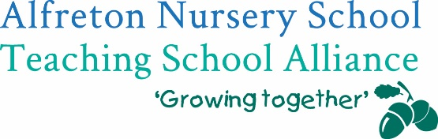
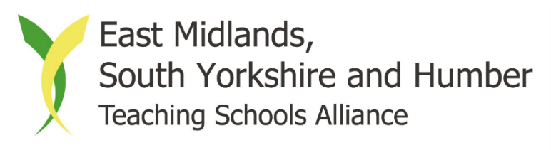
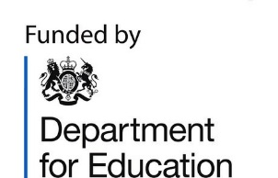

Professional Clerks’ Development Programme
As a provider nationally approved by the Department for Education, this programme offers both new and experienced clerks an opportunity to develop their role so that they can contribute effectively to governance at their school or academy trust. New clerks will be able to develop their understanding of clerking and develop essential knowledge and skills, whilst experienced clerks will be able to enhance and develop their competencies and expertise.
The programme will consist of:
- Four face-to-face modules, facilitated by experienced, high quality facilitators
- 360 evaluation to establish your competencies and areas to develop
- Inter-session research and activities to put your learning into practice
- Reflection on your learning throughout the programme
- Peer support and sharing practice with other clerks on the programme
Module 1 - Tuesday 12 November Understanding Governance and the Role of the Clerk
Module 2 - Tuesday 21 January Administration, Advice and Guidance
Module 3 - Tuesday 25 February People and Relationships
Module 4 - Tuesday 24 March Panels & Evaluation of Programme Learning & Impact
All face-to-face modules will be held at Alfreton Nursery School (Children’s Centre meeting room) from 9.30am-12.30pm. Refreshments will be provided.
The full cost of the programme is £430 per delegate; £350 will be funded by the Department for Education, which means that schools will only be required to pay £80.
For funding information, or to book your place, please contact Katie Cresswell at Alfreton Nursery School Teaching School Alliance on 01773 520031 or katie.cresswell@alfreton.derbyshire.sch.uk.
Please note that booking closes on Friday 1 November 2019
