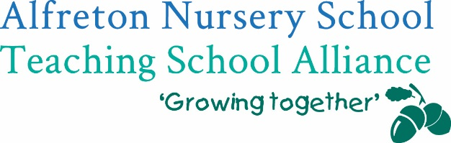

To; Head Teachers, Teachers, Early Years Leaders, Practitioners and Managers in settings and schools


Following on from the successful 2019/20 pilot we would like to invite you to join our Derbyshire Teddy Bear training

Do you want to?
✔ Support settling all children into your school using an attachment approach?
✔ Improve transition for children between home, settings and schools in your community?
✔ Take an attachment led approach to relationships in your local EYFS community?
✔ Help your less experienced learners make better progress?
✔ Develop better relationships with all families, including the disadvantaged?

Then the Derbyshire Teddy Bear training is for you!

Alfreton Nursery School Teaching School Alliance and Derbyshire Early Years Quality Service are offering schools and settings the opportunity to take part in this proven innovative training. Teddy Bear Training is based on the approaches of the Parental Engagement Network (PEN) whose work with disadvantaged families in Manchester has been recognised nationally as highly effective in reaching out to and building relationships with ALL families including the most disadvantaged.

Running on Wednesday 17 June 2020 from 4-5.30pm via Microsoft Teams this interactive training includes:

- A collaborative introduction to the story, theory and practice behind the successful Teddy Bear Project of 2019/20 through an online training session led by Derbyshire’s Early Years Quality Service and Alfreton Nursery School Teaching School Alliance’s Specialist Leaders of Education.
- Examples of good practice and collaborative ideas from the successful pilot project 2019/20
- The opportunity to join in an interactive Questions and Answer Session at the end of the training session with links to further documentation, including Frequently Asked Questions.

This approach is about tweaking practice, not about wholescale change!

To ensure the sustainability of the training, all we are asking for is a nominal contribution of £50 per school or setting. To ensure we can manage our event via teams, we are limiting bookings to 1 x person per school/setting.
To secure your place, please complete your booking using the following bookings system:
https://bookwhen.com/alfretonteachingschool by Friday 5 June.

If you require any further information about the training, please contact Alfreton Nursery Teaching School Alliance; katie.cresswell@alfreton.derbyshire.sch.uk
We look forward to working with you.

