Alfreton Nursery Teaching School Alliance are delighted to host Philosophy for Children (P4C) Level 1 Course at Leabrooks Arts Complex, 9 May & 13 June 2019

Philosophy for Children (Level 1) - Foundation Course, SAPERE validated
Course Facilitator: Paul Stockley (Head Teacher at Bradway Primary School, Sheffield)

There are plenty of reasons to develop Philosophy for Children (P4C) in your school…..

Recent research has shown that P4C enhances positive outcomes in the following areas:
- Developments in children’s cognitive ability
- Key Stage 2 attainment: overall, EEF research showed that pupils using the approach made approximately 2 additional months’ progress in reading and maths with disadvantaged pupils making the greatest amount of progress
- Critical reasoning skills and speaking and listening skills
- Emotional and social development

This is pedagogical approach to learning that can be applied across all age phases.

This is a 2 day course, running from 9.00am (9.30am start) until 3.00pm on both days, 9 May and 13 June 2019 which will enable all participants to:
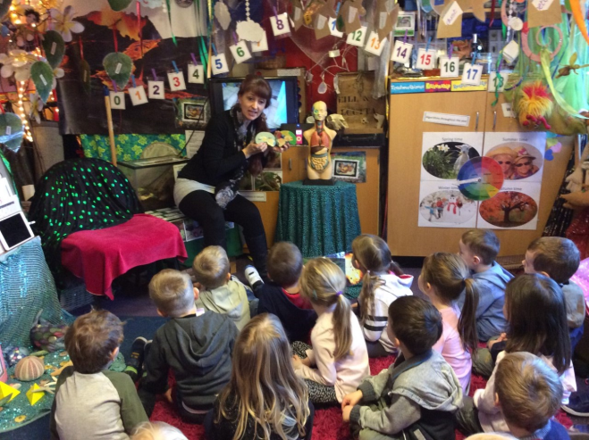
- Start practising P4C straight away
- Encourage philosophical questioning dialogue
- Learn how to facilitate a P4C enquiry
- Identify resources to stimulate rich discussions with young people

The 2 day course:
- Introduces the theory and practice of P4C
- Connects P4C to the curriculum
- Demonstrates philosophical enquiry in practice and how to embed P4C in your school

Cost: £300 per person or if more than one person from a school, subsequent delegates £200 (includes lunch and refreshments on both days, 2 days of training, SAPERE Level 1 Handbook, SAPERE membership and certificate)

Venue: Leabrooks Arts Complex, 36 Leabrooks Road, Somercotes, DE55 4HB

Bookings will be allocated on a first come first served basis up to a maximum of 16 participants. Please follow this link to book your staff places https://www.sapere.org.uk/courses/level-1-courses.aspx

