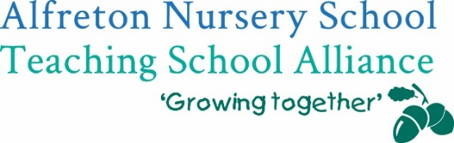

To; Head Teachers, Teachers, Practitioners and Managers in settings and schools


to the trauma caused by a pandemic which has attacked
hearts and minds

Do you want to?
✔ Ensure your Behaviour Policy reflects the needs of your children and the behaviours that may present themselves in the months ahead?
✔ Ensure you have an effective recovery curriculum in place?
✔ Discuss where we go from here and what we need to be mindful of?

Then the Stay Alert training is for you!

Following on from our successful Teddy Bear Training; the first in our series of on-line training programmes, Alfreton Nursery School Teaching School Alliance is offering schools and settings the opportunity to take part in this second collaborative programme. At a time when society is looking to us to help the nation’s children recover emotionally and academically from a global pandemic, our schools and settings need to look closely at procedures for supporting the well-being of children, staff and parents.

Running on Thursday 9 July 2020 from 4-5.30pm via Microsoft Teams this interactive training includes:

- A collaborative look at what community and personal trauma may look like and how our educational offer can hold up under the new norm led by Alfreton Nursery School Teaching School Alliance’s Specialist Leader of Education.
- Examples of how we can unpick what community and personal trauma may look like and how our educational offer can hold up under the new norm, including an opportunity for collaborative ideas.
- The opportunity to join in an interactive Questions and Answer Session at the end of the training session with links to further documentation, including Frequently Asked Questions.

Stay Alert and save the well-being of children!

To ensure the sustainability of the training, all we are asking for is a nominal contribution of £50 per school or setting. To ensure we can manage our event via teams, we are limiting bookings to 1 x person per school/setting.
To secure your place, please complete your booking using the following bookings system:
https://bookwhen.com/alfretonteachingschool by Friday 3 July.

If you require any further information about the training, please contact Alfreton Nursery Teaching School Alliance; katie.cresswell@alfreton.derbyshire.sch.uk
We look forward to working with you.

