Wild Fire Cooking Course

Looking to brush up on your fire making skills? Our Wild Fire Cooking Course will teach you how to safely make a fire using a fire pit, make drinks using a Kelly Kettle and how to safely cook on the fire pit. You will be able to take away simple, tasty recipe ideas to use back in your own setting.

This hands-on session will help build confidence when working with children outdoors, including supporting writing Fire Safety Risk Assessments.

Monday 20 May 2019 – 12.30pm-3.00pm

Suitable outdoor clothing and footwear required.

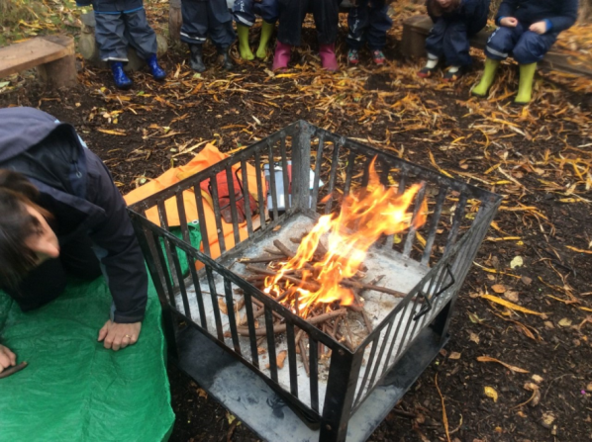
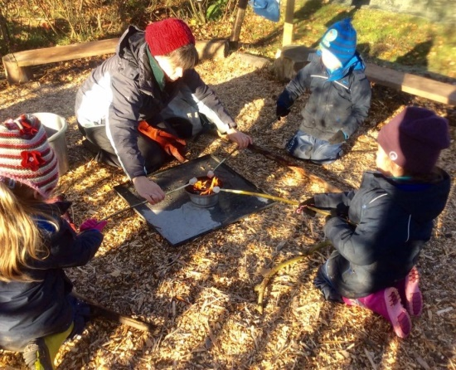

Target audience: Anyone with an interest in outdoor education

Course fees: £60 per session

Bookings will be allocated on a first come first served basis up to a maximum of 10 participants per course. Please complete the attached booking form and return to katie.cresswell@alfreton.derbyshire.sch.uk

Course Booking Form

Wild Fire Cooking Course

Monday 20 May 2019 – 12.30pm-3.00pm

Please return completed form to: katie.cresswell@alfreton.derbyshire.sch.uk

…………………………………………………………………………………………...............................................................................

Date of course: ………………………………………….

Total Cost: £ 60 per day per person

Name & Job Title of Attendee:

……………………………………………………………………………

…………………………………..……………………………………….

School/Setting Address (inc Postcode)

…………………………………………………………………………

…………………………………………………………………………

………………………………………………………………………….

Telephone No: ………………………………………………….
E-mail Address:

…………………………………………………………………………
Access Requirements (Alfreton Nursery School is an accessible venue – please give details of any access needs that you may have in order to fully benefit from your visit):

……………………………………………………………………………

…………………………………………………………………………..

Payment: (please tick/complete as appropriate)

I enclose a cheque made payable to
Alfreton Nursery School

Please send an invoice marked for the
attention of: …………………………………..

Please invoice my school using the
following Cost Centre ………………………………

Signature: (I have read and agree with terms and condition as outlined in the ‘Booking Procedures’ sheet).

Attendee: ………………………….……………………………..
Print Name: ……………………………………………………

Head/Manager:………………………….…………………….
Print Name: ……………………………………………………

