Willow Weaving Workshop

Friday 18 October 2019 or Friday 15 November 2019

9.00am-1.00pm (includes a break with refreshments)

Back by popular demand our Willow Weaving Workshops. Is your school/setting making the most of this valuable, sustainable resource? Learn how to tame unruly structures by weaving the willow back in or pruning. Make a simple creation to take away.

Suitable outdoor clothing and footwear required + gloves and secateurs.

Cost £50

To secure your place, please book on-line via https://bookwhen.com/alfretonteachingschool#focus=ev-s4cs-20191018090000

or telephone Katie on 01773 520031 for further information.

10 spaces available on each course; please book early to save disappointment!
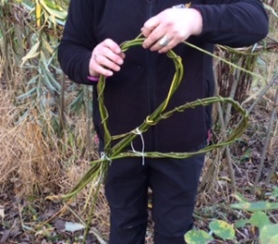
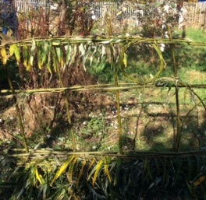
We look forward to seeing you soon.

Feedback from Willow Workshops:

- Thank you so much for today, I have come home excited, motivated and empowered!
- Thank you. I had a wonderful day yesterday (even in the weather!).
- Thank you to all the staff for making us feel so welcome!
- I feel that I have gained a skill I will definitely use again
- I enjoyed the practical experience, time to practice, lovely & friendly staff – I wanted to stay all day
Please see our Teaching School website for further Willow Workshops feedback
https://alfreton-teachingschool.co.uk/training-courses/

