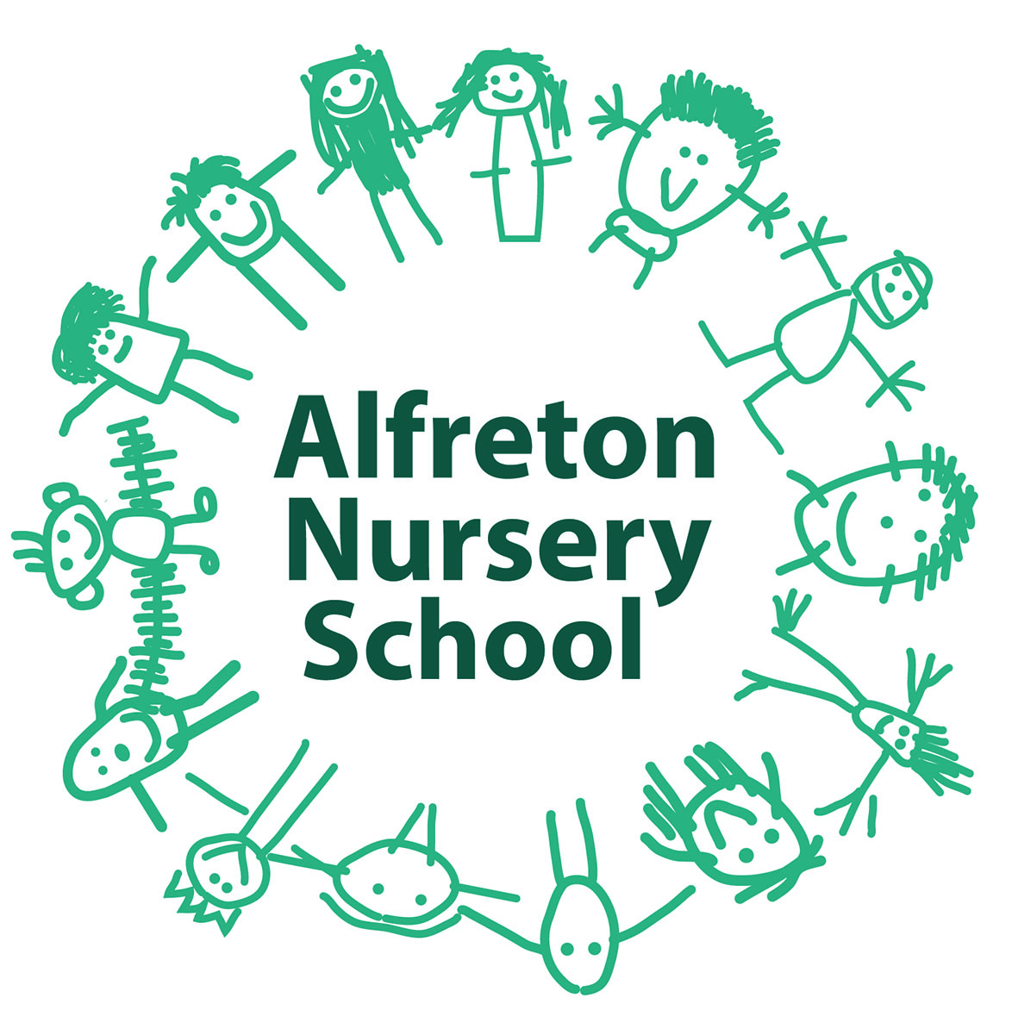
Early Years Pupil Premium Strategy

Academic Year: Sept 2016-July 2017 (Up-dated July 2017)
No of Children on Roll: 104
No of Children eligible for EYPP: 16
Total EYPP Budget Received to-date: £ 4161.05 Expenditure: £14,738.15
Date of Next Internal Review of this Strategy: Autumn Term 2017-18

Barriers to Learning
Poor attendance; language delay; behaviour (social skills); health concerns; attachment/emotional well-being issues
Desired Outcomes & How Measured | Action/s | Impact/Success Criteria | Implication for next academic year | Cost
Children’s social and emotional well-being supported through interventions and 1:1 support.  Measured through data tracking, Ferre Laevers, parent consultations. | Provide 1:1 support to work with children and their families.  All staff observe and assess with Ferre Laevers monitoring tool for children's emotional well-being & level of involvement.  The Maslow Group offers additional support for EYPP children and others, also home:school resources.  School has a Healthy food bag in the home school library as well as other resources to support basic needs. Healthy snack provided. | Interaction between home and school. Families attending regularly.  Children successfully manage their involvement and well-being independently.  Attendance at the group & active participation. Home-school library to support the work of the group with the wider family.  Children bring healthy lunches and are energised for the afternoon session. Well-being and involvement is higher. | Monitored through SMT & Governing Body and reviewed via SIP.  More efficient data tracking system introduced.  To continue to provide extra sessions and review how they impact on progress and attainment in school. | Included in current staffing costs ie 1:1 support, family liaison, class teachers.  £80 sensory resources  Daily healthy snack £10 p/week (x 39 weeks = £390)
Desired Outcome | Action/s | Impact | Implication for next academic year | Cost
 | Children targeted sessions ie baking/Earth Elves |  | To continue to provide extra sessions and review how they impact on progress and attainment in school. | Earth Elves 5 hrs p/week Nursery Nurse £72.40 p/week (x 39 = £2823.60)  Ingredients £10 p/week = £390
To extend children’s physicality through interventions.  Measured through data, team discussions, feedback from sports partners | Children identified through Every Child a Mover (ECAM), offered additional physicality initiatives ie  ‘Roly Poly Friday’  Teachers released for focused sessions for individual and small group support.  To work with professionals (Schools Sports Partnership), enabling vulnerable children to access further sporting and outdoor opportunities, linking to healthy lifestyles. Organisation did not turn up for organised sessions.  Additional Forest School sessions offered | Children’s physical development more refined and children’s core muscle strength improved. Progress tracked through ECAM data.  Professional expertise to challenge and extend children’s physicality and to offer further skills based opportunities. Staff role model/mentoring.  Engagement in outdoor learning, physicality & well-being. | To continue to provide extra sessions and review how they impact on progress and attainment in school.  To continue to provide extra sessions and review how they impact on progress and attainment in school. | £70 p/session – Summer Term 2017  (6 weeks)  Total: £420

Desired Outcome | Action/s | Impact | Implication for next academic year | Cost
To improve children’s language delay  Measured by ECAT data termly & school’s data. Speech Therapist monitors progress. | Children identified through Every Child a Talker (ECAT).  Speech & Language Therapist intervention for referred children. | Speech & language support at home, dialogue, interventions through school.  Families engaged with strategies offered at home & supported. | More efficient data tracking system introduced. Children to continue to be closely tracked through SMT & Governors.
Children’s health, well-being and attendance supported through free Early Birds’ breakfast club  & by providing free lunch sessions and through monitoring healthy eating options.  Measured through attendance registers, Ferre Laevers, data tracking. | To provide healthy, nutritious options for vulnerable children by offering a free breakfast.  To staff a daily lunch club, giving children the opportunity to eat a healthy packed lunch (provided by home) with their peers and make healthy choices.  Targeted lunch time children have the opportunity to take a Healthy Takeaway, home school liaison bag home that promotes healthy eating within the home. These have been designed so families can taste and share a piece of healthy fruit or veg within their home.  Information for parents is enclosed. | Children energised, ready to learn. Children have a sense of belonging on arrival and improved social confidence.  Children bring healthy lunches and are energised for the afternoon session. Well-being and involvement is higher. | To continue to provide extra free sessions to support individual children’s well-being.  To continue to provide extra free sessions to support individual children’s well-being.  To continue to provide healthy resources to support individual children and family well-being. | 1 x staff member, daily cover £54.65 per week (x 39 wks).  Total: £2131.35  743 free sessions taken Sept 2016-April 2017.  Lunch Club Staffing Costs 2 x members of staff, daily cover £144.80 per week  Total £5,647.20

Desired Outcome | Action/s | Impact | Implication for next academic year | Cost
Improved attendance/family support  Measured through attendance registers,  Ferre Laevers, data tracking. | To provide either a free morning or afternoon session (in addition to 15 hrs free funding) for targeted EYPP children. | Improved attendance. Progress in learning. | To continue to provide extra sessions and review how they impact on progress and attainment in school. | Sept 2016-April 2017 additional sessions total: £3276 (cost of additional sessions taken to-date – 312 sessions @ £10.50 per session)

Further Resources
Interventions offered as part of our extensive curriculum include Forest Schools, ECAT, ECAM, Emotional Wellbeing ie Love Heart Group, sessions in the Magic Room, Intensive Interaction, Aspirations Group and Ferre Laevers. Ferre Laevers is a monitoring tool used by all staff for all children, to monitor emotional wellbeing and interaction.

This extends into the Love Heart Group and Mindfulness Group, depending on the needs of the children. Children’s basic needs/rights are also extended into parental awareness through the home-school Maslow library. Children experience a multi-sensory session with a focus on nurture and comfort ie hot chocolate, aromatherapy.

