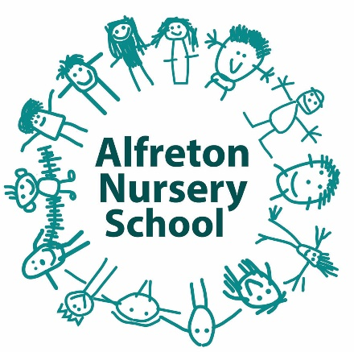

Attendance Policy

Introduction

Alfreton Nursery School believes that good attendance is essential if children are to take full advantage of the opportunities offered by our creative and inspirational school. Alfreton Nursery School offers a flexible attendance pattern which fits round individual families, to ensure all children can access as much of our rich and exciting curriculum as possible.

Due to Covid-19, in line with the school’s Covid Risk Assessment, the school is currently split into bubbles to ensure less children and staff are mixing during the school day.

Aims

The school aims to achieve good attendance through the operation of its Attendance Policy where staff, children, parents/carers work in partnership together. Attendance is regularly monitored and the staff team liaise with families and other agencies where appropriate. We encourage staff, parents/carers and children to maximise the daily learning opportunities on offer and provide clear procedures for involving parents in encouraging good school attendance. As an Attachment Aware school we understand that regular attendance can be a challenge for some families and their children, and work on an individual basis to sensitively encourage good attendance for all. During Covid-19, school remains in daily contact with all families of children due to attend, to offer guidance and support regarding testing and any attendance concerns.

Consultation

This Policy has been written by Emma Haywood in collaboration with Alfreton Nursery staff team and Governors.

Procedures and Practice

The school’s normal session times are as follows:

- 8.30am-9.00am Dropping off time
- 9.00am-11.30am Education Session
- 11.30am-12.30pm Lunchtime
- 12.30pm-12.45pm Dropping off time
- 12.45pm-3.15pm Education Session
- 3.15pm-3.30pm Collection time

Please note that these hours are subject to change due to coronavirus. Parents will be notified of any changes to their child’s hours.

Children that are eligible for 30 hours may receive up to 7 hours of continuous educational provision each day up to their full allocation of hours. Any additional hours can be purchased at £4.65 per hour.

Parents/carers of children who are eligible for 15 hours may buy additional time to their child’s 15 hour free entitlement:

11.30-12.30 – lunch hour
Additional 3 hour sessions either am/pm
These are currently charged at £4.65 per hour

Children should attend Nursery on each of their allocated sessions, wherever possible, unless the reason for the absence is unavoidable.

Children are sometimes reluctant to attend school. Any problems with regular attendance is sensitively approached through the school, the parents/carers and the child working together.

In line with safeguarding procedures, parents/carers are expected to contact school on each morning of their child’s absence so school are aware of why their child is not in school. The School’s Designated Safeguarding Leads will make contact with parents/carers if they are concerned about a child missing education.

The school applies the following procedures in deciding how to deal with individual absences:

A phone call to home, if we have had no information regarding absence to ascertain why a child is absent and see if we can support in any way.

The person responsible for attendance matters in this school is: Emma Haywood, Head Teacher

Equal Opportunities

The needs of all children and families are taken into account when dealing with individual children’s attendance.

Children that are eligible for Early Years Pupil Premium may be offered a free lunch-time or additional session to support attendance.

Monitoring and Review

The school’s Attendance Policy will be reviewed on an annual basis alongside other Safeguarding Policies.

