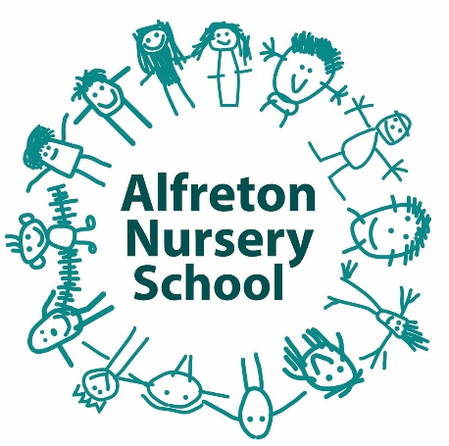

Charging & Remissions Policy

Introduction

At Alfreton Nursery School we recognise the valuable contribution that a wide range of activities and experiences can make towards all aspects of our children’s education. As part of our rich and exciting curriculum, the school and Governing Body aims to provide as many opportunities as possible for the benefit of all our children.

Aims

Our school aims to:
• Have robust, clear processes in place for charging and remissions
• Clearly set out the types of activity that can be charged for and when charges will be made

Consultation

The School Charging and Remissions Policy for Alfreton Nursery School was developed and agreed by the whole staff team and Governors.

Procedures and Practice

The school will make small charges for the following items to enhance children’s experiences within school.

- Parents are expected to contribute £1 per week towards the cost of drinks, a daily healthy snack and activities which use disposable materials, eg malleable play, baking. During Covid, children are asked to bring their own snacks so not charge is currently being made.

- For family outings, parents are expected to pay the full cost for anyone other than a nursery school pupil.

- When school equipment is damaged or lost while in the possession of a child and not on the school premises, parents will be expected to make a contribution towards its repair or replacement.

- Parents who opt to purchase additional sessions for their child will be charged at £4.70 per hour session or £4.70 for a lunch session (children must be provided with a packed lunch).

- Children who attend Forest Schools will be charged a voluntary contribution of £5 each half-term to cover additional resources required during the sessions.

Please see the school’s Lettings Policy for details of school lettings.

Equal Opportunities

The needs of all children and families are taken into account when dealing with charges and remissions.

Children that are eligible for Early Years Pupil Premium may be exempt from some of the school’s charges to ensure every child can engage with all areas of school life.

Monitoring and Review

The school’s Charges and Remissions Policy will be reviewed on an annual basis.

