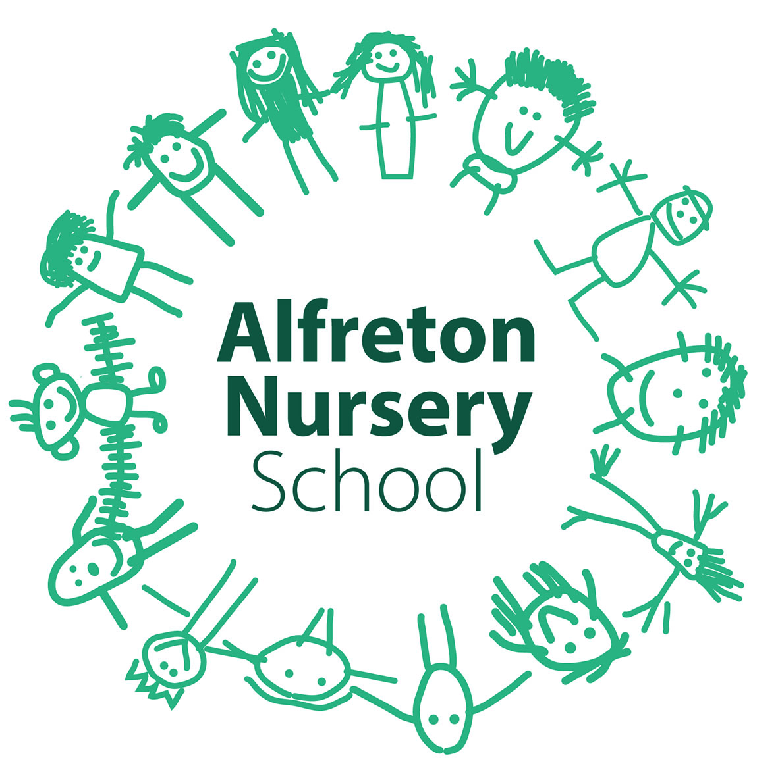

British Values & Community Cohesion Policy
Home, School, Local, National, and Global Citizenship

Introduction

Demographics of the School

The vast majority of families are of white British heritage and the school is sited in an ex-mining community with high unemployment. We have a Children’s Centre attached.

Demographics of the local area

Alfreton is a small town of 22,000 people with a busy urban centre. A substantial proportion of local jobs are in light industry, retailing and service sector. Many jobs are part time.

At Alfreton Nursery School, we endeavor to make every child’s unique learning journey an exciting adventure, which promotes a real love of learning that will last a lifetime. It is every child’s entitlement to an education which stimulates and challenges their abilities and interests. For children who demonstrate abilities that are deemed to be higher than expected, their right to have their potential turned into performance is embraced. As a school we recognise our responsibility to nurture intellectual curiosity.

As a school which places the rights of children at the centre of everything it does, we spend a great deal of time respecting the needs of every individual child in school – physical, mental, emotional and spiritual. Each curriculum area is taught with the needs of every child at its core and all practitioners in school acknowledge the responsibility they have to provide a curriculum that is creative and stimulating. This curriculum nurtures all children and allows them to be successful and proud of all their achievements.

Aims

- Every child has the right to an education that develops their talents. This education must nurture a child’s respect for themselves, others and their environment.
(UNCRC. Article 29)
- All children are immersed in the core British values of respect and tolerance, rule of law, individual liberty, democracy, and an understanding of difference and diversity.
- To help children and young people to learn to understand others, to value diversity whilst also promoting shared values, to promote awareness of human rights and to apply and defend them. These values are reflected through our Rights Respecting School work, our International School work and our work on Fairtrade.
- The integration of the following ten values, which are central to the purpose of our school. Our charter of values:

1. A love of learning for its own sake
2. Vigor and optimism in embracing the future
3. The intrinsic virtue of persistent hard work
4. Acceptance of personal responsibility
5. Equal value accorded to all persons
6. Courtesy, self-discipline and respect for others
7. A determination to achieve excellence in all we do
8. Honesty, moral courage and integrity
9. Leadership and enterprise
10. Respect for the traditions and achievements of the school

Consultation:

Policy written by Amanda Hubball in consultation with Alfreton Nursery School SMT and Chrissie Meleady - MBE. Approved by governing body.

Sources and references:

The following documentation underpins all practice, provision and policy/procedure in school:

Keeping Children Safe in Education
EYFS Framework 2018

The Education and Inspection Act 2006 profiles the need to promote Community Cohesion and the vital place that all schools have in furthering community cohesion.

This document seeks to support the implementation of the Education and Inspection Act 2006 in Britain and it sets out how the school seeks to discharge its duty to promote community cohesion

Community Cohesion defined as:-
“…working towards a society in which there is a common vision
and sense of belonging by all communities; a society in which the diversity of people’s backgrounds and circumstances is appreciated and valued; a society in which similar life opportunities are available to all; and a society in which strong and positive relationships exist
and continue to be developed in the workplace, in schools and in the wider community”

The DfE amplifies that a cohesive community is:-

“a society in which strong and positive relationships exist and continue to be developed in the work place, in schools and the wider community.”

Procedures and Practice

For schools, the term ‘community’ Government says, has a number of dimensions including:
- the school community – the children and young people it serves, their parents, carers and families, the school’s staff and governing body, and community users of the school’s facilities and services;
- the community within which the school is located – the school in its geographical community and the people who live or work in that area. This applies not just to the immediate neighbourhood but also to the city or local authority area within which a school is located;
- the UK community – all schools are by definition part of this community; and
- the global community – formed by EU and international links.

In addition, schools themselves create communities – for example, the networks formed by similar or different types of schools, by schools that are part of the specialist schools and in our case Teaching School Alliances, working collaboratively in clusters or in other models of partnership.
Alfreton Nursery School operates across all of the above dimensions, for example by providing drop-in sessions for families in our local community, right through to facilitating the training and sharing of good practice between schools locally and nationally. As a Teaching School, community links develop rapidly and impact positively on many.

Alfreton Nursery School considers that community cohesion is about building a more tolerant, more understanding and a fair and transparent society, in which all members share a common sense of belonging that overcomes their differences.

Alfreton Nursery School seeks to build community cohesion by promoting equality of opportunity and inclusion for different groups of pupils within our school. But alongside this focus on equalities and a strong respect for diversity, we consider that we also have a role in promoting shared values and encouraging students to actively engage with others to understand what they all hold in common.

We recognise as an equalities promoting school that we are responsible for equipping our students to live and thrive alongside people from many different backgrounds. As a school with a mainly white British student population, we see our role in exposing children to difference and diversity as more important than ever. We do this through activities and work aimed at raising awareness of people from different ethnic backgrounds, with other equalities protected characteristics and from varied socioeconomic backgrounds. We also provide opportunities for interaction, awareness raising and building of solidarity between children and young people and others from different backgrounds, through our varied provision in school

Equal Opportunities:

Community Cohesion - Our school is pro- active in promoting community cohesion by:-
- ensuring equality of opportunity for all learners
- encouraging a strong sense of belonging and a shared vision by all members of the school community
- promoting high standards of behaviour
- providing opportunities for students to participate in a wide range of activities.
- providing an ITT student base for a number of Higher Education providers, both locally and nationally.
- engaging constructively and generously with other schools/educational settings and the wider community to help build real links to bind societ
- helping to teach students tolerance, respect, acceptance and understanding for other cultures and faiths and other protected equalities considerations.
- promoting shared British values and positive Universal values and challenge prejudice, inequalities and discrimination in all its forms
- promoting respect for the rule of law
- promoting awareness of equalities and human rights and of their responsibility to uphold and defend them
- developing skills of participation and responsible action
- operating significant peer support systems within school, celebrating effort and achievement and embracing inclusivity
- tracking all students comprehensively, with particular consideration for targeted students such as those with speech and language concerns, English as an additional language and those from minority ethnic, disabled, LGBT, pupil premium and other protected equalities characteristic groups.

Equity and Excellence - As a school we are always striving to ensure equal opportunities for all to succeed at the highest level possible, striving to remove barriers to access and participation in learning and working to eliminate variations in outcomes for different groups.

Engagement and extended services - As a school we are always providing reasonable means for children, young people, their friends and families to interact with people from different backgrounds and build positive relationships, including: links with different schools and communities; the provision of extended services; and opportunities for pupils, families and the wider community to take part in activities and receive services which build positive interaction and achievement for all groups

Health and Safety:

A generic approach to the health and safety of children is appropriate, as no specifically risk attributed activities are routinely included within the provision for community cohesion and British values.

Planning:
- Differentiated curriculum planning booklets – Amanda Hubball & Laura Dolby are jointly responsible for this planning.
- Specific differentiated planning related to Global Citizenship, British Values and Community Cohesion falls to the Coordinator, Amanda Hubball.
- The responsibility for the planning behind specific targeted provision will usually fall to the curriculum coordinator who oversees the related curriculum area. For example, Maths Target Time – Amanda Hubball, Literacy Target Time – Laura Dolby. The planning systems reflect the findings of data analysis, tracking systems etc.
- Findings of the assessment and recording systems that impact on cross curricular provision, are shared with the whole team, as they all contribute to the planning for cross curricular target and intervention work in school, e.g. Music, Story sessions.

Teaching:
The children are immersed in the rights of all children around the world. Decisions and opinions are formed based on education and collaboration, and we foster an understanding that all views share equal value. The UNCRC permeates all levels of planning, provision and assessment for all children. The school ethos celebrates difference and diversity and encourages individual expression and a freedom to develop personal opinions. Everyone is afforded equal respect and children are taught through example, i.e. all staff openly respect themselves and each other. All children have a voice within our school and the culture is therefore based heavily on tolerance and shared appreciation for communication.

Our school has a fully inclusive, non-discriminatory ethos and uses a school charter to underpin and support a climate of tolerance and acceptance. The work on respect is integrated fully through the global citizenship focus in school.

Roles and Responsibilities
Teaching Staff
- To deliver lessons and other learning activities which promote Community cohesion and British values to all children.
- To take responsibility for personal skill development and communicate any perceived weaknesses to the coordinator- therefore ensuring support and training.
- To support the behaviour and views of children in a positive and creative way, ensuring at all times that children are never exposed to feelings of shame or rejection.
- To challenging any negative views or beliefs held by children towards people who are different from themselves, in a compassionate and fair way.
- To remain aware at all times that behaviour is a means of communication and to remain aware of the power of implicit messages which exist in families, responding to every child individually and with respect.
- To lead by example at all times, with regard to respect and tolerance.
- To attend CPD/PSED meetings, thus ensuring high professional standards
- To build positive relationships with all children and their families.

Organisation/Resources:
The Community Cohesion and British Values Coordinator has overall responsibility for the organisation, upkeep and renewal of related resources, but this is done in conjunction with the highly skilled team of professionals in school.

In school we have
- A clear focus in the School Improvement Plan.
- Regular CPD to ensure current and up-to-date knowledge of all staff and the highest standards of practice.
- Coordinator leadership
- A School Charter
- British values and Community cohesion permeate every aspect of our physical and emotional school environment.

Roles and Responsibilities:

Community Cohesion Link Practitioner – Sandra Meakin
British Values Link Practitioner – Jane Blant
- To support the Coordinator in disseminating and training staff in the practice of Community Cohesion and British values.
- To seek CPD opportunities and work in liaison with the coordinator to maintain an inclusive climate, which embraces difference and diversity, whilst ultimately placing British values at the fore of all practice.
- To remain aware of the impact of implicit home culture on children’s behaviours and respond with compassion and understanding, whilst challenging negative views and beliefs.
- With the support of the coordinator, plan, implement, monitor and evaluate Community cohesion and British values provision in school.

Assessment:
Informal monitoring and assessment procedures conducted by all staff, e.g. observations, discussion and staff meetings. More formal assessment systems include Eazmag data analysis system, Tapestry online learning journal, IRIS digital monitoring, curriculum tracking systems and Ferre Laevers well-being and involvement monitoring system. For more information on assessment and monitoring, please see the Recording and Assessment policy.

Monitoring and review:
Roles and Responsibilities

British Values Lead Practitioner – Angela Stanton
Community Cohesion and British Values Coordinator – Amanda Hubball
- To review and maintain an overview of the breadth and quality of experiences being offered and received in school, with a view to inclusivity, emotional well-being and the core British values.
- To lead by example and to support practitioners in their skills and awareness of how to work in a climate where British values underpins all aspects of provision.
- To take responsibility for the up-keep and purchasing of specialised resources, displays and home-school documentation.
- To support all staff with all matters concerning the implementation and consistent provision of a British values based curriculum when working with the children and their families.
- To attend CPD opportunities, adopt and implement relevant new initiatives and keep other members of staff up to date in their knowledge and skills.
- To ensure personal knowledge of safe guarding procedures in relation to British values, extremism and radicalisation is always up-to-date.
- To ensure that staff have their knowledge of procedures relating to safeguarding issues updated regularly.
- To remain up-to-date with the issues and risks that pose real threats to the local community, with relation to extremism and radicalisation.
- To encourage and support with the continued professional development of all staff in relation to the diverse curriculum and pastoral provision in school with relation to the local, national and global agendas.
- To lead, monitor and adapt provision in all aspects of the global curriculum in school.
- To monitor the ethos and inclusivity of all messages that emanate from the school towards all members of the community.
- To support other practitioners to plan for, implement, monitor and evaluate specific Community cohesion and British values work in school.
- Maintain an overview of overall practice and its impact.

Head Teacher
- To have overall responsibility for all matters relating to British Values and the impact of school practice on children and staff within the school.
- To ensure appropriate and up-to-date CPD for the coordinator and all staff thus ensuring inclusivity and a consistent message with regard to British values.

Link British Values and Community Cohesion Governor – Gill O’Hagan
- To monitor annually the provision in school to support with all related matters
- To drive practice forward through leading the implementation of different inclusive practice and remaining at the forefront of CPD.
- To be a critical friend to school practitioners, challenging practice where appropriate and driving up standards.
- To ensure an up-to-date knowledge of the local community and the risk factors associated with it, with regard to extremism and radicalisation.

The Head Teacher and Senior Management Team will review the policy in line with the School Improvement Plan Overview and monitoring schedule.

Concluding notes

The Specialist Leader of Education (SLE) who is responsible for sharing good practice within and beyond the school, on British Values and Community Cohesion, through our role as a Teaching School, is Amanda Hubball. This includes specialist knowledge of how issues around Community cohesion and British values impacts of children, their families and the delivery of a school curriculum.

