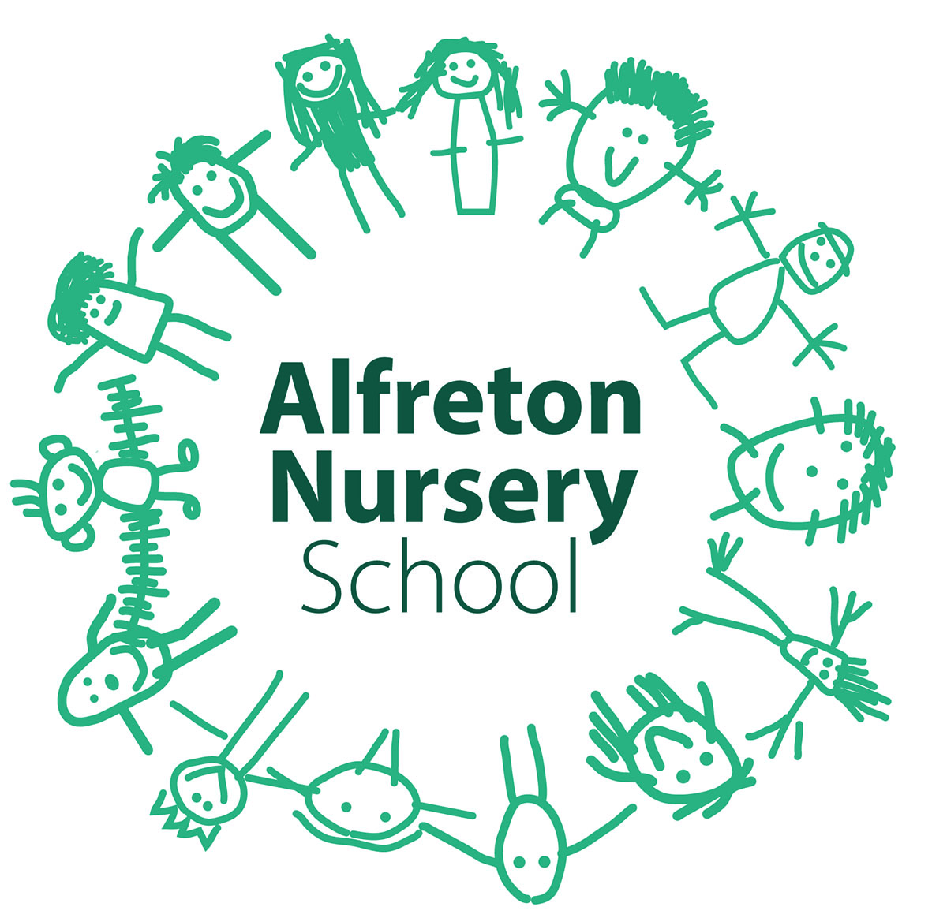

Every Child a Talker (ECAT) Policy

Introduction

At Alfreton Nursery School, we endeavor to make every child’s unique learning journey an exciting adventure, which promotes a real love of learning that will last a lifetime.

As a school which places the rights of children at the centre of everything it does, we spend a great deal of time respecting the needs of every individual child in school – physical, mental, emotional, spiritual, and linguistic. The ability to talk and develop communication skills has a huge impact on children’s overall development in all areas of their learning. It impacts on their ability to make social connections with friends and people close to them and to make connections with the world in which they live. The ECAT approach, has this at its core and through identification, nurturing and interventions, it ensures all children have the support they need to become successful communicators.

Aims

All Practitioners engage in a rich communicative environment, understanding, and differentiating, nurturing and supporting communication skills for all children.

All children will be encouraged to look and attend, listen and hear and to remember and recall, to enable them to understand and make sense of the language around them.

Children will be encouraged to express themselves communicatively. Nurturing confidences, and supporting communication challenges through ECAT will enable all children to develop the skills they need to become confident communicators.

Consultation:

Policy written by Laura Dolby ECAT Coordinator and Communications and Language Coordinator in consultation with Alfreton Nursery School SMT and staff team.

Sources and references:

EYFS Framework 2018
ECAT – Demonstrating Real Progress
Procedures and practice
All 4 areas of Communication and Language will be assessed on entry to school: Listening and Attention, Understanding, Talking and Social Communication, and ECAT children will be identified through the school’s data system.

ECAT children will be identified by the ECAT coordinator, and interventions for support will be shared and supported through a whole team approach. Specific needs will be supported in conjunction with outside professionals ie Speech and Language Therapists (SLT).

ECAT specialists will support specific language skills and will liaise with the SLT and the family, to ensure their practice is informed and appropriate and a whole team partnership will be created, for maximum language development.

ECAT specialists will be responsible for monitoring individual progress, creating and communicating interventions and collecting and recording termly data.

Equal opportunities:
All children will be assessed and their individual needs will be differentiated accordingly, and relevant professionals will work alongside the ECAT specialists to ensure that opportunities to communicate are as inclusive as possible. All the nursery children will have opportunities to sign and use Makaton, this is now part of our weekly planning and provision
Health and safety:
Make others aware when working alone with a child, where you will be and who you are working with.
Planning:
Individual children will have specific interventions, depending upon their communication needs, these will develop and change as the children make relevant progress, this will be at the discretion of the ECAT specialist and the SLT.
Lots of initiatives will be embedded into the nursery curriculum, alongside individual interventions, to ensure in depth communication opportunities for all, these may include; Social Singing Time, Nursery Rhyme times, Roly Poly Friday, signing and Makaton, story sharing and Aspiration Group.

Home school support will be available to encourage communication at home, through providing exciting language and play opportunities, to create a continuity of learning. These resources aim to encourage an understanding of the importance of valuing and engaging in their child’s communication, play, and language development.

Teaching:
The teaching of Communication and Language is embedded into the nursery curriculum and all practitioners are encouraged to listen and observe, before they engage in talk through the children’s play, to encourage child led talking as much as possible.
Teaching through ECAT means the whole team having an understanding of the needs of particular children and are able to differentiate their approach as they engage in talking through their play. It is the responsibility of the team to ensure they are aware of these children.
Particular strategies to encourage and extend talk will be used for individual children. For example the use of modelling.
Organisation/Resources:
2 ECAT Professionals ensure that ECAT is a high priority within the nursery curriculum and are responsible for its implementation and monitoring.
An assigned SLT works alongside the ECAT team to offer advice on those children that have been referred and to also support those children’s families. It is the ECAT Coordinator’s responsibility to refer children in liaison with the SLT.
Assessment:
ECAT monitoring, and data collection, is ongoing over a year, to ensure that these children make relevant progress and have the support they require.
The ECAT identified children all have individual targets and interventions in place to support and encourage progress, these are assessed and amended termly by the ECAT team
An ECAT data system, has been adapted by the ECAT team to monitor progress and inform next steps for individual children.
Tapestry shares and celebrates the children’s achievements, between home and school
Our Tapestry assessment system records and monitors data.
Monitoring and review:
The Link Governor with responsibility for ECAT is primarily responsible for monitoring the implementation of this policy. This will be through annual discussion with the curriculum leader and ECAT Co-ordinator, Laura Dolby. The work of the curriculum leader will also be subject to review by the Head Teacher as part of the school’s performance management arrangements.

The Head Teacher and Senior Management Team will review the policy in line with the School Improvement Plan Overview and monitoring schedule.

Responsibilities within this Policy

Laura Dolby - ECAT coordinator, responsibilities are: liaising and communicating with the SLT, monitoring progress of ECAT children and communicating with the team on their concerns, alongside progressions of individual children, Referring children where necessary, communicating with and supporting families in a partnership of learning. Overviewing targets and interventions for these children, collecting data for these children and giving team members support and advice on how best to meet their needs.
Sharon Mogford – ECAT professional in school – Sharon supports interventions and works with ECAT children to help them to progress, she also supports Laura in the collection of data and selecting appropriate interventions for the ECAT Children

Emma Haywood- Headteacher- will oversee any concerns regarding the delivery and assessment of ECAT.
Emma Haywood – SENDCo- Will report information, regarding ECAT, that she feels is relevant and appropriate. The SENDCo will liaise with the ECAT Coordinator to gain information relevant to the production of IEPS and for writing funding bids. She with also communicate with the team to share information and support ECAT targets, which are outlined in Individual Education Plans (IEP’s).

Concluding notes
The ECAT Coordinator and ECAT Practitioner have both been on the EVERY CHILD A TALKER course, run by Speech and Language Professionals. They use EVERY CHILD A TALKER documentation to monitor the children’s progress and refer to documentation recommended through this course, which is also enforced by Derbyshire.
Individual children’s progress is monitored through the National Strategies ECAT monitoring tool
DATA is collected and recorded termly using the National Strategies Early Communication and Language progress monitoring sheet
Other documents and appendices:
The ECAT team refer to the ECAT documentation, Demonstrating Real progress, and their EARLY LANGUAGE BUILDERS book as a reference material for support.
Letters and Sounds Phase 1
The ECAT policy should be read in conjunction with The Communication and Language and Literacy Policy

COVID 19
Due to the global coronavirus pandemic and the constant disruption to schools, our teaching, learning and assessment offer remains flexible and responsive to the needs of the children in school. We endeavour at all times to provide the highest standard of provision. At different times during our educational offer, interventions have been suspended. This is response to guidance from the DFE and risk assessments within school.

