Our Creative Adventure

Can you see the colours of autumn? A 4 step pictorial sensory dance session plan

- Start with autumn, it’s all around you. Can you see the colours of autumn? Using the simple game of musical statues ask the children to move around your outdoor space and when you stop the music (yes you have music outside!) ask them to look around them and collect something from autumn.
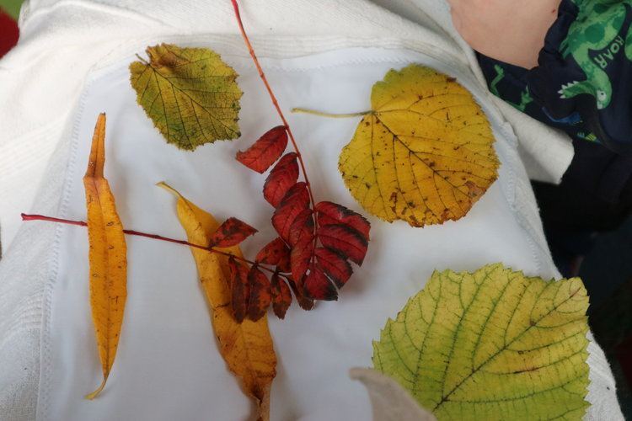
Each leaf is to be explored; leaves can twist, float, spin, swoosh, fall, scuttle (if they’re dried out), twizzle, balance, line up, slot in between toes, crunch, drop, spin. The possibilities are endless….
If you’re outdoors don’t forget to put on your waterproofs (or you’ll get a wet bum)
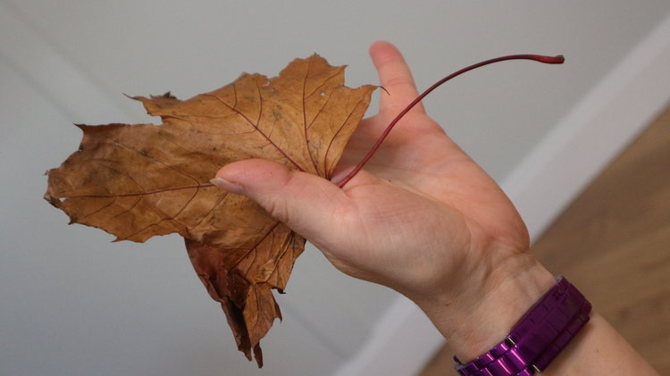
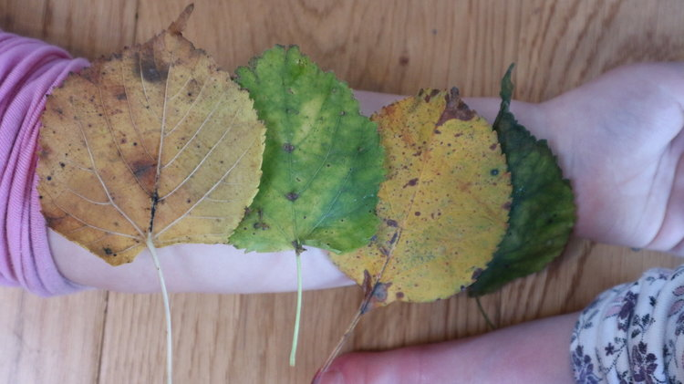
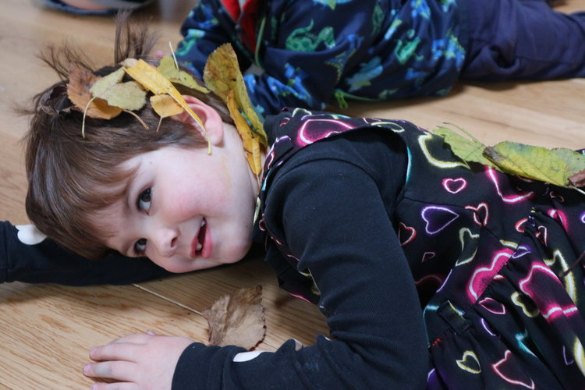
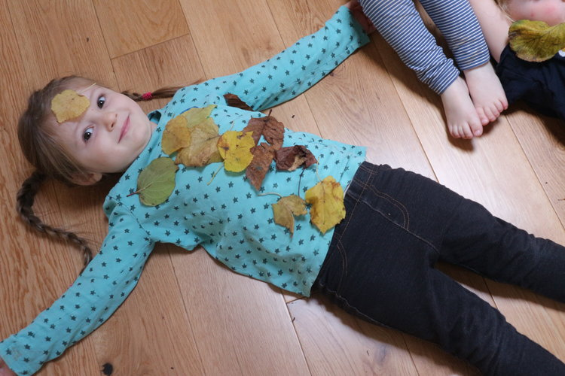

2. Can you see the colours of autumn? Soft lycra squares become the autumn all around us. We can hide, slide, bundle, scrunch, swish, pull, fold, wrap, wiggle, plop." 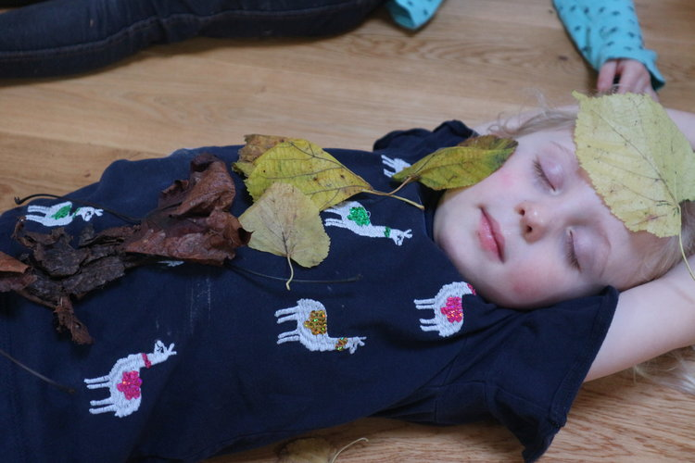
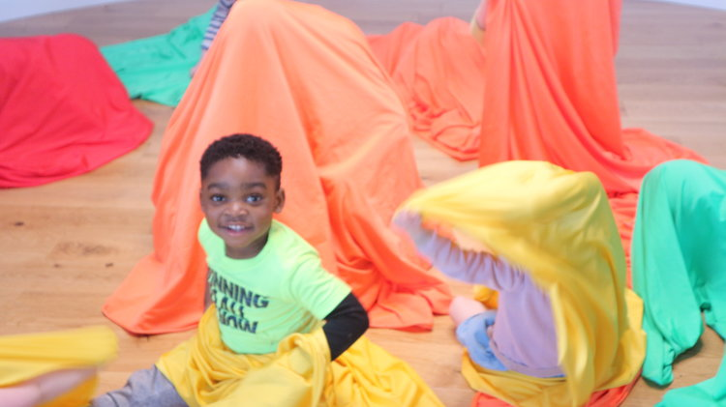
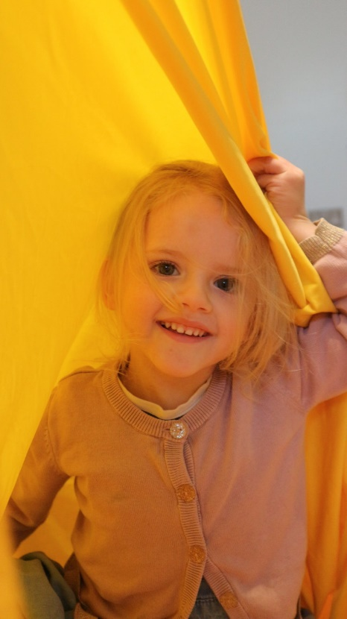
3. Can you see the colours of autumn? Cellophane can hide, peep, curl, rustle, flap, smooth, slide. We can look, place, order, stare, quint, notice.
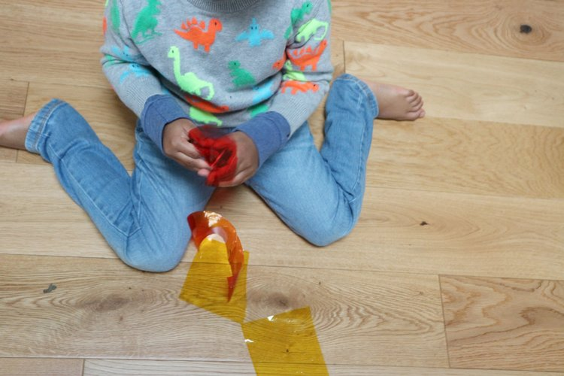
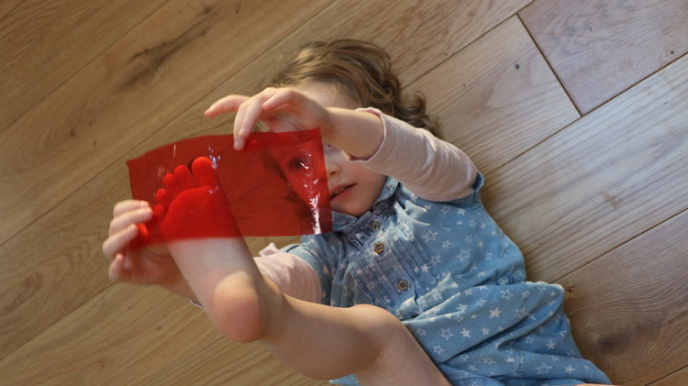
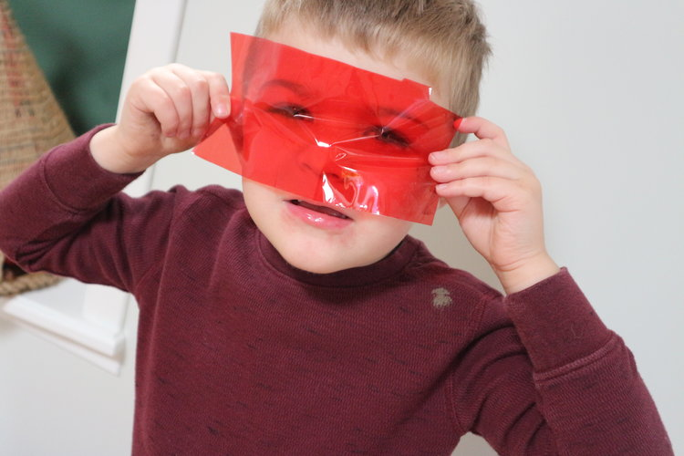
4. Can you see the colours of autumn? We used our OHP but you can use your windows, glass doors, or even the sun itself.
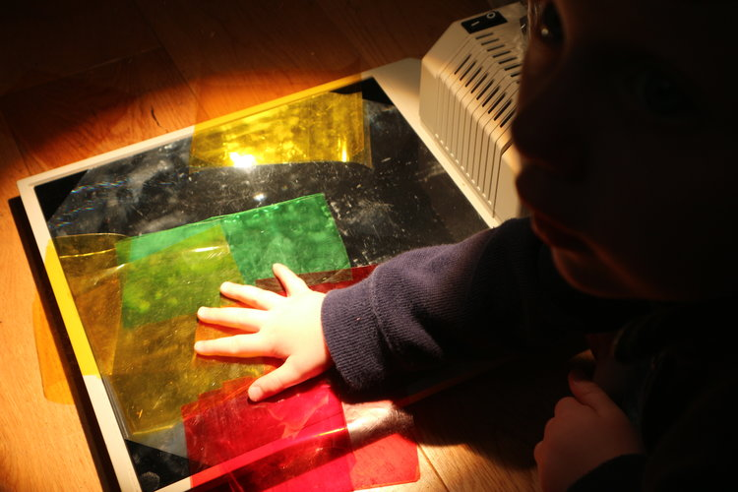
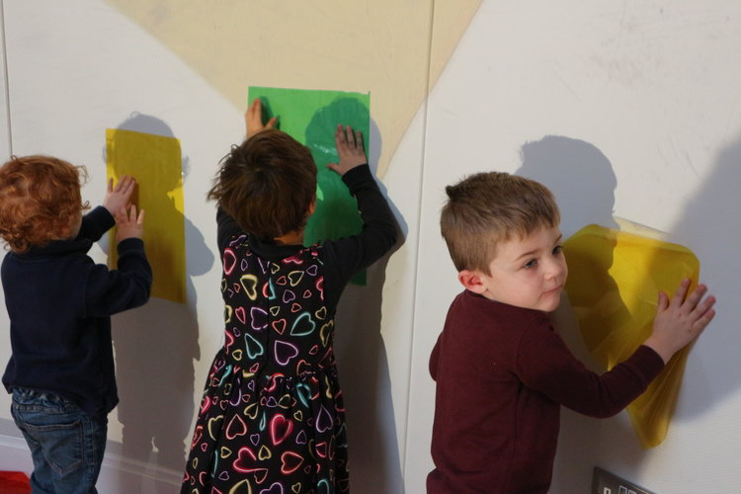
Created by children at Alfreton Nursery and Teaching School where staff are dedicated to creating a stimulating and exciting environment in which children and their families can grow and learn.

