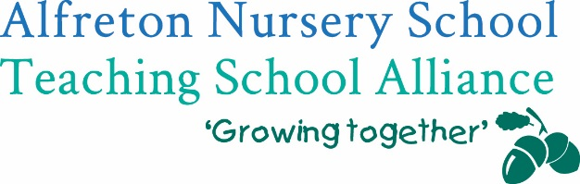


To; Early Years Leaders, Managers, Teachers & Head Teachers in settings and schools


You are invited to join our Derbyshire Teddy Bear Project

Do you want to?

✔ Help your less experienced learners make better progress?
✔ Develop better relationships with all families including the disadvantaged?
✔ Take an attachment led approach to relationships in your local EYFS community?
✔ Improve transition for children between home, settings and schools in your community?

Then the Derbyshire Teddy Bear Project is for you

What does it cost and what do we get?

Alfreton Nursery Teaching School Alliance, Derbyshire Early Years Quality Service and the Parental Engagement Network (PEN) are offering a small number of schools and settings in identified communities the opportunity to take part in this innovative project.

Running from January 2019 to December 2019 the project includes:

- Two twilight training sessions based on the approaches of the Parental Engagement Network (PEN) whose work with disadvantaged families in Manchester has been recognised nationally as highly effective in reaching out to and building relationships with ALL families including the most disadvantaged. Their approach is about tweaking practice, not about wholesale change!
- 4 consultancy visits from Specialist Leaders of Education (SLEs) and members of the Early Years Quality Service, including a planning and development meeting for schools and PVI settings to get attachment clubs going in your community with schools and PVI settings
- Free access to a celebration event in December 2019 to share learning from all the settings involved in the Teddy Bear Project.
- A free attachment resource for every child involved in the project.

To ensure the sustainability of the project, all we are asking for is a nominal contribution of £200 per school (could be pupil premium funding) or £50 per setting. The project is worth at least £2545 per school/setting

To secure your place, please confirm by 26th October at the latest:
Schools - Katie.cresswell@alfreton.derbyshire.sch.uk at Alfreton Nursery Teaching School Alliance (01773 520031)
Settings - vicky.buxton@derbyshire.gov.uk at the Early Years Education Improvement Service

