ADVISORY NOTE
External Health & Care Provider to Provider
Reporting of Incidents & Near Miss Events

- Introduction

NHS Greater Manchester (Wigan Locality) promotes a culture of openness and transparency in relation to the reporting of incidents and near miss events through:

- Prompt and effective communications between provider staff; key stakeholders and where required patients and patients representatives.

- Minimisation of distress to those who have been affected by an incident.

- Prompt and precise gathering of factual information and data through the application of a robust internal investigation and review process.

- Identification of themes and trends in the occurrence of incidents and near miss events.

The aim being to minimise, in so far as is reasonably practicable any potential future risks by taking prompt and appropriate preventive action and monitoring.

- Background

The rationale for putting this advisory note together is to promote and encourage providers to report incidents to each other. It is also intended to give providers the opportunity to open up channels of communication in resolving issues across the system.

- Purpose:

The purpose of providing this information is to ensure that incidents and near miss events involving NHS Providers and other Health and Care Organisations are reported and investigated internally.

Investigations will be conducted in compliance with the individual organisations policies and procedures.

4. Reporting Process by Organisation

Wrightington, Wigan and Leigh NHS Trust (WWLFT):

Should Health and Care Providers / General Practices identify an incident / near miss event involving the Trusts Services (Acute / Community / GP Out of Hours) it should be reported directly to the Trust via the following email address: datix.incidents@wwl.nhs.uk

On reporting the incident / near miss event to the Trust the following information
should be provided as a minimum requirement:

- An outline summary of incident / near miss event inclusive of the site / clinical area involved.

- Please remember you must not include any patient identifiers in the summary.

- Please do provide your (reporter) contact details in the email and this will enable a member of the WWLFT Patient Safety Team to call you to obtain the patient information that will be required.

- Always copy Carrie McManus, Head of Patient Safety and Improvement into the emails so that the themes and numbers of other provider incidents coming into the trust can be reviewed. The email address is: carrie.mcmanus@wwl.nhs.uk

5. Greater Manchester Mental Health NHS Foundation Trust

Should Health and Care Providers / General Practices identify an incident / near miss event involving GMMH NHS Foundation Trust Services this should be reported directly to GMMH via the following email address: incidents@gmmh.nhs.uk

On reporting the incident please include:

- An outline of the incident and include any information available regarding the clinical team and/or individuals involved.

- Ensure that any documents are encrypted prior to sending patient identifiable information.

If you need to speak to someone about an incident please contact PatientSafety@gmmh.nhs.uk, or Jo-Anne.Padgett@gmmh.nhs.uk, Head of Patient Safety, or Sarah.Heeley@gmmh.nhs.uk, Patient Safety Quality Lead, or Joanne.Murphy@gmmh.nhs.uk, Patient Safety Manager or telephone the Incident Team on 0161 358 2099.

6. Wigan & Leigh Hospice

Incidents identified outside of the organisation involving Wigan & Leigh Hospice clinical services should be reported directly to: Wigan & Leigh Hospice via the following email: WLHUlysses.nhs.net

- Outline the nature of the incident and include information available regarding the clinical team and/or individuals involved in an attached document.

- Ensure that the attached document is encrypted prior to sending patient identifiable information.

Incidents that have been identified within the organisation and need to be external reported will be forwarded from: WLHUlysses.nhs.net

Externally Identified Related Incidents

Incidents identified by Wigan & Leigh Hospice staff identified outside of Hospice Grounds whilst on Wigan & Leigh Hospice Duty are to follow:

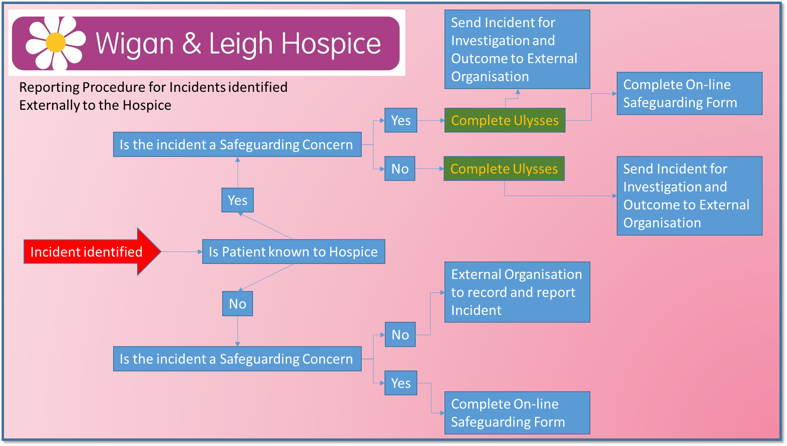

All reported incidents received will be entered onto the Hospice Risk Management system (Ulysses) as per Wigan & Leigh hospice Incident Reporting Policy. If you require further assistance please don’t hesitate to contact the Quality & Governance Lead on 01942 525566

7. Northwest Ambulance Service (NWAS)
Incidents identified involving NWAS should be reported via the Healthcare professional (HCP) and social care complaint/enquiry form:
Healthcare professional (HCP) and social care complaint/enquiry form - NWAS - North West Ambulance Service

Quality Team, NHS GM – Wigan Locality: gmicb-wb.wigan.quality@nhs.net January 2025

