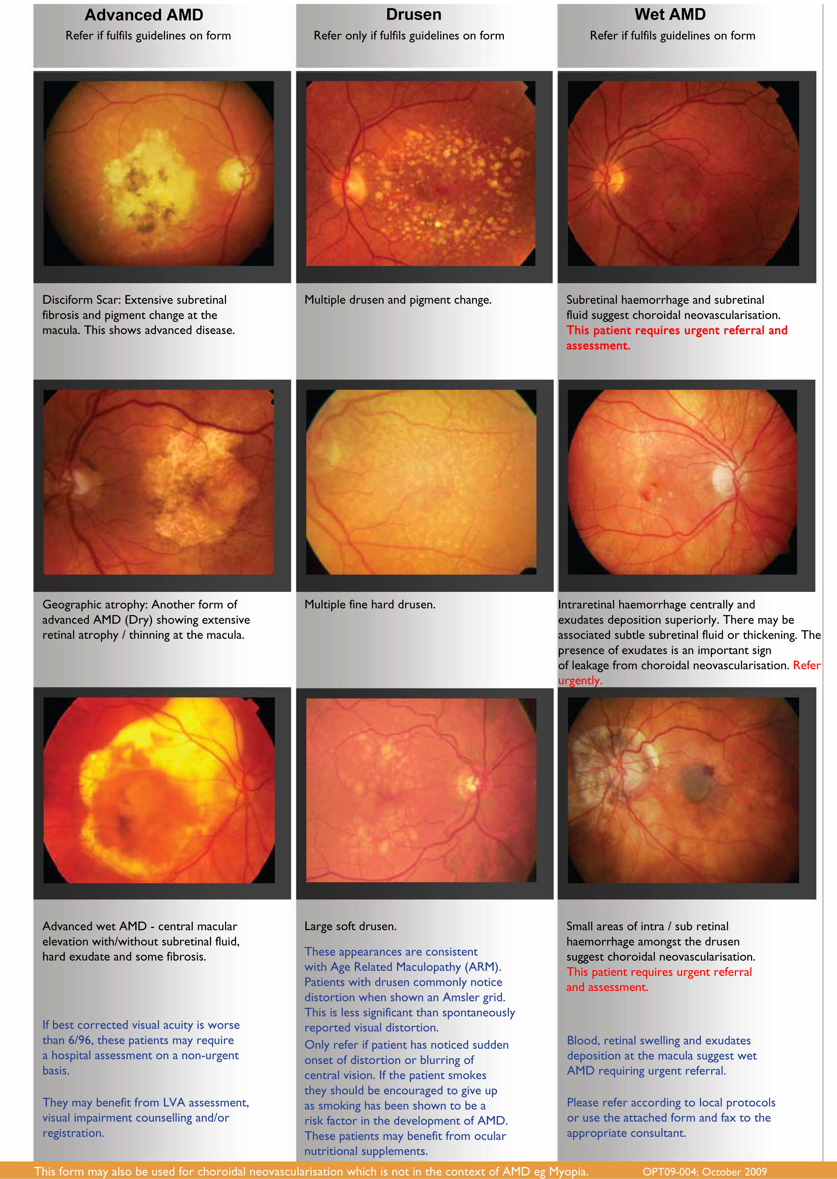

BOLTON NHS FOUNDATION TRUST

FAX 01204 390051 email:- ann.haughton@boltonft.nhs.uk wendy.dawson@boltonft.nhs.uk

WET AMD RAPID ACCESS REFERRAL FORM
Name of Consultant: MR S KELLY/MR E SIORAS
Hospital Contact Details: Ann Haughton/Wendy Dawson tele 01204390390 ext 3529
PATIENT DETAILS
NAME:  ADDRESS:  CONTACT TEL NOS: | DOB: |  | HOSPITAL NO:  (If known)
GP NAME: |  | GP SURGERY:
OPTOMETRIST DETAILS:  NAME:  GOC NO:  TEL: |  | PRACTICE:  ADDRESS:  FAX:
AFFECTED EYE: |  | RIGHT: |  | LEFT:
PAST HISTORY IN EITHER EYE  PREVIOUS AMD  MYOPIA  OTHER |  | RIGHT:  RIGHT:  RIGHT: |  | LEFT:  LEFT:  LEFT:
REFERRAL GUIDELINES
PRESENTING SYMPTOMS IN AFFECTED EYE (one answer must be yes, please mark the correct box with an ‘X’)
Duration of visual loss:
- Visual Loss  - Spontaneously reported distortion  - Onset of scotoma (or blurred spot) in central vision |  | YES  YES  YES |  | NO  NO  NO
FINDINGS Best corrected VA (must be 6/96 or better in affected eye)
- Distance VA  - Near VA  - Macular drusen (either eye) |  | RIGHT: /  RIGHT:  RIGHT: |  | LEFT: /  LEFT:  LEFT:
In the affected eye ONLY, presence of:
- Macular haemorrhage (preretinal, retinal, subretinal)  - Subretinal fluid  - Exudate  - New macular lesions |  | RIGHT:  RIGHT:  RIGHT:  RIGHT: |  | LEFT:  LEFT:  LEFT:  LEFT:
Additional Comments

This form is intended for use by optometrists and general practitioners. It is based on the work of the Thames Valley Macular Group, namely: Susan Downes, Consuela Moorman, Lyn Jenkins and Sarah Lucie Watson. This group has audited the results of rapid access referral using this form and The Royal College of Ophthalmologists is keen to highlight and promote examples
of good practice

